Members’ Weekend 2025 Round Up Branch Magazine of the Year
24/06/2025 by WB Reporter
Campaign

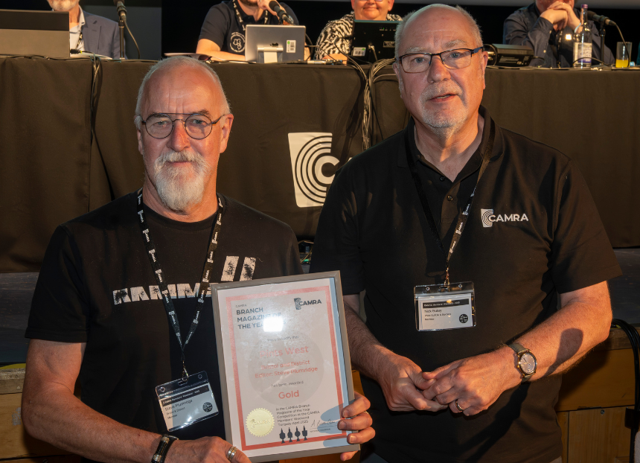

What’s Brewing is rounding up key moments from Members’ Weekend 2025 in Torquay, with video recordings of all the speeches, awards and debates. Watch the video below to see the Branch Magazine of the Year award ceremony and read CAMRA Campaigns and Communications director Nick Boley’s speech. View the PowerPoint presentation here. Nick Boley: It’s now time for the results of our Magazine of the Year competition. Our local magazines are so often the first interaction that ordinary consumers in pubs have with CAMRA, and they bring great joy and education to both interested locals and stalwart CAMRA members on their travels. And before I move on to the winners, please can we have a round of applause for the judging team, ably led by Andy Shaw, John Clarke, Paul Donatantonio, Mary Galliers, Dave Richardson, David Cooper, Karen Brice and Ken Paul. Many of them are successful magazine editors themselves, taking time out from those time-consuming roles to judge the competition for us. We also have a brilliant team of volunteers that provide support and advice on local magazines all year round, and I again want to take a moment to thank them for what they do for the Campaign. Now onto the winners. As always, could either the editor of the magazine or a branch or regional representative make their way up here to collect the award after each announcement. Runner Up
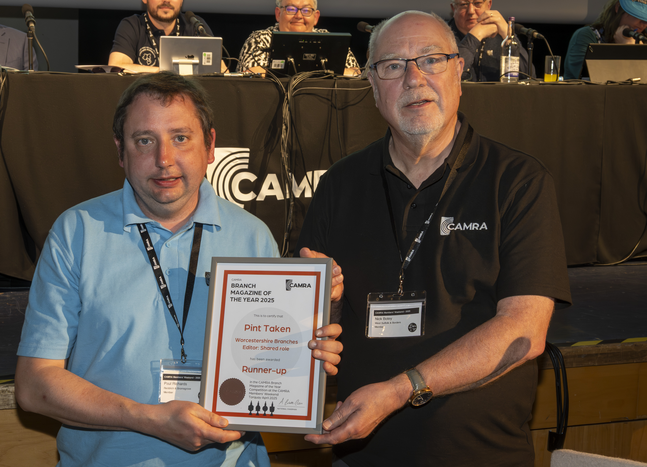
Pictured above: Paul Richards and Nick Boley First, our Runner Up. A close contender for the Bronze award which I will announce afterwards. Judges thought that this magazine covered the basics to a high standard, with especially strong campaigning messaging. Bright and colourful, with a good mix of features, the judges thought the whole magazine was well illustrated. The Runner Up in Magazine of the Year competition is Pint Taken, produced by Worcestershire branches. Bronze
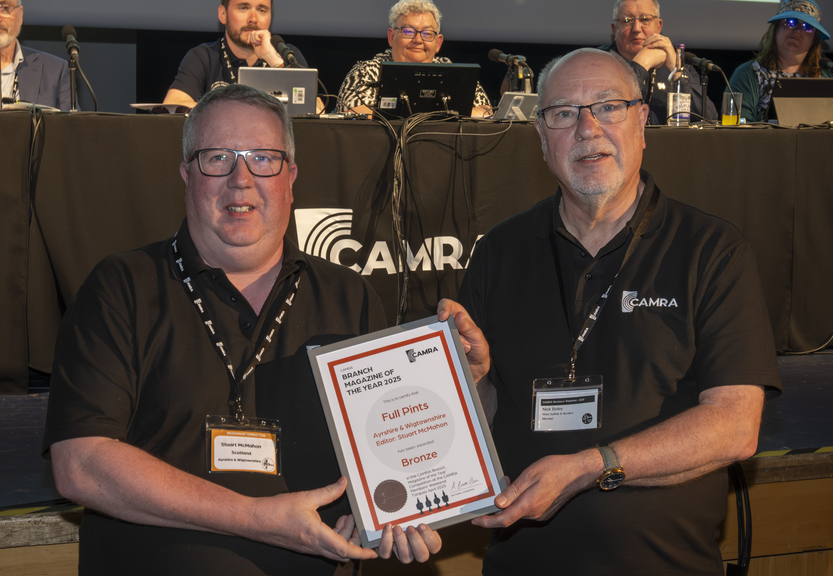
Pictured above: Stuart McMahon and Nick Boley Now our Bronze award winner. Judges loved the use of colour, with frequent comments on the bright and colourful layouts. A strong all-rounder, the quality of local information was commended, but also the efforts to cover wider campaigning issues in Scotland. The winner features frequently in these awards, and you may have already guessed the magazine. Our Bronze Award winner is Full Pints, edited by Stuart McMahon, and produced by Ayrshire and Wigtownshire CAMRA. Silver
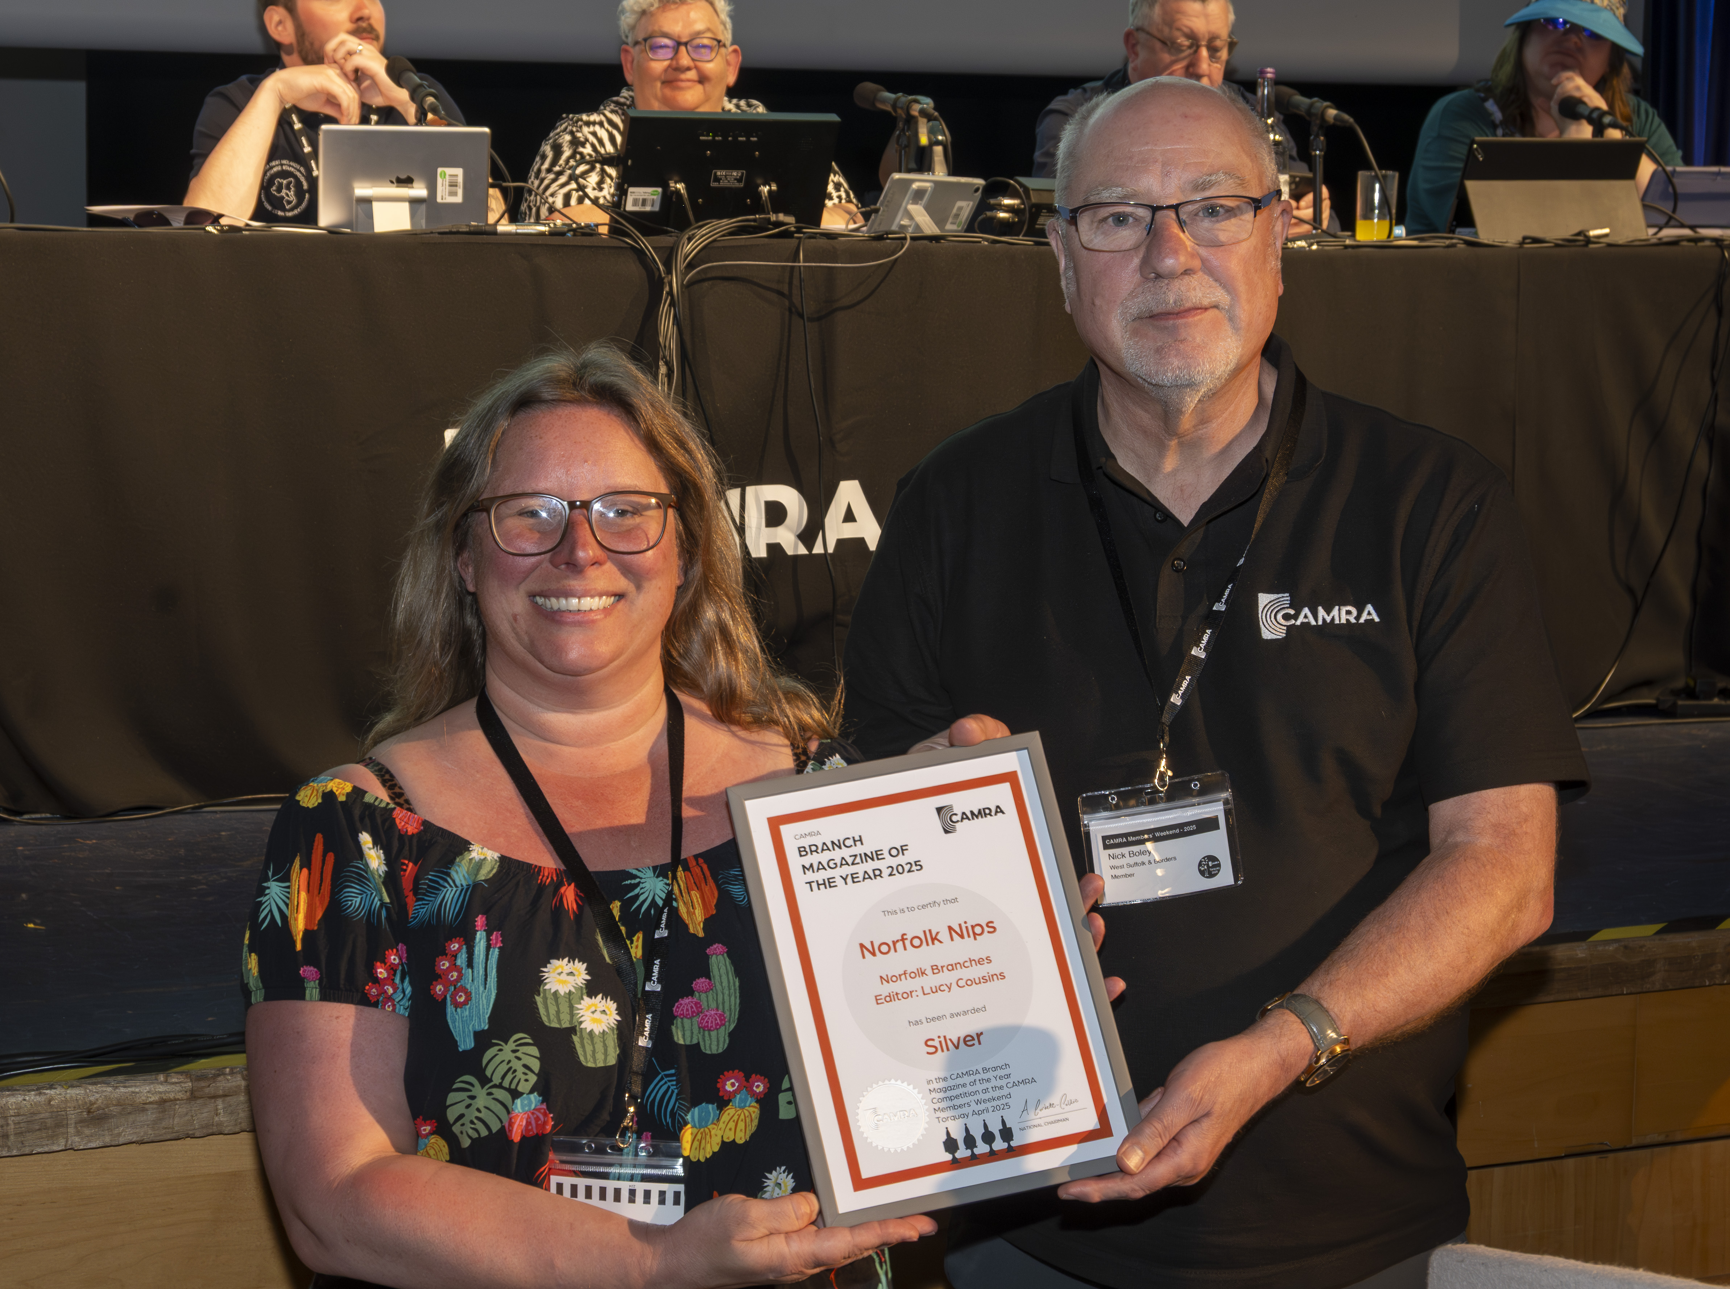
Pictured above: Lucy Cousins and Nick Boley Moving on to our Silver award. Described as “bright, colourful and very reader-friendly”, the judges liked that this magazine showed off local branch activities, showing a fun and sociable group of volunteers learning about all aspects of beer and cider. A very modern-looking magazine, the page layouts were praised, especially for strong use of colour and photos. Our Silver award goes to Norfolk Nips, edited by Lucy Cousins, and produced by the Norfolk branches. Gold
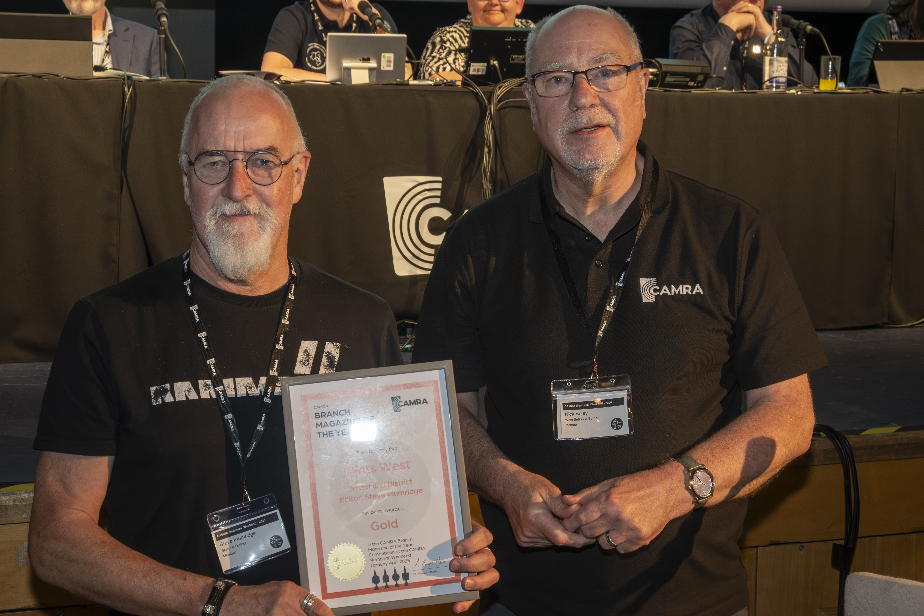
Pictured above: Steve Plumridge and Nick Boley And finally, our overall winner, the Gold award. Judges noted the highly professional look of the magazine, and the assuredness of the content, which includes a large amount of articles on more unusual topics. This magazine uses imagery incredibly strongly and often features great photos of branch volunteers enjoying trips and socials. Always packed with local news and campaigning content, this year the brewery news was highlighted as being particularly strong. Our Gold award in the 2025 Magazine of the Year competition goes to Pints West, edited by Steve Plumridge, and produced by Bristol and District CAMRA.

