History under the hammer

24/06/2025 by Timothy Hampson

Campaign

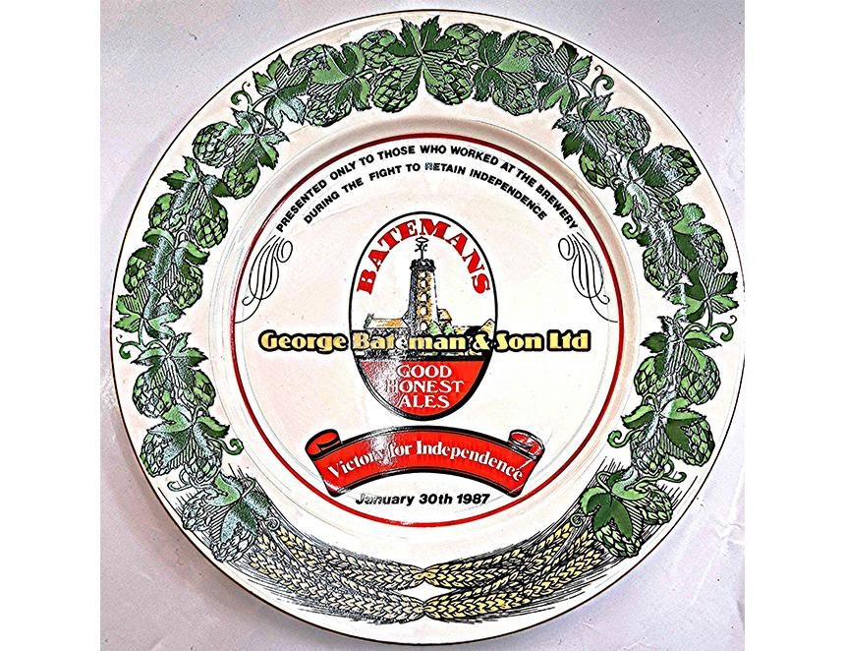

If you fancy owning a slice of brewing history then the CAMRA National Breweriana Auction, which returns to Burton-on-Trent’s Town Hall on Saturday 25 October, is a must. It will have circa 150 lots covering everything from mirrors to trays: advertising signs, water jugs, flagons, bottles, books and pump clips as well as more unusual items. Plus there will be stands selling brewery memorabilia adding to the atmosphere in the Victorian venue. What about a Guinness clock or a plate from Lincolnshire’s Batemans brewery (pictured)? The plate was issued to its employees after the brewery was saved from closure in 1987. One of the key components to saving the brewery was its XXXB winning CAMRA’s Champion Beer of Britain, resulting in full order books. As always, there are a number of advertising display cards including two from London’s Barclay Perkins (set up in 1616 and merged with Courage in 1955) and one from the less known Simpson’s of Baldock, Hertfordshire. The brewery was founded in the 1730s and renamed Simpson’s in 1853 when it was bought by Joseph and Thomas George Simpson. To avoid death duties, the business was sold to Greene King, with 130 pubs, in 1954 for £525,000 and closed in 1965. Another item from Barclay Perkins is a corked bottle of imperial Russian stout, probably 70 years old. Other lots from past London brewing giants are two Toby jugs from Charringtons, which was known for its Toby jug logo. Two items, you can either use or more likely display, are trays from Wadworth of Devizes (founded in 1875 and still in family hands) and Tennants. This is not the better known Scottish Tennents brewery but an operation established by two brothers in 1840 in Sheffield. It was acquired by Whitbread in 1961 with 700 tied houses becoming Whitbread East Pennines but closed in 1993. You don’t have to be an expert to attend the National Breweriana Auction and the event is great fun to take part in or even just to watch. And, of course, like any CAMRA event, there is some good beer on sale all day (from a local brewery). Burton is easily accessible by train, and the Town Hall is just a short walk from the railway station. The event starts at 10.30am with the opportunity to view lots and browse the stands. Bidding starts at noon and is normally finished by 3pm. Entrance is by catalogue (£3), available on the day, or in advance by post: £6.15 (first class) from Bill Austin: 07831 688276 or baustin1951@btinternet.com. If you can’t get there, postal bids are accepted, just contact Bill. Similarly contact Bill if you have breweriana items you would like to enter into the auction. The event is wheelchair accessible. For more details see: gandc.camra.org.uk.