Members’ Weekend 2025 Round Up Campaigner of the Year

23/06/2025 by WB Reporter

Campaign

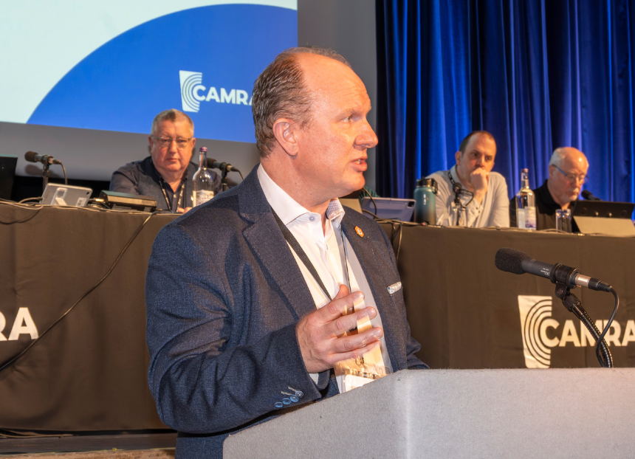

What’s Brewing is rounding up key moments from Members’ Weekend 2025 in Torquay with videos of all the speeches, awards and debates. Watch the video below to see the Campaigner of the Year award ceremony and read Steve Alton’s (pictured) speech and CAMRA's Awards Committee chair Gary Timmins’ introduction. Gary Timmins: Ladies and gentlemen, it is a pleasure to be announcing our Campaigner of the Year 2025. This is one of our most prestigious awards, honoring a person or group whose campaigning has created positive change in the world of pubs, clubs, beer, cider and perry in the last year. The criteria the nominees were assessed against leadership, impact, innovation, commitment and inclusion.  This year we have received a large number of nominations, and it was a pleasure to read about their activities.  The judging panel for this award is made up of stalwart campaigners and current Campaign leaders. It’s been a real team effort and I would like to personally thank all of our judges this year – Ruth Sloan, Nick Boley, Laura Hadland, Nick Bosley, Ash Corbett-Collins, Tom Stainer and Christine Cryne.  Very sadly however, one of our longest standing judges left us.   John Mackie, known to many as Jim, judged the competition until he passed away last June. A campaigner to the end.   Please find some time this weekend to raise a glass for John. So now, onto our runners up. As I already said, we have received many nominations this year, each distinctive and worthy in their own special ways. Please join me in congratulating our runners up this year. A fair few of them are here today, and I’d like to invite them to come up and receive their certificates. Our runners up for Campaigner of the Year 2025 are:  Russell Gilbert and Team In recognition of Russ and his team’s achievement in organising the Derby Heritage Beer Festival in November 2024.  Rob Green For taking a lead role in organising and delivering the Kelham Hall Festival.  Katherine Lilley A leading member of the Bedford Beer and Cider Festival stewarding team for many years, and taking on the role of festival organiser in 2022 and remained in the role for the festivals in 2023 and 2024.  Dave Pickersgill For his series of five books, Sheffield’s Heritage Pubs from 2017-24, and uncovering many unknown facts.  John Vanderwolfe For his work in Exeter and East Devon branch as clubs officer and actively seeking out clubs and encouraged them to stock real ales and ciders.  Ian Webster For all the work he does for the pubs in Burton, and organising the Burton Ale Trail. He is a great voice for beer, beer and brewing history.  Now onto our winner.  This campaigner has been a prominent voice in the media in recent years, fighting for the interests of publicans in Westminster.   Campaigning tirelessly to raise awareness of how pubs are at the heart of communities, they have launched a dedicated campaign to highlight this with MPs and with wider society.   Aside from their work leading a prominent trade association, they also dedicate their spare time to raising money for charitable causes in the licensed trade.   In the last year, they have taken part in two endurance cycle challenges as part of Pedalling for Pubs – including leading the UK version of the event, where one of the other riders was our very own chief executive, Tom Stainer.   In 2024, helped greatly by our winner’s efforts, Pedalling for Pubs hit the milestone of £1m raised for charities like Only a Pavement Away and the Licensed Trade Charity.   I’m very pleased to tell you that the winner of our Campaigner of the Year 2025 is here today to accept the award and say a few words.  Ladies and Gentlemen, your 2025 Campaigner of Year is Steve Alton, chief executive of the British Institute of Innkeeping.  Steve Alton: “Thank you, Gary, and thank you CAMRA. “It’s a huge honour to be recognised by an organisation that’s been fiercely campaigning for pubs and brilliant beers for over 50 years, so it means an awful amount. “I’m passionate about pubs and I’m driven by and for our members across the UK, 13,000 of them, predominantly running single pubs and right now it is incredibly, incredibly tough, but brilliant people are at the heart of it. Brilliant beers, as Tom [Stainer] knows well, I’m a cask ale drinker and the reason I’m on the bike is to get to the pub. There’s no other reason I can assure you. And we raise the money for the charities. “But I share that passion with the brilliant team at the BII. We have a single purpose and it’s to do everything we can to keep pubs thriving at the heart of every community, and we’ll do everything we can to keep that going. “But right now, we’re under incredible threat and pubs matter. You know that better than anyone. We are about connections, we are about careers, and we are about community for absolutely everyone. So that threat is very real. There’s unfair taxes, this government is hammering us with is pushing brilliant longstanding operators to the brink, and it needs to stop. The communities are going to be so much lessened by them failing, and that is an unnecessary failure. “So, we launched our pub campaign to get everybody that loves pubs to write to their MPs. You heard it from the MP earlier. We need to fill their mailbags, their inboxes with letters from everybody, from licensees, from all the local suppliers that support these amazing local pubs, their team, the amazing people that work in pubs that create that fantastic experience, and you, the customers. “If we get everybody to shout, write to their MP, get their MP to notice this is a serious issue. We are at the heart of these communities. We’re key for social mobility, key for investment and we’re key for bringing people together. That’s needed now more than ever. So if you can add your powerful network to that, that would be absolutely fantastic and let’s leave them in no doubt of the issues that is at stake for our heritage and our communities. “But it is an absolute honour, so thank you and thank you for everything you’re doing so. Thank you to Ash. Inspiring words. Fantastic to hear. And I work very, very closely with Tom kind of day-to-day to make sure we’ve got aligned voice going to government, but this means a lot. “So, thank you to CAMRA.”