MP backs bid to keep Dolphin afloat

23/06/2025 by Timothy Hampson

Pub

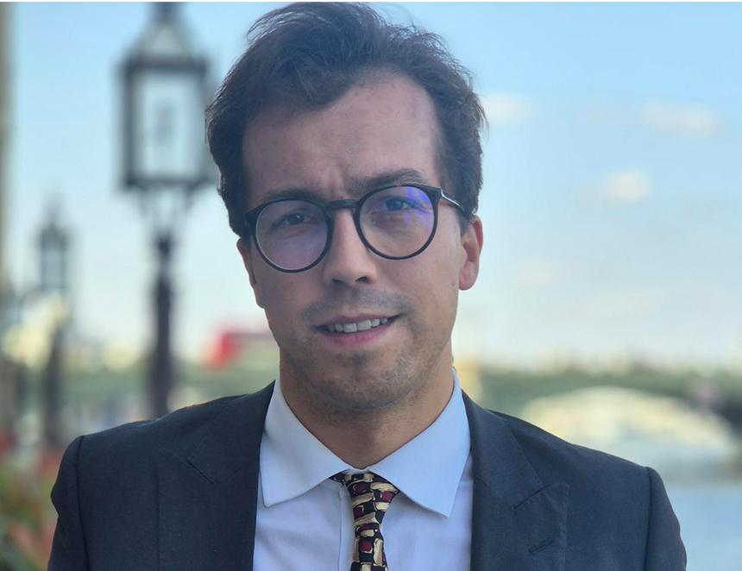

St Austell and Newquay MP Noah Law (pictured) has backed a move by the local community to take over the Dolphin Inn in Grampound, Cornwall, which has been put on the market  £415,000 by owner St Austell brewery.   A group has been set up and is exploring buying and running the pub as a community asset.   “If you really want to understand the true value of pubs, just ask the man who set up a blind pub darts team, attracting a full house of disbelieving visitors and media from across the world,” said Labour MP Law.   “It was, of course, a moment of kudos for the Dolphin Inn, Grampound, but more importantly, it showed the true value of UK pubs, uniting people of all abilities around a community event that was quirky, silly and hugely inspiring,” said Law.   The leader of the darts initiative, Richard Prior, who lost his sight unexpectedly, credits drinking “thousands of gallons” in the Dolphin for meeting other visually impaired people preventing isolation through face-to-face chats rather than through phones, which steal human contact.   Law’s letter to BEER Magazine added: “As automation and globalisation reshape the world, it’s a good example of why we must have bold thinking into what kind of society we want to build. Is it one that just prioritises efficiency and profit, or one that values creativity, knowledge, and community?   “We must make a profound political choice: and recognise pubs, shops, and community facilities as public goods essential to a thriving society. And if we adopt that bold approach, we must also commit the necessary resources to sustain them.   “This status gives villagers an extended deadline to potentially take over the pub, while also supporting the hunt for a new buyer.   “I was elected as a new MP last July, on a pledge to revitalise the towns of St Austell and Newquay, a constituency home to almost 200 pubs run by St Austell brewery, a major local employer. So, the need to value the high-street and local pubs resonates with me as much as anyone.    “Labour has already agreed a 40 per cent business rates relief for the next financial year, as well as broader benefits for around 865,000 small UK businesses through measures such as the employers’ allowance.   “But we must go further. Pubs aren’t just businesses, and we must protect them,” said Law.