PUBlic Affairs round up – June

22/06/2025 by Tori Wood

Campaign

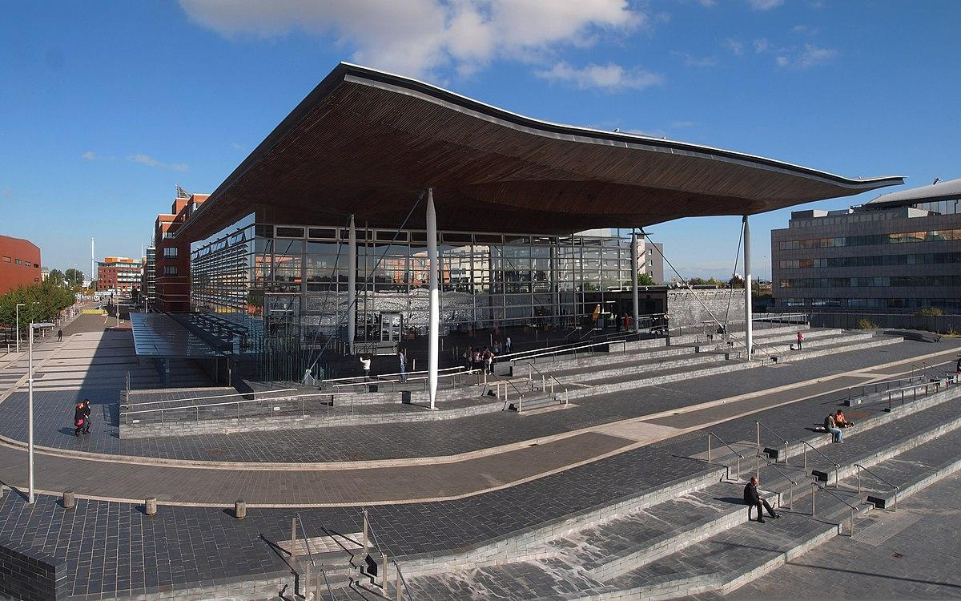

The PUBlic Affairs series returns as preparations for Cider and Perry Month are underway for July, and CAMRA continues to back the Craft Beer Channel’s petition to get cask beer Intangible Cultural Heritage status. Submit your Cider and Perry Month events, sign the UNESCO petition and read on to find out how the Campaigns and Communications Team has been making sure our wider campaigns for pubs, pints and people reach Westminster, devolved parliaments and local government.  Westminster  Access to Market Review Since the chancellor announced the government will review access to market for independent breweries at her Autumn Budget 2025, the team has been working closely with its officials.  Ellie Hudspith (CAMRA Senior Campaigns and Communications manager) discussed our submission to the review that highlights market issues for independent brewers with civil servants at the Department for Business and Trade.  All-Party Parliament Beer Group inquiry The All-Party Parliament Beer Group is a dedicated group for all parliamentary parties which work together to promote and support the beer and pub sector.   The group is running an inquiry, Driving Economic Growth and Investment: A Vision for the UK Beer and Pub Sector. CAMRA’s official submission to the inquiry is here.  Community ownership (England only) On 19 May a ‘Pubs and Community Funding debate took place in the House of Commons.  Rebecca Paul MP (Conservative, Reigate) called the debate which was responded to by Alex Norris MP, the minister for Housing, Communities and Local Government.  While no new announcements on the matter were made, the minister confirmed the government’s new Community Right to Bid policy will be introduced as part of the English Devolution Bill legislation later this year.  In response to questions raised about replacing the Community Ownership Fund, which was closed in December 2024, the minister said “there will be further announcements relating to communities this year” after the government’s Spending Review on 11 June.  Extended Producer Responsibility scheme  The team continues to work with industry bodies to lobby the UK, Northern Ireland, Scottish and Welsh governments about the joint Extended Producer Responsibility (EPR) scheme.  As well as the letter sent to the Environment secretary on issues the scheme poses for pubs and wider hospitality, CAMRA has written another two to amplify our concerns.  In conjunction with the British Beer and Pub Association (BBPA), British Institute of Innkeeping (BII), IFBB, Society of Independent Breweries and Associates (SIBA), UK Hospitality, Federation of Wholesale Distributers and the Wine and Spirits Trade Association, the Campaign has written to the prime minister and the chancellor.  This letter addresses the double payment for pubs, seeks clarity on costs and administration burdens of the scheme, and challenges disproportionate financial burdens on glass packaging.  The team also called for the implementation of the scheme to be delayed until these issues are resolved.   The second letter was to Craig Hoy MSP, convenor of the Cross-Party Group on Beer and Pubs in the Scottish parliament, about how EPR will impact consumers, pubs and breweries in Scotland.  The House of Commons debate ‘Glass Packaging: Extended Producer Responsibility’ took place on 14 May, which the team issued a briefing to MPs ahead of to discuss EPR’s impact on consumers, pubs and breweries.   Sarah Champion MP had a meeting with the Environment minister Mary Creagh to discuss concerns further, sharing our issues on our behalf.  Additionally, Craig Hoy MSP raised concerns about EPR to the Scottish parliament.   Licensing hours extensions – Women’s Euros (England and Wales only) The Home Office announced additional opening hours during the semi-finals and final of the 2025 UEFA Women’s European Championship which is here.  Pubs Code for England and Wales  On 22 May, the Department for Business and Trade launched the Pubs Code and Pubs Code Adjudicator (PCA): statutory review and post-implementation review, 2022 to 2025.  Outside of the three-year period statutory review from 1 April 2022 to 31 March 2025, the government is running a post-implementation review of the Pubs Code.  The implementation review will look at how the Pubs Code is working, if it has achieved its objectives, whether the current regulation should be the most appropriate approach, and if the PCA is still required.  The team is drafting an official submission, as well as a political engagement strategy and making campaigning resources for our local branches and members.  The consultation does not specify a guest beer right for tied tenants, who must currently serve beers as agreed by their pubcos, resulting in no advances for a free-of-tie guest beer from independent breweries.  After flagship campaigning resulted in a guest beer right for the Scottish Pubs Code, CAMRA will be campaigning for a similar beer right for England and Wales tied pub tenants as part of this review.  CAMRA’s Pub and Club Campaigns Committee has written to the PCA to clarify her comments about “innovative agreement types”, such as franchise agreements which could fall under her remit under the existing Pubs Code legislation.  After writing to the Cabinet Office last month arguing for the PCA for England and Wales to remain during their review of government quangos and arms-lengths bodies, the minister for Business and Trade, Justin Madders MP, said this would be decided alongside the statutory review.   UNESCO cask beer petition  The Craft Beer Channel recently launched its Keep Cask Alive campaign, including a petition to get cask beer UNESCO Intangible Cultural Heritage protection, which the Campaign is fully behind and continue to promote.  The government quickly and positively responded after the petition reached 10,000 signatures, welcoming submissions on including cask beer in the Living Heritage inventory once nominations open later this year.  The team will continue to push the petition until it has 100,000 signatures so it can be considered for debate in parliament. This will significantly raise the profile of the campaign, which is a great step for cask beer, brewers, pubs and consumers alike.  At the time of writing, 28,000 people have signed the petition. A massive thank you to our members who have already signed it, and if you haven’t already, you can sign the petition here.  Scottish government and parliament  Scottish government: programme for government  The first minister published the programme on 6 May. It covers legislative commitments and government priorities over the next 12 months, and in the run up to the Scottish parliament elections in 2026.  The programme has a commitment to review business rates valuation methodology for hospitality, stating: “Recognising the ongoing concerns raised by the licensed hospitality sector on the valuation methodology applied to non-domestic property in this sector, we will commission an independent review to report by the end of 2026 and consider any recommendations in advance of the 2029 revaluation cycle.”  A consultation to reform community right powers will be held, which should appeal to pub-saving campaigns and community-owned pubs.  The team will make an official submission to the consultation when it opens.   Separately, plans to ban alcohol advertising and sponsorship have not been brought back since the consultation that took place in 2023.  Scottish Pubs Code  Paul Edgeworth (Campaigns and Communications manager) attended the Scottish Pubs Code adjudicator’s stakeholder engagement panel on 21 May.  The first round of provisions for the Scottish Pubs Code came into force on 1 April, including a guest beer right which is a massive win for tied pub tenants in Scotland.  Guidance on how the code will operate has been released which is on the Scottish Pubs Code Adjudicator’s website and its LinkedIn page.   More information will be published when the remaining provisions in the code, relating to market rent only, comes into force on 30 June.  So far, the adjudicator has dealt with eight enquiries about guest beer rights, flow monitoring equipment and the timetable for the impending market rent only provision.  Provisions will apply to 638 tied pubs in Scotland.  Welsh government and Senedd Cymru  Business rates  The Welsh government recently announced it will hold a consultation on introducing permanent, lower business rates multipliers for small retail premises.  The team is drafting a response from CAMRA to ensure the review is extended to pubs.  Gary Timmins (CAMRA Pub and Club Campaigns director) and Chris Charters (director of CAMRA Wales) have written to cabinet secretary for Finance, Mark Drakeford, to extend this review to pubs while expressing wider concerns for the sector.