Prices and profits up at pubco

20/06/2025 by Timothy Hampson

Industry

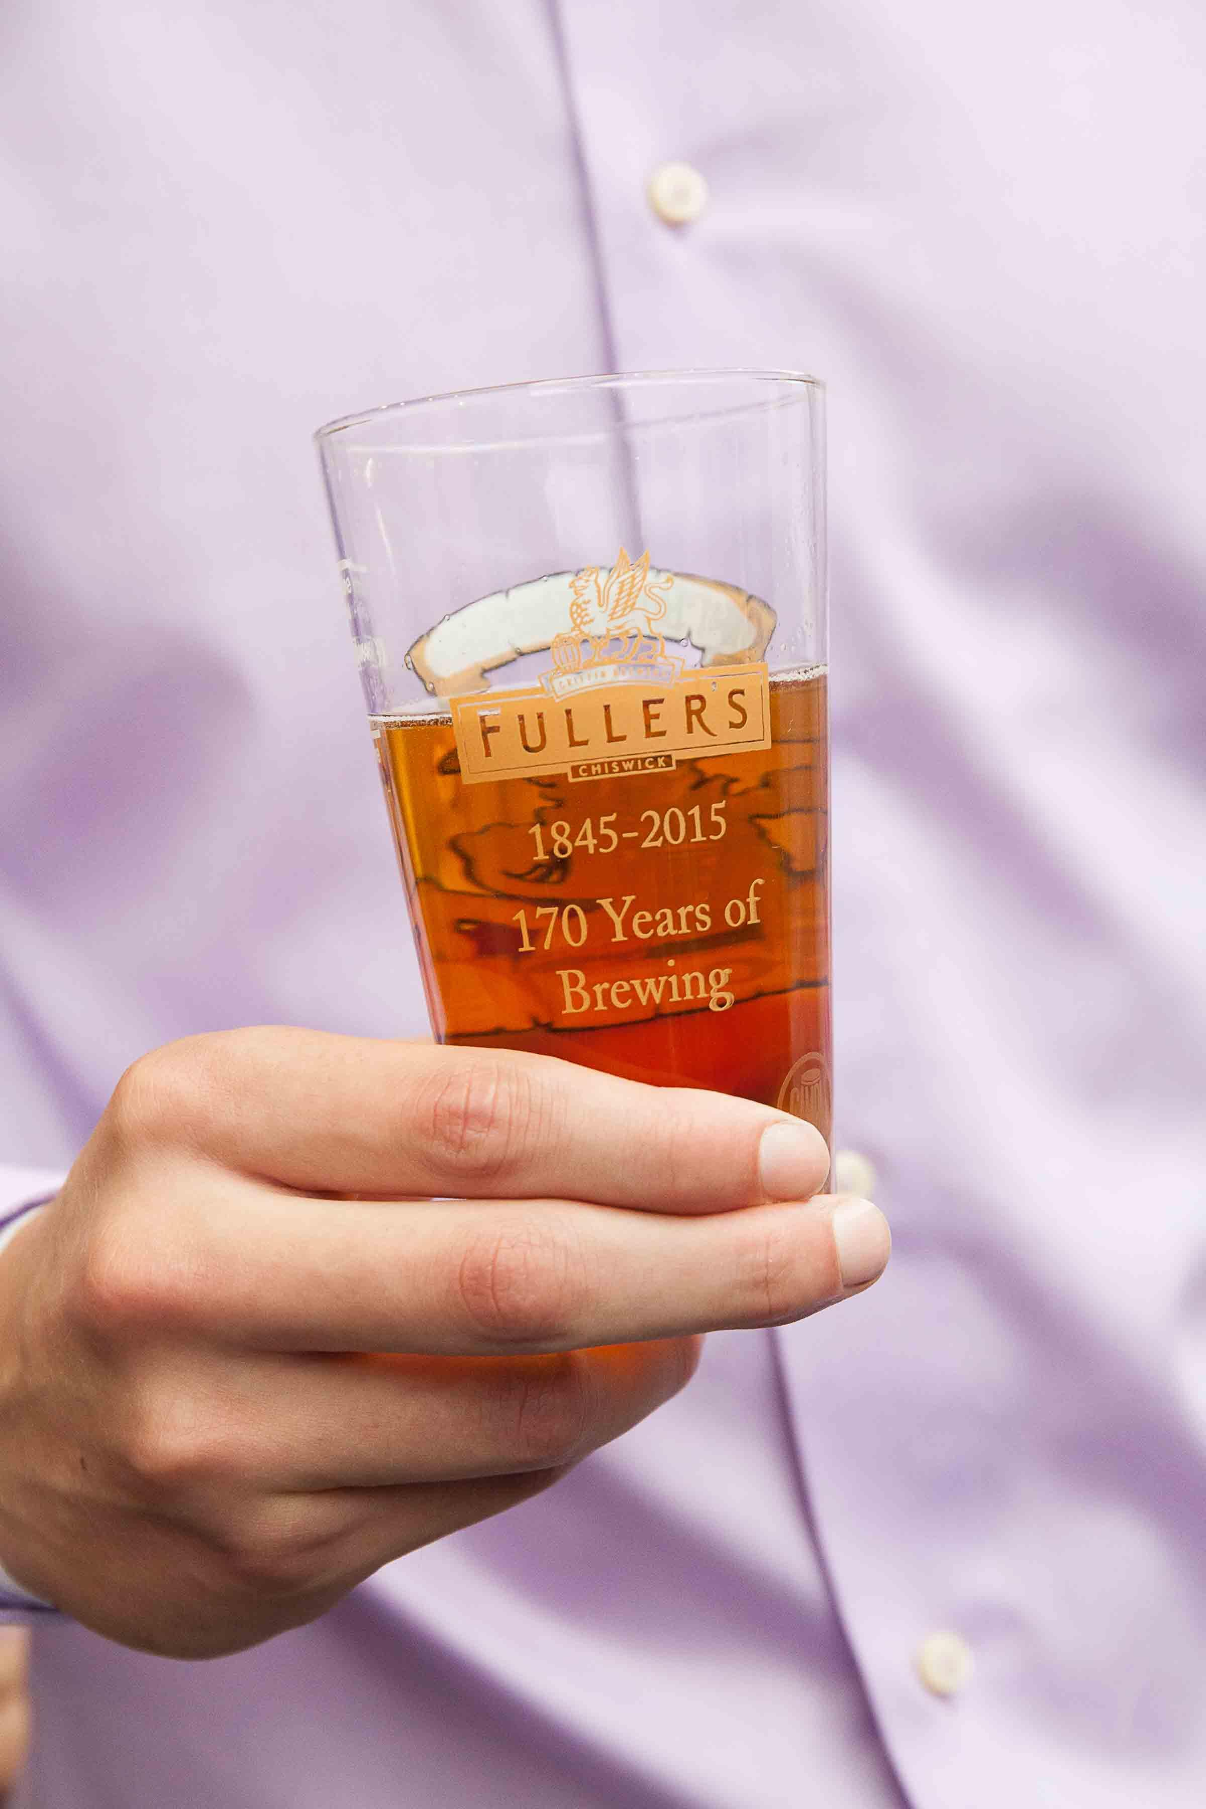

The Fuller, Smith and Turner pub group has hiked prices to offset soaring labour costs as it revealed profits jumped by almost a third last year. Chief executive Simon Emeny has said the group increased the price of a pint of beer by about 15p across its sites after being hit with £8m in extra staff costs due to the autumn budget. Emeny said the business raised prices at the end of March in response to the chancellor’s tax raid, which saw employers’ national insurance contributions increase from April. In a double whammy for the sector, firms also faced a rise in the minimum wage from April, with pubs and hospitality companies among the worst hit. Emeny said Fuller’s had tried to be “sensitive” with price increases, to “make sure that going to the pub remains an affordable treat”. He said the group would keep its pricing under review for the rest of the year as it could not offset the cost impact with price increases alone. The group, which has around 5,500 staff, is doubling down on investment in pubs and staff training, to drive sales higher, which it hopes will counter the extra costs. Emeny said: “Six months down the line and I don’t think price increases are the only answer. It has to come through higher sales.” But he said the consumer spending outlook would be sensitive to the interest rate outlook, and whether the government moved to increase personal taxes. The comments came as Fuller’s posted a 32 per cent rise in underlying pre-tax profits to £27m for the year to 29 March. Like-for-like sales rose 5.2 per cent, and the group said growth had continued into the first 10 weeks of the new financial year, albeit at a more muted rate of 4.2 per cent. It also announced that its chairman of 18 years, Michael Turner, a member of one of the three founding families, will retire at the group’s annual general meeting in July, after a 47-year career with the group. He will be replaced by Emeny, who will become executive chairman, the first person to take the role who is not a member of the founding families. Fred Turner will be promoted from retail director to chief operating officer. The outgoing chairman said it had been an “excellent” past year. “This strong performance has been achieved despite the business operating in a challenging and, at times volatile, economic environment. “The geopolitical situation has caused uncertainty in global markets and the decisions made by the chancellor in her October budget hit the sector hard and reduced confidence in hospitality stocks.” The British Beer and Pub Association recently said the average price of a pint of beer would rise past £5 – up 21p – for the first time because of cost hikes hitting the sector.