Lights, CAMRA, action!

19/06/2025 by WB Reporter

Campaign

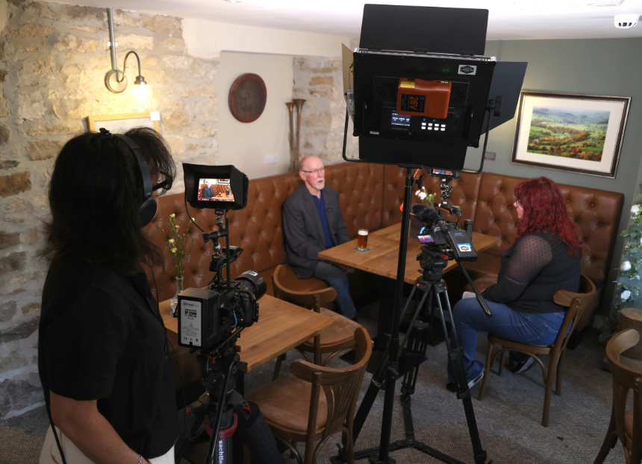

CAMRA is partnering with Plunkett UK to produce a new three-part documentary film series for its educational Learn and Discover platform, celebrating communities which have banded together to save their much-loved pubs.  The series will highlight the many stages and challenges faced by campaigning groups, shedding light on the process of securing and running a community pub. CAMRA hopes the documentary will encourage people to see community ownership as a viable and accessible option for their own local.    The film’s production team boasts the expertise of This Film’s Katie Greenhalf (pictured left) and Cameron Rae Consultancy and founder of Women On Tap CIC Rachel Auty (right), who have documented the highs and lows of groups which have campaigned to save and now run the Traveller’s Rest in Skeeby, North Yorkshire, the Antwerp Arms in Tottenham, London and Yr Heliwr in Nefyn, Wales.  Campaigns and Communications manager: Learn and Discover Alex Metcalfe said: “Following the success of CAMRA’s award-winning documentary, Desi: A Pub Story, I cannot wait for the next addition to the exciting library of Learn and Discover content.   “Pubs are more than a place to enjoy cask beer and real cider and perry, they are social hubs for the local community, bringing people together to help tackle loneliness and social isolation. In many areas, pubs provide the last remaining public communal space, allowing friends and families to meet and feel part of a greater community.  “Once a pub is gone, they never come back. The effort volunteers put in to save their locals from closure, to bring a pub into community ownership, should be put into the spotlight. Viewers will enjoy learning more about community owned pubs and all the trials involved in keeping them alive, from organising fundraising activities to forming a community group.  “With a huge catalogue of entertaining videos, engaging articles and audio clips about beer, cider and perry plus the pubs and clubs which serve them, CAMRA’s award-winning educational platform Learn and Discover is the perfect place for this new project. I cannot wait to show you the amazing work Katie Greenhalf and Rachel Auty have produced.”  Plunkett UK chief executive James Alcock added: “As a national charity supporting people in rural areas to set up and run a wide range of businesses in community ownership, Plunkett UK is delighted to be partnering with CAMRA on this important documentary series that highlights the important role that community pubs have to play. The films will shine a spotlight on businesses based across the country that are part of our membership network."  “At Plunkett, we see time and time again how crucial it is to save local assets such as village pubs from closure. When such businesses close, they leave people without access to vital supplies and services and increase the risk of isolation.  "By transforming them into community businesses, we know they can be truly inclusive and benefit everyone who lives and works there. They are highly effective at acting as multi-service hubs that proactively reach out to support those most vulnerable in a rural community, positively tackling issues of poverty, isolation, and loneliness.”