Unique collab mild created on ‘wondrous beast’

19/06/2025 by Timothy Hampson

Industry

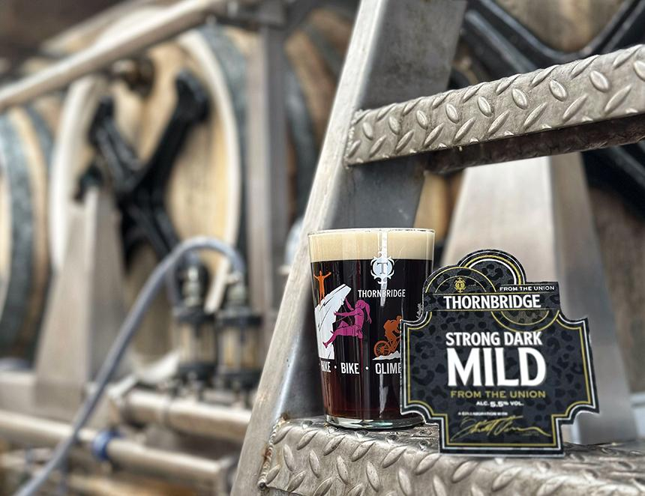

Thornbridge brewery is collaborating with Brooklyn brewery brewmaster Garret Oliver to create a unique beer brewed on the world’s only operational Burton union set. Proceeds from this limited-edition release will benefit the Michael James Jackson Foundation for Brewing and Distilling (MJF). In 2024, Oliver played a pivotal role in assisting Thornbridge with the rescue and restoration of an historic Burton union set – a system once central to British brewing. Now operational at Thornbridge’s brewery in Bakewell, it stands as the sole functioning example of its kind anywhere in the world. Since its installation, Thornbridge has used the union to explore heritage styles and innovative collaborations. This new release marks the first beer brewed on the system with Garrett Oliver himself: a strong dark mild crafted with Maris Otter, premium crystal and chocolate malts, and West African fonio, an ancient grain that contributes creaminess and subtle fruit character. Dark brewing sugars further enhance the beer with complex layers of caramel and richness. In addition to its historical and technical significance, the collaboration supports a vital cause. Oliver founded the MJF, a non-profit organisation that funds technical education and career advancement for people of colour in the brewing and distilling industries. For every pint and can of this beer sold, 10 pence will be donated to the foundation. “We were incredibly excited to brew with Garrett using the union,” said Thornbridge co-founder and CEO Simon Webster. “To combine this brewing milestone with the opportunity to support such an important cause makes it all the more meaningful.” Oliver said: “I’m 36 years into my brewing career, and yet this still counts as one of the most personally significant beers I’ve had the opportunity to brew. “My journey into brewing started with British cask beers at the pub, and to brew on this singular and wondrous beast is a great privilege.” The beer will be available in Thornbridge bars and free trade pubs around the UK.