Cider is not the villain

18/06/2025 by Dale Lord

Industry

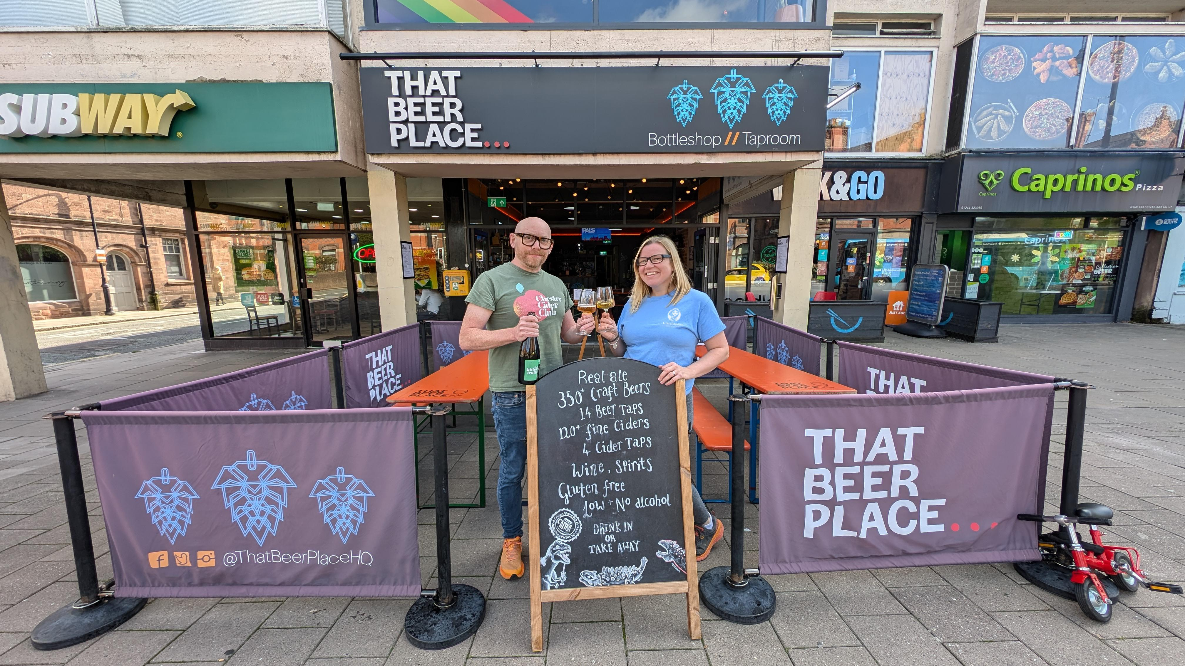

Cider is not the villain. It’s a drink of craft, culture… and quiet revolution. Recent coverage in the Guardian has rightly raised concerns about ultra-cheap, industrial cider. However, it has overlooked something more important: an extraordinary cider renaissance that is quietly unfolding across the UK and beyond. In our bottle shop and bar at That Beer Place in Chester, CAMRA’s Cider and Perry Pub of the Year 2024, we see it every day. Cider made from nothing but apples, often rare, heritage varieties pressed and fermented with care and crafted with techniques that many winemakers would be proud of. The ciders we champion have more in common with natural wine than with the mass-produced drinks that cause so much public concern. And therein lies the real story: cider is a drink of place, culture, biodiversity, and flavour. It deserves to be seen, tasted and celebrated as such. Much of the industrial cider on our supermarket shelves contains as little as 35 per cent apple juice, often from concentrate, with the remainder made up of water, sugars, and flavourings. That’s why it can be sold cheaper than pure apple juice. In contrast, the small producers we work with craft their ciders from 100 per cent freshly pressed apples, no artificial sweeteners, no concentrates, no shortcuts. The price difference simply reflects the difference in quality and authenticity. Across the UK, a wave of talented cider makers is redefining what this drink can be. Using wild fermentation, heritage apples, and techniques like pét-nat, barrel-ageing and fractional blending, they are creating ciders of remarkable complexity and beauty. Makers like Ross-on-Wye, Little Pomona, Oliver’s, Find and Foster, Wilding Cider, and many others are leading this quiet revolution. They are not the problem. They are the future. Cider also has a vital role to play in our food culture and landscape. Many of these producers are helping to restore and protect ancient orchards, preserve biodiversity, and champion local food systems. Every bottle of real cider supports a living ecosystem and a community of skilled artisans. Of course, there is a need to tackle harmful drinking and reform tax policies that allow large corporations to exploit loopholes. But let’s not throw out the orchard with the apples. Good cider is a drink of heritage, community and joy. So next time you raise a glass, seek out cider made with care. Visit your local pub or bottle shop that supports small producers. Look for names like Ross-on-Wye, Little Pomona, Oliver’s, and many more. You’ll not only be drinking something delicious, you’ll be also helping to keep alive a tradition as old as Britain itself. It’s time we told a fuller story about cider, one that goes beyond problems and celebrates possibility. Dale Lord (pictured on left) is the co-owner of That Beer Place, CAMRA Cider and Perry Pub of the Year 2024. You can read the original Guardian article here.