Midsummer madness returns

16/06/2025 by WB Reporter

Campaign

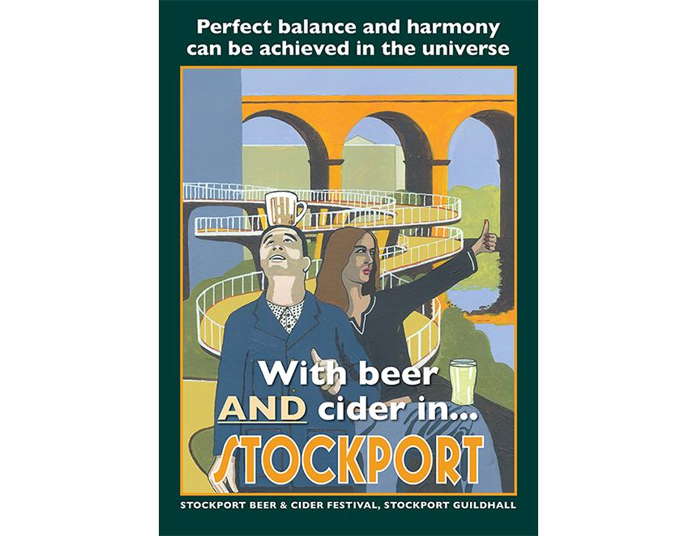

It’s midsummer, so it's time for the annual CAMRA Stockport Beer and Cider Festival. The 37th festival runs from Thursday 19 to Saturday 21 June at the refurbished Masonic Hall on Wellington Road, Stockport. It will feature more than 250 beers, ciders and perries. In addition there will be food, entertainment, and stalls for posters, jewellery, and CAMRA products. An undoubted highlight of the beer order is three casks from the T.E.A. brewpub in Krakow, Poland. The brewer is English and will be delivering the beers to Stockport himself. This will be the first time his beers have been seen in the UK for many years. Other highlights include the five beers brewed at commercial breweries by the winners of Stockport CAMRA’s homebrew competition, which has been running longer than any other similar CAMRA event. These, along with other brand-new beers, will be on the Bar Nouveau. A special Festival Ale, a 4 per cent ABV pale, has been brewed by Wakey Wakey brewery in Rochdale in collaboration with the Stockport and South Manchester branch's Club of the Year, the Ladybarn Club, and some of it will be available in wooden casks. The popular strong beer, Theakston’s Old Peculier, will also be available in a wooden cask. Local Stockport favourites, Runaway brewery, will once again be present with its keykeg bar, which will feature a dozen beers over the course of the event. Ciders and perries will come from across the UK, including local producers Dunham Press and SiDa from Macclesfield. There will also be cider from St Briavels, a small producer in the Forest of Dean in Gloucestershire, which has never been available on draught this far north. On the bottle and can bar, there will be a range of beers from the UK and Europe, including some no and low alcohol beers. Several drinks across all bars are suitable for vegetarians and vegans and some are also gluten-free. In addition, there will also be a stall run by the festival charity, Reuben’s Retreat from Glossop, which will offer several rare beers, as well as bar snacks and soft drinks. The entertainment, in a separate room, features several local bands, plus BAFTA-winning actor and singer-songwriter Phil Mealey, on Friday afternoon, and a DJ set by Clint Boon of the Inspiral Carpets on Saturday evening. There will also be an artist in residence. Eric Jackson, a former journalist, has returned to his first love, painting, and specialises in quirky modern poster art of local towns and landmarks. He has produced a poster (pictured) for the festival celebrating Stockport’s beer scene, which will be on sale along with other examples from his portfolio. Festival organiser Jim Flynn said “The volunteer team has been working hard to organise a festival which has lots of different activities to enjoy. We hope you will come along and join us in our celebration of Midsummer Madness.” For further information, and to buy priority entrance tickets go to: stockportfestival.org.uk You can also pay on the door.