Tributes paid to barley pioneer

15/06/2025 by Timothy Hampson

Industry

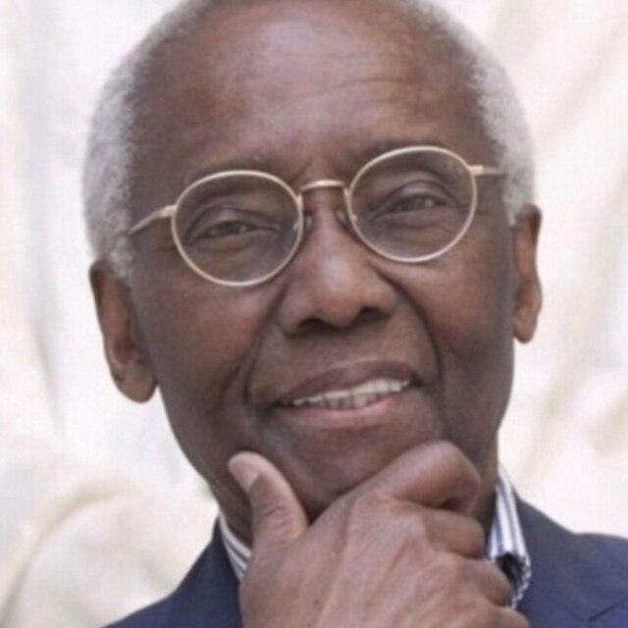

Tributes have been paid following the death of barley pioneer and Scotland’s first Black professor Sir Geoff Palmer, at 85. Sir Geoff, a chancellor and professor emeritus at Heriot-Watt University, moved to the UK from Jamaica as a teenager and became a professor in 1989. His death was confirmed on Thursday night by Heriot-Watt University, which described him as an “inspiration”. Sir Geoff undertook world-leading research into barley malt. Principal and vice-chancellor of Heriot-Watt University Professor Richard Williams said: “He was an inspiration not just to me but to colleagues past and present and countless students around the world. “His infectious enthusiasm and passion for education was impossible to ignore and this university was all the richer for having such a strong association with him over the years. “He will be dearly missed, and our thoughts are with his loved ones at this difficult time. “Sir Geoff was a pioneer and an outstanding intellectual. He had a hugely positive impact on Scotland and will be sorely missed.” Born in St Elizabeth, Jamaica on 9 April 1940, he moved to London as a 14-year-old in 1955, where his mother had emigrated some years earlier, as part of the Windrush Generation. A keen cricketer, he earned a place on the London Schools’ cricket team and at Highbury Grammar School. In 1958, upon completion of his schooling, he was employed as a junior lab technician at Queen Elizabeth College while gaining further qualifications studying one day per week at a local polytechnic. In 1961, Sir Geoff enrolled at the University of Leicester, graduating with a degree in botany. He then began his long association with Heriot-Watt University when he embarked on a PhD in grain science and technology, which he completed in 1967. This was carried out jointly between Heriot-Watt College, as it was known then, and the University of Edinburgh. After completing his doctorate in 1967, he began working at the Brewing Research Foundation, where his academic work saw him invent the industrial process of barley abrasion and pioneer the scanning electron microscope to study cereal grains. Sir Geoff retired in 2005 but was appointed chancellor of Heriot-Watt in 2021. He was knighted in the 2014 New Year’s Honours for services to human rights, science and charity and in July 2024, he was recognised for his contribution to Scotland and installed in the prestigious Order of the Thistle. Also known as a passionate advocate for the rights of Black communities, Sir Geoff’s legacy saw him invited by Edinburgh City Council to chair a review group looking at its colonial heritage.