Say “Cheers to beer!” with our top picks

14/06/2025 by Tori Wood

Campaign

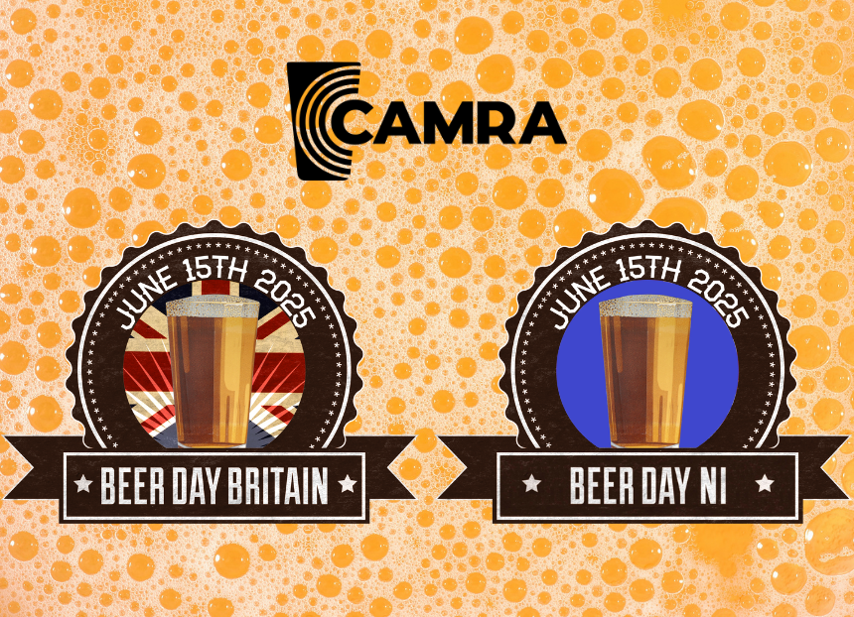

To celebrate Beer Day Britain and NI, CAMRA’s regional directors have put together the perfect pints to say “Cheers to Beer!” with tomorrow (Sunday 15 June) at 7pm.  CAMRA has been supporting the Craft Beer Channel’s Keep Cask Alive campaign to promote  and protect real ale. A petition to get cask beer Intangible Cultural Heritage UNESCO status has now passed 26,000 signatures, with 100,000 needed to get it debated in parliament.   CAMRA chairman Ash Corbett-Collins said: “Our regional directors started their CAMRA journey similarly to me: volunteering to promote and protect the experience of enjoying a great pint of cask in our fantastic pubs across the UK. And now we get to share some incredible cask beers this Beer Day Britain and NI with you!  “We’re not just championing cask in Britain, but also Boundary Brewing in Northern Ireland which is one of the few producers of cask beer in the area. The Northern Ireland Executive needs to take a serious look at reforming NI’s alcohol licensing system so more brewers can produce the great quality cask consumers are asking for.  “Enjoy hunting these fantastic beers and, please, support brewers by ordering a pint of cask at your local, sign the UNESCO petition, and join us in saying ‘Cheers to Beer!’ this Sunday.”   Ash Corbett-Collins:  Colchester brewery: Brazilian (4.6 per cent)  Style: flavoured porter  “Colchester brewery Brazilian is my needle in a haystack beer. One of the first years I volunteered at the Great British Beer Festival (GBBF), this was one of the Champion Beer of Britain (CBOB) competitors and I got the chance to try it straight from the cask in perfect condition. The depth of flavour was incredible.   “But, sadly, I am yet to see it available anywhere near me, and so it continues to be just a memory. If we can achieve better access to market for smaller, independent breweries then hopefully one day I will see it available in a pub near me!”  Stuart McMahon: Scotland  Swannay brewery: Scapa Special (4.2 per cent)   Style: pale ale  “I love visiting the Orkney Islands on holiday as there’s loads to see and do, from visiting historic neolithic sites such as Skara Brae, to watching puffins or orcas around the islands. The islands are also blessed with two great breweries, Orkney and Swannay.   “My first choice is Swannay’s multi award-winning Scapa Special, a delicious, easy-drinking pale ale that takes its name and imagery from the scuttling of the German naval fleet in 1919 in nearby Scapa Flow.”  Five Kingdoms: McGregor’s Mild (3.8 per cent)   Style: mild  “Milds are something of a rarity in Scotland and the country’s most southerly brewery, Five Kingdoms, which is located in the idyllic village of Isle of Whithorn, has hit the mark with McGregor’s Mild.   “Named after the publican in the Wickerman film, which was mainly shot in the local area, McGregor’s Mild has won numerous awards including Champion Mild of Scotland in 2024, and recently won silver in its heat at the Champion Beer of Britain category finals held in Cambridge in May 2025.”  Chris Charters: Wales  Twt Lol - Dreigiau'r Diafol / Diablo Dragons (5.5 per cent)  Style: New World IPA  “A New Zealand hoppy IPA including Waimea, Green Bullet, Southern Cross and Sticklebract. Hoppy Beer Day Britain and NI!”  Greytrees Brewing: Afghan Pale Ale (5.4 per cent)  Style: premium bitter  “Brewed in the style of an American pale ale with three different hop varieties: Cascade, Citra and Simcoe. Maris Otter malt brings a light colour to the beer and a dryness that compliments the taste and aroma left by the hops.” Ralph Warrington: North West  George Shaw: Common (3.8 per cent)  Style: mild  “This was a style of cask beer that was the most prolific seller until the mid-1960s. The brewery itself, George Shaw & Co of Leigh, Lancashire (now Greater Manchester) was one of the many local family brewers that overextended itself in the early 20th century and floundered in the depression of the 1930s. Even though it was taken over by another family brewer, Walkers of Warrington, the beers (including Common mild) were brewed well into the 1960s to satisfy the local demand. Walkers itself had merged with Cain’s of Liverpool before being gobbled up by Tetley (later Allied) in the takeover frenzy of the 1960s onwards.  “The beer is an authentic revival of the original, founded by a locally owned cooperative to revive brewing in Leigh. It is currently brewed by Dunham Massey brewery locally while permanent brewery premises are sought. Dunham Massey itself is a revival success story, formed by a massively experienced former brewer from the defunct Greenhall Whitley company.  “I rather enjoy the beer, it is delicious, as well as being a bit of cask beer history in a glass.”   Shelly Bentley: West Midlands  Sarah Hughes brewery: Snowflake (8 per cent)  Style: barley wine  This Snowflake isn’t just for winter. Champion Beer of Britain Judging Panel organiser Christine Cryne said it was “a beautiful amber barley wine with fruity, slightly spiced nose inviting the drinker to indulge. The rich, smooth, sweet palate has orange spicy notes balanced by a growing bitterness, leading to a spicy dry bitterness. Remarkably moreish.”  Paul Sanders: South East  Firebird: Parody (4.5 per cent)  Style: premium pale ale  “My recommendation is from my own CAMRA branch, Surrey Hants Borders. The key brewer behind this is Bill King and is a take on a former King and Barnes brew, the name is the result of contractual obligation as Hall and Woodhouse owned all the recipes and names from when it took over King and Barnes.   “Why do I like this beer? It took me back to the beer taste when I first moved to Sussex in the 1980s.”  Andrea Briers: East Anglia  Crouch Vale: Amarillo (5 per cent)  Style: premium golden ale  Champion Beer of Britain Judging Panel organiser Christine Cryne described it as having “a tangy aroma with a faint note of biscuit, full of tropical and citrus notes on a sweet biscuit base. A full flavoured beer with a dry sweetish bitter finish.” This beer has been brewed for 30 years and continues to use Amarillo hops from Washington State in the USA.  Peter Bridle: South West Penzance: Mild (3.6 per cent)  Style: mild  “Mild is a particularly rare beer style for the South West, which is why the CAMRA Cornwall branch and I have chosen Mild by Penzance.   “The beer is a current finalist in this year’s Champion Beer of Britain, which will take place at the Great British Beer Festival in Birmingham this August.”   Robert Hamnett-Day: East Midlands  Baker’s Dozen: Electric Landlady (5 per cent)  Style: premium golden ale  “Electric Landlady is Baker’s Dozen’s flagship multi-award-winning pale ale, brewed with Mosaic hops. Its strong mango flavour and aroma is a delight from start to finish.”  Ian Garner: Merseyside and Cheshire:  Rock the Boat  “I am not going to recommend a beer but a brewery. Rock the Boat is one of the most successful breweries in the North West, a multiple award-winner with multiple styles in its repertoire.   “Its beers are to be found and enjoyed across the region, and a welcome sight on any bar.”  Norman Clinnik: South Central  Siren: Broken Dream Breakfast Stout (6.5 per cent)  Style: flavoured specialty beer  “Who says you can’t have breakfast at 7pm on a Sunday? Say cheers to Siren’s Broken Dream Breakfast Stout on Beer Day Britain but get ready for a deep and complex tasting experience that includes a gentle touch of smoke, chocolate and coffee.”    David Martin: East Central Towcester Mill: Mill Race 3.9 per cent  Style: blond ale  “For me, Mill Race ticks a lot of boxes. It is from a local independent brewery. It is a relatively low ABV pale beer with plenty of flavour, perfect for summer drinking and exactly what I want to see on the bar at my local independent free house.”  Ellen Eames: Greater London  Anspach & Hobday: The IPA (6 per cent)  Style: New World IPA  Judges described the IPA as “a wonderful fruity New World IPA. Aromas of citrus and tropical that are also on the palate where the developing bitterness is perfectly balanced by the bitterness leading to a dry, spicy finish. Morish for a six per cent beer.” The best result for a London brewery since Fuller’s ESB won silver back in 1991.  Kevin Keaveny: Yorkshire  Half Moon: Dark Masquerade (3.6 per cent)  Style: mild  “Brewed by a vibrant microbrewery at Ellerton, it is a very pleasant pint indeed. A ruby, brown beer that is filled with chocolate and liquorice flavours.”  Hubert Gieschen: North East  Darwin: Extinction (8.3 per cent)   Style: strong ale  “Darwin’s Extinction has a strong depth of flavour, one that has a solid mouthfeel and is overall a smooth and satisfying cask beer.”  Brett Laniosh: West Central  Oakham: Inferno (4 per cent)  Style: session golden ale  “A straw-coloured golden ale with a strong citrus hop character that begins on the nose, and builds intensity on the palate, with a dry citrus finish. This fruity and spicy brew will not disappoint any palate.”  Ruth Sloan: Northern Ireland  Boundary brewery: Imbongo (5.5 per cent)  Style: IPA  “I remember the first time I tried Imbongo in cans from Boundary Brewing. It was bold, tropical, full of juicy hops, and everything I love in a hazy IPA, certainly a fitting tribute to its fruit juice namesake. Then I had the pleasure of being able to taste it on cask and be able to compare the two, to say it was a completely new experience is an understatement and must be one of the most enjoyable pints I’ve ever had.”  “Cask beer is a rarity here in Northern Ireland, never mind local brews on cask. Unlike other parts of the UK where it’s relatively easy to find handpulled cask beer, most pubs tend to stick with kegged beer, lagers, or macro-options, closing off the market for cask for local producers. The market doesn’t exist at the moment, so there are no producers producing, the market doesn’t grow, it’s a vicious cycle that ends up closing off local consumers from experiencing the nuanced, living beer that cask ale represents.  “That’s where Boundary Brewing comes in. Based in Belfast, it has been doing incredible work with modern beer styles: NEIPAs, stouts, saisons, you name it. But what really makes it stand out for me now is its willingness to go against the grain and start to embrace cask and lead the way for consumers and producers alike, and the choice of Imbongo to be its main cask offering. One of its juiciest, hoppiest IPAs on cask is a bit of genius from the brewers in East Belfast that I think should be celebrated by all CAMRA members.  “For anyone who hasn’t had a chance to try it, Imbongo in can and keg has vibrant tropical notes of mango, pineapple, citrus, but on cask, everything just mellowed beautifully. The bitterness softened, the carbonation was gentle and creamy, and the whole thing became beautiful drinkable sessionable beer.”  “One of the few times and places you can reliably find a wide range of cask ales in Northern Ireland is at the Belfast Beer Festival, held every November (tickets on sale soon!). Organised by CAMRA NI, this event is a much-loved highlight of the year for local beer lovers - an oasis of hand pulled goodness in a region where it’s far too scarce.  “For a few glorious days, you get a glimpse of what Northern Ireland’s beer scene could look like with more cask: vibrant, diverse, and proudly local.  “While we take loads of beers from breweries all over Northern Ireland, I would be remiss in not highlighting the fantastic offerings in cask we received last year from Boundary (Belfast), Rough Brothers (Co Londonderry), Hilden (Co Antrim) and Whitewater (Co Down). Hopefully the success of these offerings and with enough interest and support, we might see a true local revival of cask brewing and serving, driven by pioneers such as these.  “Cheers to Boundary. Cheers to the Belfast Beer Festival. And cheers to a future with more Northern Irish cask beer in our pubs!”