All change for top city fest

13/06/2025 by Timothy Hampson

Campaign

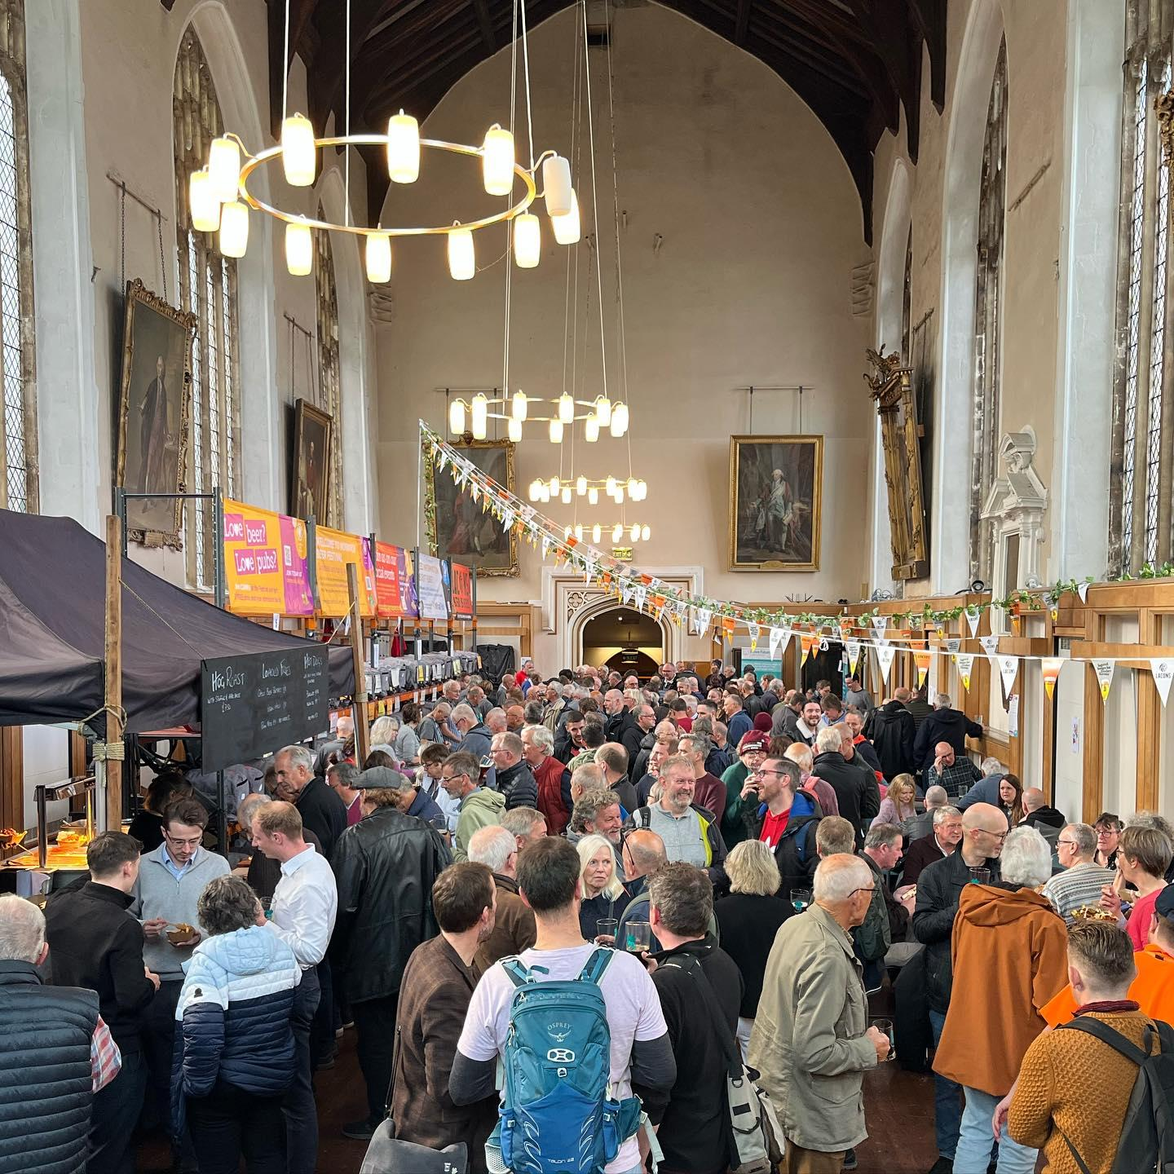

Norwich Beer Festival is to move venues and dates due to the ongoing refurbishment of the city’s Halls (above) which has been its home for 45 years. Norwich & District CAMRA has said alternative dates and details will be announced soon. The branch has stressed the festival is not cancelled, it is simply relocating for this year. The committee is continuing the festival’s legacy of celebrating Norfolk and the UK’s vibrant beer scene and will also showcase ciders, perries and international beers. Organiser Craig Harmer said: “We know how important the Norwich Beer Festival is to the local community and, while we’re disappointed that the refurbishment of The Halls will not be completed, we’re excited to announce that the festival will continue. “We’ll be releasing more details of the dates and locations soon. We’re looking forward to sharing this experience with everyone! We’re also looking forward to returning our festival to The Halls as soon as we can.” Branch chair Ian Stamp added: “Rest assured, the festival isn’t going away and the beer will flow, so stay tuned for updates.” For updates go to norwich.camra.org.uk or the branch’s social media. The branch has also announced it will be visiting up to 400 of its pubs in one day! On Saturday 14 June, CAMRA volunteers will be conducting the annual survey of district and city pubs to raise the profile of their offerings, while also gaining a deeper understanding of trends. If you’re a CAMRA member and interested in taking part, a few more volunteers are needed, particularly in Norwich, Dereham, North of Norwich, North Norfolk and North West Norfolk. Contact organiser Craig Harmer before 14 June at organiser@norwich.CAMRA.org.uk if you can help.