Branch founder and saviour remembered

12/06/2025 by Peter Trout

Opinion

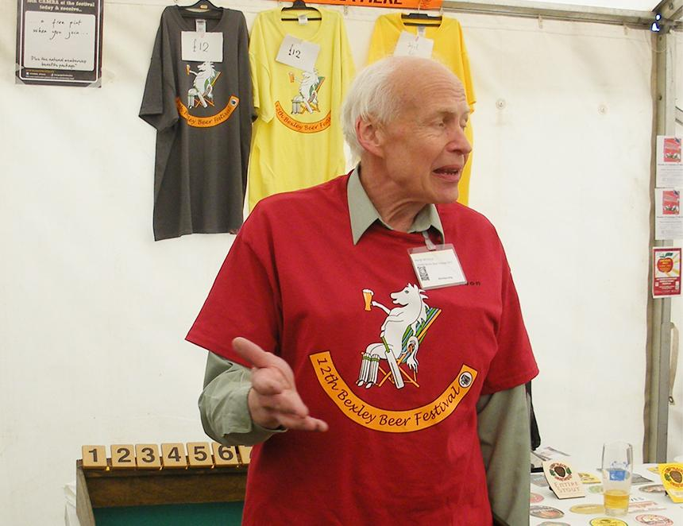

CAMRA’s Bexley branch was saddened to hear of the death of its longest-serving chairman and only president Martyn Nicholls. For a few months in 1975 Bexley and Bromley were one CAMRA branch, but the former thought there was enough interest to start its own. On 21 July 1975, at the Blue Anchor pub in Bridgen (now just the Anchor), Bexley CAMRA was born. Martyn took the minutes and was elected on to the first committee. Jeff Tucker (now of Maidstone and Mid-Kent CAMRA) was elected chairman and everyone contributed 10p so a bank account could be opened. Martyn, in his long association with Bexley CAMRA, managed to take on all jobs just to keep the branch active, particularly through the lean years in the 1990s and had a 20-year spell as chairman. Working for Bexley council’s planning department, he put as many pubs as possible into conservation areas, which helped when they were keen to promote a pseudo-Australian lager with extra-large illuminated outdoor signs that were far larger than existing ones. Martyn’s move meant the pubs had to settle for signs the same size as the ones already there. Working with other Bexley groups, Toby Carvery had to reinstate the original name of the public house it had taken over to the Crook Log. The Kent guides benefitted from his line drawings of pubs from the 1988 edition onwards. He supplied the Kent, Gravesend and Bexley beer festivals with logos to be used on glasses, T-shirts and advertising and assisted Terry Whitta with the posters for the early Mild Month campaign, which he took great pleasure in doing as he was a big fan of the style. Each Christmas meeting attendees were sent a Christmas card depicting a line drawing of a Bexley pub, his favourite being the award-winning Robin Hood and Little John. Martyn worked at many festivals over the years including the 1975 Covent Garden event, and the two South East London events held in Woolwich Polytechnic, plus of course Kent and Bexley. He began his working career with the old Greater London Council, until it was abolished in 1986, then joined Bexley council, becoming senior planning officer. Apart from drinking cask beer and a love of folk music, he had a huge interest in transport having articles published in model railway magazines, helping in the restoration of old buses and being a marshal at motor rallies. A lot of his time was spent within Bexley organisations, as he considered it important to contribute to all aspects of the local community.   Without Martyn's enthusiasm and determination, Bexley CAMRA would have folded. A much-missed member, RIP.