Frank’s makes it three

11/06/2025 by Timothy Hampson

Industry

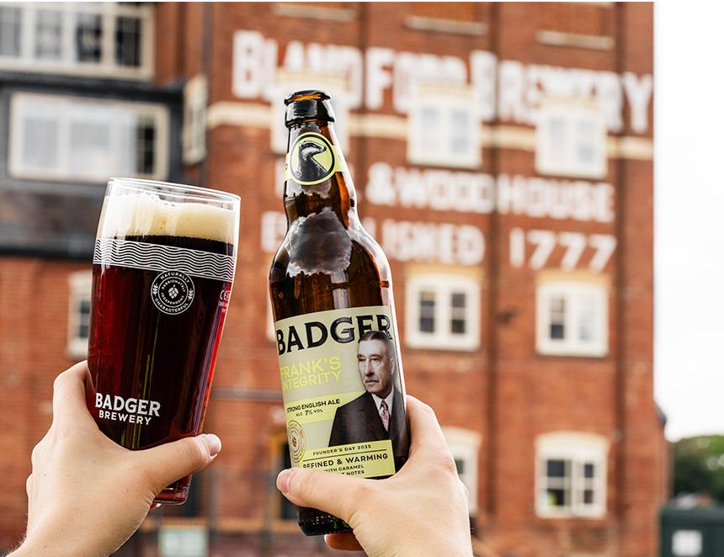

Dorset-based independent family brewer Hall and Woodhouse is marking its Founder’s Day on 8 June with a new limited-edition beer, Frank's Integrity. The 7 per cent ABV refined and warming, bottle-conditioned chestnut ale is a tribute to former chairman Frank Woodhouse and is the third in a series of five Founder’s Day beers which are being released annually in the countdown to the brewery's 250th anniversary in 2027. Founder’s Day has been a Hall and Woodhouse tradition for many years, as a way of celebrating the key people who have moulded the brewery over the last two centuries and more.  Frank’s Integrity, like other Founder’s Day beers, will be available in 500ml bottles from Hall and Woodhouse pubs, the brewery shop and the Badger online store badgerbeers.com. It has an RRP of £4 per bottle. Hall and Woodhouse head brewer Toby Heasman said: “Frank Woodhouse spent nearly 60 years working for the family brewery and his sharp instincts and steady leadership helped to shape the business we have become today. “We’re pleased with the beer we’ve created to honour him and his remarkable tenure: a bold, warming ale which reflects his character. We hope customers in our pubs and at home will join us in raising a glass to Frank on or around Founder’s Day.” Frank’s Integrity is brewed from a blend of pale ale, crystal, and chocolate malts with English Target, Goldings, and WGV hops. Frank trained as a doctor before joining his two older brothers in the family business, becoming its chairman in 1916. He steered the company through major changes including the move from its original site in Ansty to its current home in Blandford. His quick thinking saved Hector's brewery in Ansty from a fire in 1900, saving most of the valuable casks and vital records. Previous Founder’s Day beers were Teamwork in 2024 and Jock’s Dedication the year before. Teamwork was a 9 per cent stingo ale celebrating Edward and John Woodhouse, two brothers who made the style famous during their tenure in the 1960s. Jock’s Dedication was a strong English ale brewed in tribute to John “Jock” Woodhouse who joined the brewery in 1962 after a career in the army, eventually serving as chairman until 1988. The beer was brewed to 6.2 per cent to reflect the year he joined the business.