Campaign reveals top pub designs

10/06/2025 by WB Reporter

Campaign

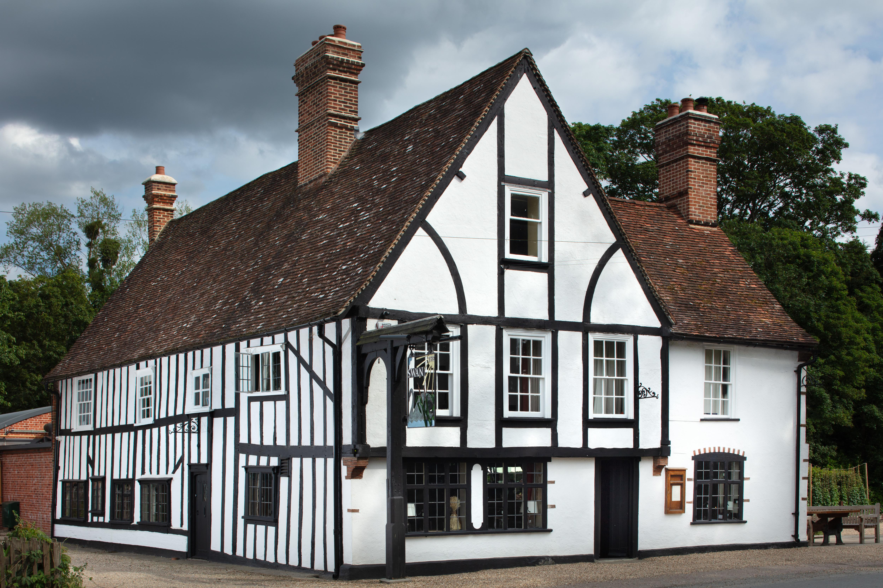

CAMRA has revealed the winners of its  Pub Design Awards 2025, celebrating some of the most visually stunning, historically significant and lovingly restored pubs across the UK.  Judged by experts in design and conservation, the awards are run in collaboration with Historic England and highlight both the importance and vulnerability of pub architecture.  Judging panel chair Andrew Davison said: “The awards recognise the highest standards of pub architecture, rewarding artistic flair and painstaking historical conservation. From inviting street-corner locals to striking medieval coaching inns, there are some stunning pubs in the UK, and the craftmanship involved in making these venues a gorgeous place to enjoy cask beer and real cider or perry should rightfully be applauded. I encourage heritage enthusiasts and pub lovers alike to visit these inspirational buildings." CAMRA's Awards Committee chair Gary Timmins added: “This year’s awards are tinged with sadness, as one of our winners, the Python’s Arms, has had to make the heart-breaking decision to close its doors for good. Due to the financial pressures facing all pubs across the UK, the local community has lost what should have been a valuable new social hub for generations to come. Within just a year from being converted into a beautiful pub, this rapid closure should be ringing alarm bells. Real action is needed to support the pub industry, otherwise we will lose many more locals in the near future.”    The winners: Historic England Conservation: Swan, Stratford St Mary, Suffolk (pictured) The Grade II-listed timber-framed pub, believed to date back to the 17th century, has been carefully renovated and conserved by Boudica Inns, owned by Mark and Sophie Dorber. A glazed conservatory housing a new bar, servery and dining area has been added to the original building, designed by architects KLH of Ipswich. Judges admired how the contemporary design of the large extension, with an exterior finished in steel and glass, made a striking contrast between the older elements of the pub.   New Build: bod Lichfield, Staffordshire  Titanic brewery, Stoke-on-Trent has previously won awards for its conversions of existing buildings, but this is the first time that it has created a building from scratch. Architect and designer Mark Smith of Mark Smith Design has included several trademark bod design elements in an imaginative and stylish fashion. Judges admired the pub’s industrial chic design, which makes use of recycled wood, distressed paintwork, quirky light fittings and exposed ceiling pipes. The judging panel felt the new pub was a great addition to Lichfield’s beer scene.  Conversion to Pub Use: Joint winner: Borough Beer House, Farnham, Surrey  A conversion of the former Bailiff’s Hall in the historic Grade II-listed Town Hall Buildings, dating from 1674. Owner Mark Curran oversaw the conversion of the former dress shop, sensitively retaining existing features, including beamed ceilings, period fireplaces, wood panelling and a herringbone pattern floor. Custom crafted benches have been designed to be in keeping with the historic character of the building.  Joint winner (now closed): Python’s Arms, Lyonshall, Herefordshire  A conversion of a 13th century rural farm building at Penrhos Court, which once housed the Penrhos brewery owned by Terry Jones of Monty Python fame, owners Mark Bentham and Laura Lane have carried out a thorough renovation of this characterful building. Judges praised the rustic décor noting characterful design touches such as the lobby doorhandle shaped in the form of a python.  Refurbishment: Druid Inn, Gorsedd, Wales  The latest addition to a small group of pubs owned by Pubs, a company set up by Jerry Brunning of Brunning and Price, and his wife Beth. Acquired in June 2023 after closure by Thwaites brewery, the Druid reopened in March 2024 after an extensive yet thoughtful renovation. Judges praised the refurbishment noting the pub’s cosy nooks and crannies, a welcoming central bar, comfortable seating, quirky artwork, soft lighting, roaring fireplaces and a private dining room.   Commended: Peasants’ Tavern, North Walsham, Norfolk  Owner Charlie Holden employed DCP Architecture of Rackheath, Norwich, to design and oversee the refurbishment of the former market tavern. The interior has been given a careful make-over, with quality woodwork and furnishings finished in shades of green. Judges noted the use of old maps to relieve what might otherwise have been a rather dark interior as an interesting feature.  Community Local: Forester, Ealing, London  A Grade II-listed pub featured in CAMRA’s National Inventory of Historic Pub Interiors, with Edwardian fireplaces, art nouveau-style stained glass and even long-defunct remnants of gas lighting in the public bar. Owner Fuller’s has carried out a very respectful refurbishment of the building, carefully conserving the historic features, and adding a first-floor function room to enhance the facilities the pub has to offer its community.  View photos of the pubs here.  Find more information about the Pub Design Awards here.   Learn more about Historic England here.  Photo of the Swan by Historic England