Members’ Weekend 2025 Round Up Chairman’s speech

08/06/2025 by Ash Corbett-Collins

Campaign

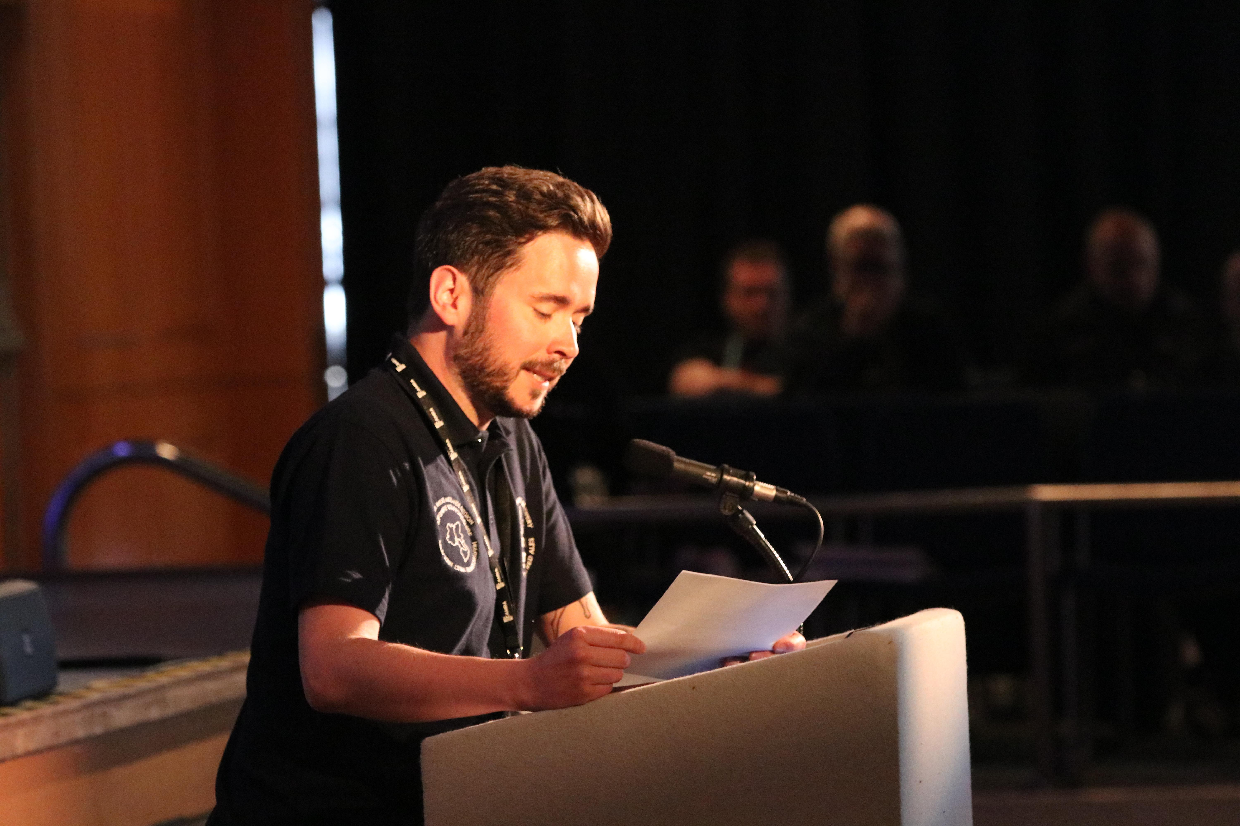

Watch CAMRA Chairman Ash Corbett-Collins adress Conference at Members' Weekend 2025 in Torquay, and read the transcript of the speech below. Hello Conference  It’s great to be speaking to you today.   As many of you will know, this is my first Members’ Weekend as your chairman.   So, this is my first opportunity to speak to you about my vision for our Campaign, and how we secure our future.  But first, I just want to say a couple of words of thanks.  To the people that have made this weekend happen, and the members that have come and volunteered to help it run smoothly.   The Local Organising Committee, led by Ian Packham, has done a great job and I hope you’ll join me in thanking them over a pint or two in the Members’ Bar or a local pub later.   It’s only right that we’re in the South West this year, as we mark 50 years of CAMRA campaigning for cider and perry.   And you’ve got a range of choices to celebrate the milestone this weekend. There’s plenty of suggestions in your Members’ Handbook for local pubs to get a pint, as well as a great selection in the Members’ Bar.   So again, thanks to everyone who helped make this happen.   This has been a big year for the Campaign.   We’ve had some big changes, and a lot of internal challenges.   Nik Antona, our previous chairman, stepped down last year to concentrate on his treatment and recovery.   That meant a new chairman – me, and a new vice chair to replace me – Gillian.   With another director – Gary Chester – departing the board mid-term, it’s been a time of massive changes for the National Executive, and we took decisive actions to strengthen our ranks and minimise the impact on you – our volunteers.   We need a solid team of directors, with a mix of skills, who are not afraid to make bold choices and enact the changes we need, to grow in numbers and influence.   That’s why we chose to co-opt two directors last year, Neil McGovern and Ian Hill, who have both brought specialist knowledge and experience to their IT and Finance briefs – important roles that require a huge amount of work and dedication.   And that’s also why we did a big push to promote standing in the National Executive election.   I’m really pleased that we have had a contested election, giving members a proper choice of candidates to vote for.   Regardless of the result, I am personally grateful to all my fellow candidates for standing and making our internal democracy strong and healthy.   You get back what you put in to being a director. I’ve gone into it with an open mind, trying to communicate as openly as possible, and I’ve got the same back from members in return. It means I’ve made better decisions, and that has meant more meaningful changes for the Campaign.  One of my favourite things about being a director of CAMRA is getting to meet you – the membership. I’ve been able to speak with a wider range of members, discuss my ideas, but also hear other opinions and learn from them.  In that spirit, please grab me for a chat if you see me in the Members’ Bar later, so I can hear what you think about this weekend, or about our campaigning.    In my opinion, we’re now at a tipping point for the future of pubs.    Access to market is finally back on the government agenda with the current review.    We’ve got the business rates reforms underway, but not enough details to know if that will fix the underlying issues yet.    Nearly 10 years on from the inception of the Pubs Code in England and Wales, it’s under review again this summer.    Energy bills and the cost of goods continue to bite.    National Insurance contributions have gone up.    We’ve got a new-ish government in Westminster that’s yet to decide if they are pro community pubs and choice, or more invested in keeping big business interests happy.    All things that affect pubs, brewers and consumer choice.   And we see the effect of that tipping point here, in Torquay, literally as I speak.  The Hole in the Wall pub is closing this weekend, with the departure of its current tenants. They just can’t afford to keep the doors open. This is a sad reality for a lot of publicans. And when pubs close their doors, it’s consumers and communities that suffer. The worst pub is a shut one.  So, please visit the Hole in the Wall this weekend, make sure the current licensees are seen off in style, and help them shift the rest of their stock.   But sadly, this isn’t a unique situation.   It’s a pattern that I know repeats constantly, in branches across the UK.   And, we have to be ready for what comes next, if we’re going to get what we need from the government, to tip the balance back in our favour.   We’re already planning for our Autumn Budget campaign.   We’re putting together data and comments for the access to market review.  We’re gearing up for the Pubs Code Review this summer.   We’re even fighting for the UN to recognise the traditions and value of cask beer – more on that one later.   And we need to be out there, recruiting new members to help us in this fight.   Now, I’m going to tell you a little bit about my vision for CAMRA and how we work.   I want to be upfront with you.   About where I see a need for change, and where I see a need for us to remember our roots and core mission.   I want CAMRA to be the best campaign we can be, because that’s how we get the best deal for independent brewers and publicans, and the best choice of beers for consumers.    But to do that, we need to be honest with ourselves about how we recruit more members and volunteers, how we better our campaigning, and how we need to put consumer choice front and centre.    So, we have work to do.    That’s not to say that we haven’t achieved a lot, or that you – our grassroots volunteers across the UK don’t do amazing things – because you do,  But we also need to recognise that the beer industry is changing, and we need to change with it if we’re going to grow in numbers and strength.    And I think we get there by being decisive about where we put our time and resources.   I want us to be leaner, and more focussed. I want us to zero in on the issues where our campaigning will have the most impact, and recruit the most people to join us.    We need to be crystal clear in our message and bold in our language.   I hope that you have already noticed this in my comments, and our wider communications.   It’s been one of the first things I’ve asked our professional staff team to look at, and I’ve made it a priority in all my interviews and speeches so far.   And alongside building that clear, punchy narrative, we need clearly defined campaigning aims.  In my mind, it’s clear that there are three key things we should campaign for.   First – greater access to market and the consumer choice that comes with it   Second – greater support for independent brewers.   And third – greater support for publicans.    And alongside those, we need to convert legions of pubgoers into campaigners.  It’s the pubs, pints and people.  A clear message to take us into this new era of campaigning, when the stakes have never been higher for pubs and independent brewers.   I’m starting to sound like a broken record on this because I’ve talked about it a lot recently.    But I’m incredibly angry at the wool being pulled over the eyes of the public by certain drinks manufacturers – and I hesitate to call them brewers.   They’re happy to perpetuate the lie that all is good.    That the consumer gets lots of choice.    That prices are kept low by competition.    That independent brewers can thrive in the current environment.    That if a pub or brewery closes it’s probably to do with competition and that ultimately the best will survive.    They’re happy to perpetuate these lies because placated, uninformed customers keep their profits high as they hoover up brands, reduce genuine choice, and throttle access to market.   If the government do nothing to change the status quo soon, that’s what we’re going to get.   And it’s not just about a manufactured illusion of choice for consumers. If something doesn’t change, more and more tenanted pubs will become managed operations with more control from head office. This could be the end of the traditional pub tenancy as we know it.    So called free houses will be tied into more exclusive purchasing agreements with the big players, wiping out the fraction of the pub market open to independent brewers.   And there will be consequences for wider society.    Bland, dull and almost identical pubs aren’t what we want or what our nation is famed for. There’ll be no celebration of heritage and individuality, no choice for people if they want to go somewhere a bit different.    Even worse than that, we could lose the sense of community around pubs.   The social cohesion and the wider benefits to society of a brilliant pub.    We started in the 1970s because people were concerned that the new influx of keg lagers were pushing traditional British cask beer off the bar and into extinction.   That was not so much about keg lager existing, as it was about the threat to choice and quality.   Today, we see lots of interesting and good-quality keg beers on the bar, alongside cask instead of replacing it. Thanks to those who have gone before us, the existential threat to cask beer we faced in the 1970s was averted.   But that doesn’t mean the threats to choice and quality are gone, they’re just different.   Today people might look at the beers available in their local and think that the battle has been won.   But we know that’s not true.   And it’s because we’re still not seeing genuine choice.   We’re still not seeing the local and independent beers on most bars.  And unfortunately, it’s brewing giants that used to be in British ownership becoming the worst offenders.   Slowly eroding choice and damaging pubs with bland and corporately curated product selections.   There is little autonomy for the publican, no power to give consumers the local and independent beers that they want.     This time last year, my predecessor, Nik, talked about enemies of consumer choice.   Global brewing giants that are happy to perpetuate the myth.   It’s a tragedy that the largest cask-producing brewer in the UK is now in global ownership.   And while talking about their commitment to cask beers, they’ve removed them from bars in Scotland, closed traditional cask breweries and badged up a beer as a “Lake District Original” while brewing it over 100 miles away in Wolverhampton.   This time last year, Nik talked to you about our complaint to Trading Standards about Fresh Ale.   Shockingly, we’re still waiting for a formal response from West Northamptonshire Trading Standards.   A damning indictment of the dire situation in local consumer investigations and enforcement.  If we have to wait over a year for a proper response, how long will other consumers have to wait if they complain about short measures, about lack of price lists, about misleading dispense methods?   And returning to that punchy, outspoken messaging that I’ve put in place since taking charge, I have been clear that we will be vocal supporters for independent breweries.   That’s demonstrated in our support for SIBA’s Indie Beer campaign and us speaking truth to power about the global brewers and pub-owning businesses that aren’t giving brewers or consumers a good deal.   And really, when you think about it, that support for independent over corporate, local over global, has always been there. We’ve just maybe not shouted about it enough in recent years.  When you look a little closer, it’s everywhere across our Campaign.  Our awards – for beers, pubs and clubs – recognise and celebrate independence and choice.    Since the inception of the Champion Beer of Britain award in 1978, the only non-independent brewers to win the overall title were Ind Coope in 1990 and Caledonian in 2002. The rest of the winners have been independent, and often relatively small operations.     When you look at our pubs and clubs of the year, they’re full of local and independent beers, often true freehouses, sometimes with licensees that have revived a churned pub, or those that have beaten the odds and have been allowed a proper choice of drinks from their pubco owners.   That can’t be a coincidence.   The Indie Beer campaign, which Ian Ward from SIBA will speak to us about later, is the best and most relevant to consumers that I’ve seen outside of CAMRA in years.    It speaks truth to power about what certain global brewers are doing to create confusion over independence and genuine choice, to the detriment of consumers and actually independent brewers.    That’s why we’re fully behind both the campaign and Indie Beer Week, making sure the public knows about the consumer choice con that’s being perpetuated.   Because, sadly, not enough beer drinkers know that what they see on a lot of bars isn’t actually choice.    Far too often it’s been constructed by the global brewer or the pub company. It’s just a choice of brands from the same business, deliberately trying to appear independent.    So that’s why we are doubling down on our commitment to champion independence and quality.    Doubling down on our campaigning means just that – carrying on, focussing, and sharpening our message.   Because nothing annoys me more than when people say that we’re not campaigning.  Firstly, it’s an insult to you – our most dedicated volunteers.   It’s an insult to your local members, your festival volunteers, the people taking magazines to local pubs, the people organising your social events and speaking with your local brewers and cider makers.   We won’t succeed in recruiting and activating more members if we don’t articulate that joining and volunteering is a campaigning act in itself.   It’s more people on our team, helping our cause, wanting to learn about the issues and the solutions.   Secondly – the idea that we’re not campaigning just isn’t true.   We’ve been securing national media attention for pubs by partnering on the Mirror’s Your Pub Needs You campaign.  We’ve been in front of the Business Department team running the access to market review, telling them about the consumer con perpetuated by global brewers.  We’ve been in consultation with the Scottish government, shaping the Pubs Code and guest beer rights, while waiting for the pubcos and global brewers to exhaust their tedious legal challenges.  We’ve been fighting for change to the archaic licensing system in Northern Ireland, to help independent brewers find local routes to market.   We’ve been tracking unlawful conversions and demolitions of pubs, highlighting the scandal of developers ignoring hard-won planning protections in the wake of the Crooked House disaster,  We’ve been hosting MPs – over 70 of them – in parliament to talk about business rates and draught beer duty before the last Budget.   We’ve been backing the Craft Beer Channel’s Keep Cask Alive campaign and their push to get cask beer recognised by UNESCO.  We’ve been speaking with the independent brewers at BeerX, getting our message of vocal and unequivocal support directly to them.   We’ve been carrying on as ever, with our team of volunteer experts helping communities all over the UK fight planning applications and take pubs into community ownership.   These are considered, focussed actions.   They cover our core range of campaigning issues, with different audiences and methods. They are focussed on maximising outcomes and working with our allies to achieve change.   What these are not is a lack of campaigning, a lack of knowledge, a lack of experience or passion.   So please, next time you hear someone telling you that we’re not campaigning, politely put them right.  I welcome challenge. I welcome debate about the best way to achieve our goals. and I welcome views on where our attention should go next. It’s the beauty of our Campaign and how we shape our policies.   But please, don’t tell me that we’re not campaigning.   And, returning to my vision for us.   Access to market and consumer choice. Support for independent brewers. Support for pubs and publicans.   Punchier, more ruthless, more focussed.  CAMRA under my tenure is going to be more outgoing, more combative, and a more modern campaigning organisation.  And that means cutting down the long meetings, the reports, and the bureaucracy that can drag our spirits down and dampen the fun of the Campaign.   First and foremost, we’re a social campaigning group.   If we are asking you to volunteer hours of your time to run your branch, put on festivals and campaign for beer and pubs, we’ve failed if you’re not having a good time while doing it.   Our founders didn’t care much for meetings, definitions, or reports.   They wanted to campaign and had fun while they did it.   Yes, we needed to professionalise to gain the influence and standing that we have today. We’ve nailed that bit – with policies and procedures to safeguard our Campaign and our members, and a staff team to move us forwards day to day.   But that won’t come at the expense of our plucky spirit, our natural instinct to challenge the status quo, or ever dampen our passion or enjoyment of our cause.    Because, our power as a consumer group is that ability to speak with passion and knowledge.   That means being educators as well as campaigners. Taking those complex policy issues and intricacies of the beer industry and distilling them into messages that the wider public will understand, and that our volunteers can campaign on.    And we need to do this because there’s so much at stake. We know that the beer and pub sector isn’t working for consumers.    We know that there’s unmet demand for independent and local beers – and there’s a tonne of independent brewers making them – but they’re just not appearing on bars.    So, our focus needs to be on ensuring that there is quality and choice on the bar and that the pub will continue be there to serve it.   I know that we can do this.   But I need your help.   We all know that we need more members, more volunteers, more people that love cask beer and want to know more about pubs and social clubs.   We need them not just to keep us going financially, but because it’s bloody hard to take on multinational businesses and win.   We need that army of pub campaigners, ready to fight for consumer choice and better beer and cider.   But here’s the thing, there’s no silver bullet to fix it.   There’s not one magic thing I can click my fingers and do to make thousands of people want to join us.   We’ve got to do it together, and all take responsibility for it. If we want more members, more volunteers, more campaigners, we all need to go out there and get them.  Talk to people at the pub.  Make sure your branch socials are open for everyone to join.  Welcome people who show an interest in what we’re doing.   Tell them about beer, consumer choice and how the pub industry really works, and invite them to help us change it.  I’ll focus on keeping our finances in order, getting our committees focussed, and modernising our decision making and methods.   I need you to focus on campaigning, having fun and bringing new people into our not-so-little family.   Because we do have big challenges ahead of us.   It’s a David and Goliath fight against global drinks producers, to keep quality and independent drinks on bars.  It’s a mammoth effort to make sure our new government makes pro-pub, pro-consumer decisions.  It’s a huge push to expand our ranks.  It’s a mission to make anyone who enjoys beer thirsty to find out about how it’s made and why it matters.   Conference, that’s my challenge for us.   Now it’s over to you, and those watching at home, to ask some challenging questions of me. Photo of Ash Corbett-Collins by Robert Hamnett-Day