Master class for beer judges

06/06/2025 by Timothy Hampson

Campaign

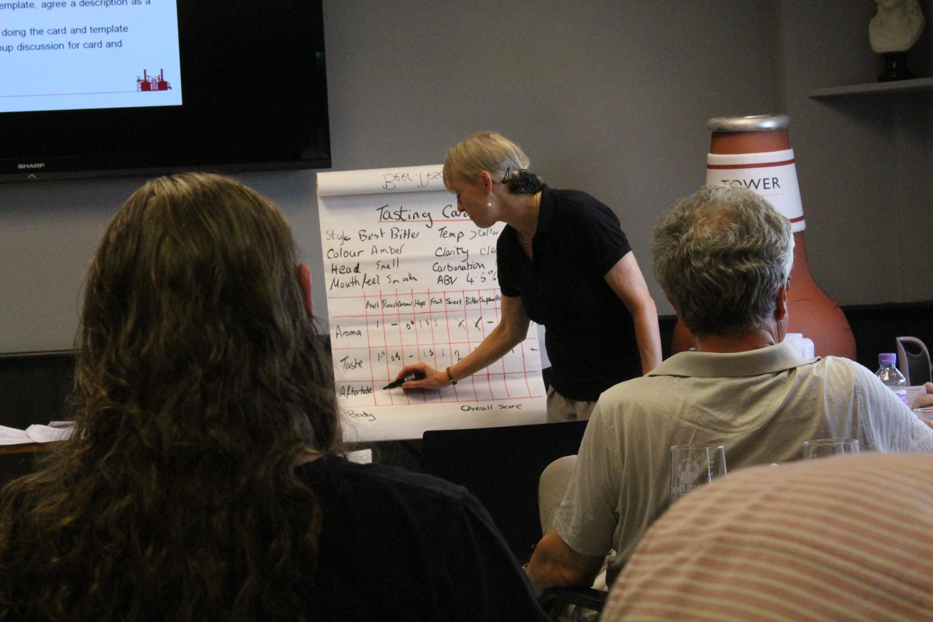

CAMRA’s Christine Cryne (above) is running a master class for beer judges at the Bohemia pub in North London on 26 July. It is open to those who have either: – undertaken beer judging training but have not yet have had a chance to judge – have judged but never have had feedback and would like to. For the first time, the master class will be judging the shortlisted beers in the 4.4 per cent and under category in CAMRA’s London and South East Bottled Beers round at the Bohemia. Not only will the class help find the winner, but it will also provide the opportunity for one-to-one feedback on how people are scoring against the average. The winning beer will then go forward to the finals in 2026. There is also an opportunity for people to chairing a panel in a supportive environment. A full briefing will be given and anyone attending will get a Certificate of Attendance. The £15 ticket price also includes a pint of London Brewing Company’s cask beer (up to 4.6 per cent). The session will start at 2pm; doors will open 15 minutes earlier. The session is likely to last no longer than 2.5 hours and it will take place in a downstairs room that involves a short set of stairs. Get your master class tickets here.