Beer drinkers’ Net gain

05/06/2025 by Timothy Hampson

Industry

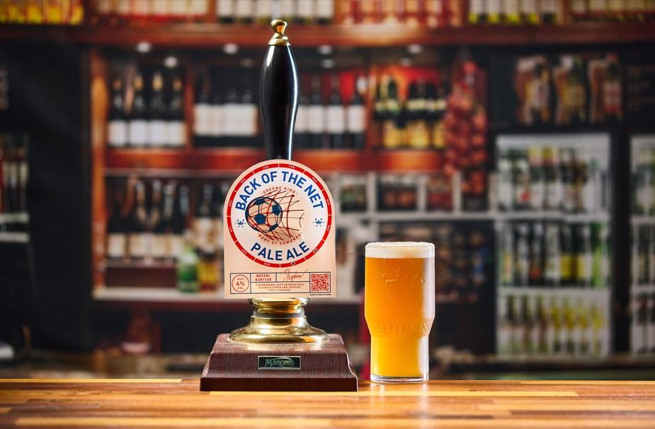

Greene King’s latest seasonal brews celebrate women’s sport with Back of the Net and brings back a blast from the past, Amplified. Amplified, a 4 per cent ABV golden ale, was first launched in 2017 as part of a partnership with a radio station. Amplified is a blend of grapefruit, orange, mango and pineapple notes, complemented by subtle herbal and floral undertones. Amplified will be available in June and July. The brewer is also celebrating the Women’s Euro 2025 this summer with Back of the Net, a 4 per cent ABV golden ale with juicy citrus and tropical fruit characters. It will be available throughout the tournament, from the end of June until the end of July. A survey by OnePulse found that of those who said they would likely go to the pub to watch at least one game during the Women’s Euro 2025, two thirds would also likely buy a pint of Back of the Net. Greene King technical brewer Alan Fulcher said: “We’ve already experienced some brilliant weather so far this year and I am sure we’re all hoping it continues into the next few months as we get ready for summer festivals and sporting occasions. “We’ve seen great uptake of our seasonal cask beers so far this year. With both beers packed with fruity notes, they are the ideal choice as an additional cask beer.”