Pubgoers demand action on scandalous pub demolition

03/06/2025 by WB Reporter

Campaign

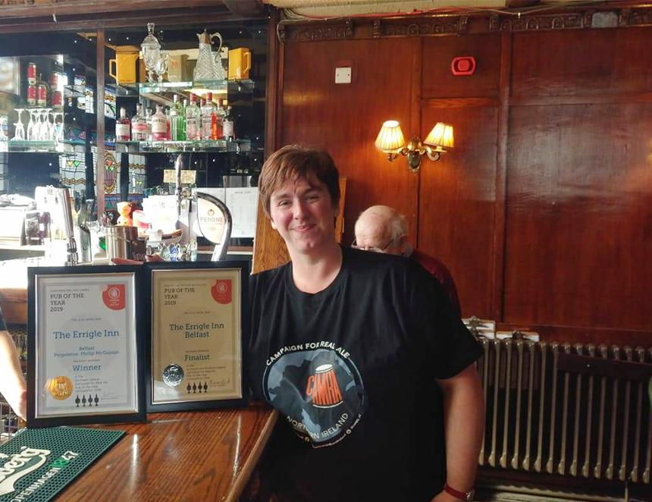

CAMRA NI wants new laws to protect and rebuild pubs following the demolition of Finn MacCool’s pub in Bushmills, which CAMRA thinks may have been unlawfully demolished without planning permission last month. The Campaign said pubs must be protected from unlawful conversion and demolition because of their unique community value. Developers found to be flouting the rules should be forced to turn buildings back into pubs or rebuild them brick by brick. Unlawful demolition or conversion of pubs is now higher in the wider public consciousness, after the tragic case of the Crooked House in Himley, Staffordshire, nearly two years ago. Across all these islands, we need robust planning protections for pubs and strong enforcements powers where developers have flouted the rules. Director of CAMRA NI Ruth Sloan (pictured) said: “Pubs are key parts of our culture and our social fabric. They are vital community assets and deserve to be properly protected. “The case of Finn MacCool’s pub in Bushmills has shone a light on how developers can flout planning rules and protections. In other parts of these islands, councils can force developers who have flouted rules to rebuild pubs brick by brick. This should be the case here too. “CAMRA NI want Causeway Coast and Glens to require the former Finn MacCool’s building to be rebuilt and reinstated as a pub. We also want the infrastructure minister and the executive to strengthen planning laws so councils must hold unscrupulous developers accountable by forcing them to reinstate pubs that have been converted or demolished unlawfully.”