Raise a glass – our top fest is back!

02/06/2025 by Timothy Hampson

Campaign

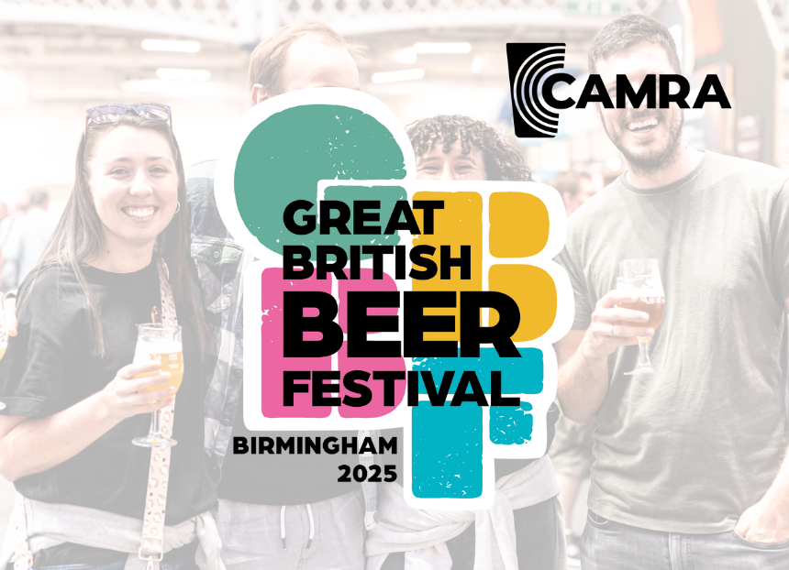

After a year’s break CAMRA’s Great British Beer Festival returns for 2025 at a new location. Hailed as the UK’s most popular beer festival, it takes place at Birmingham’s National Exhibition Centre (NEC) from 5-9 August. Leaving the UK’s capital city after a successful 34-year stint, the festival’s new location makes it even easier for festivalgoers to explore the many drinks on offer. CAMRA has been running beer festivals on this scale for 50 years, with the first four-day event taking place in 1975 at Covent Garden. The first Great British Beer Festival was in 1977 at Alexandra Palace. With tens of thousands planning to attend, the festival, which is part of CAMRA’s mission to bring together beer-lovers, will feature more than 500 cask and other beers, a cider and perry bar, “no and low”, wine and cocktails. These are provided from UK and international breweries including St Austell, Brains, Green Duck Beer Co, Harvey’s, Greene King, Siren and Thornbridge, as well as Birmingham-based Attic Brew Co. Alongside its vast range of beers, attendees will also be able to enjoy food and snacks, as well as a variety of entertainment including live music in the afternoons and evenings. And the winner of CAMRA’s much-coveted Champion Beer of Britain competition will be unveiled at the festival, with the winning beers available at the event. For non-beer drinkers, a wide array of low-and-no alcohol drinks will be on offer, along with hot and cold options so there’s something for a whole group including designated drivers. Organiser Adam Gent said: “At CAMRA, we’re proud to stand for beer drinkers and pubgoers across the UK. We know that pubs are a vital social centre for many and are passionate about promoting real, good quality beer, cider and perry. “The Great British Beer Festival is a fantastic way to bring people together and has played a leading role for more than half a century in our successful campaigning to protect our pubs and champion cask beer. “Whether you’re a seasoned beer enthusiast or just curious to try something new — we’ll have more than 500 drinks across a range of styles to choose from, so you’re sure to find something you love. And after a year off, we’re delighted to be bringing the festival back bigger and better than ever at the iconic NEC in Birmingham, so let’s raise a glass.” Secure your tickets to the Great British Beer Festival at greatbritishbeerfestival.co.uk Stay up to date with future events and campaigns from CAMRA, visit camra.org.uk