Plan your summer festival trips

30/05/2025 by George Robbins

Campaign

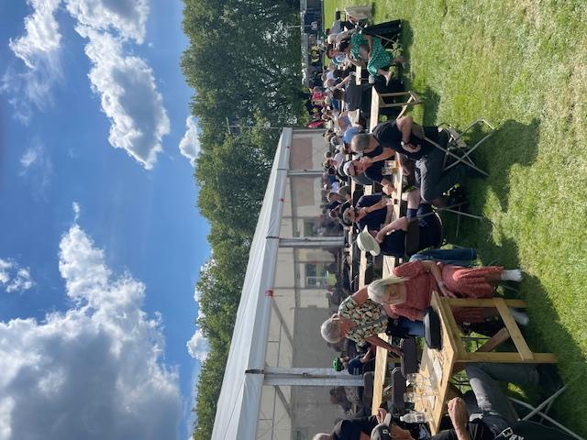

For your next festival trip, look no further than the list below. To see all upcoming CAMRA events, visit the events webpage.     Arun Yacht Club Real Ale and Cider Festival, 30 May-1 June  Arun Yacht Club Rope Walk, Littlehampton, West Sussex, BN17 5DL  visitlittlehampton.co.uk/whats-on/arun-yacht-club-real-ale-cider-festival/    Thurrock Beer and Cider Festival, 3-7 June   Civic Hall Blackshots Lane, Grays, Essex, RM16 2JU   thurrock.camra.org.uk/viewnode.php?id=242456       Braintree Real Ale Festival, 5-7 June   Bocking Arts Theatre (formally Braintree Institute), Bocking End, Braintree, Essex, CM7 9AE   braintreebeerfestival.co.uk/       Hitchin Beer and Cider Festival, 5-7 June   Hitchin Rugby Club, Old Hale Way, Hitchin, SG5 1XL    hitchinbeerciderfestival.org.uk       Stratford-Upon-Avon Beer and Cider Festival, 6-7 June   Stratford On Avon Racecourse, Luddington Road, Stratford-upon-Avon, CV37 9SE   shakespeare.camra.org.uk/festival       CAMRA KESR Railway Real Ale and Cider Festival, 6-7 June   Kent and East Sussex Railway, Tenterden, Kent, TN30 6HE   afrm.camra.org.uk/viewnode.php?id=230145      Kingston Beer Festival, 12-14 June   25 Old London Road, Kingston upon Thames, Surrey, KT2 6ND   kandl.camra.org.uk/viewnode.php?id=246125      Ale and Steam, 13-15 June   Gloucestershire and Warwickshire Steam Railway, Winchcombe and Toddington Stations, Winchcombe, Gloucestershire, GL54 5DT   gwsr.com/events/real-ale-festival-2     Glasgow Real Ale Festival, 19-21 June  The Briggait 141 Bridgegate, Glasgow, Glasgow, G1 5HZ  g-raf.camra.org.uk/      Stockport Beer and Cider Festival, 19-21 June   Stockport Guildhall, 169-171 Wellington Road South, Stockport, Greater Manchester, SK1 3UA   stockportfestival.org.uk/       27th South Downs Beer Festival, 20-21 June   Lewes Town Hall Corn Exchange, Fisher Street, Lewes, Sussex, BN7 2QS   brighton.camra.org.uk/     Salisbury Summerfest, 20-21 June  The Guildhall, Market Place, Salisbury, Wiltshire, SP1 1JH  salisburycamra.org.uk/event/summerfest-2025-friday/    Leicester CAMRA Beer Festival, 26-28 June   Corporation Road, Leicester, LE4 5PX   leicester.camra.org.uk/festivals/       Winchester Beer and Cider Festival, 27-28 June   University of Winchester Student Union, Sparkford Road, Winchester, Hampshire, SO22 4NR   winchesterbeerfestival.camra.org.uk/     12th Rutland CAMRA Beer Festival, 27-29 June   County Museum, Catmos Street, Oakham, Rutland, LE15 6HW   rutland.camra.org.uk/viewnode.php?id=241929      Totnes Beer and Cider Fest, 3-5 July   Totnes Civic Hall, High Street, Totnes, Devon, TQ9 5SF   southdevon.camra.org.uk/     Bromsgrove Beer and Cider Festival, 3-5 July    Bromsgrove Rugby Club, Finstall Road, Aston Fields, Bromsgrove, B60 3DH   bromsgrovebeerfestival.org.uk/     Chorlton Beer and Cider Festival, 3-5 July   Edge Lane, Chorlton, Manchester, M21 9AE   chorltonbeerfestival.org.uk/     Maidenhead Beer and Cider Festival, 4-5 July   Summerleaze Park, Off Summerleaze Road, Maidenhead, Berkshire, SL6 8SP   maidenheadbeerfest.camra.org.uk/     Devizes CAMRA 24th Beer and Cider Festival, 4-5 July   The Wharf, Devizes, Wiltshire, SN10 1EB   devizescamra.org.uk/    Ealing Beer Festival, 9-12 July  Walpole Park, Mattock Lane, London, W5 5EQ  ebf.camra.org.uk    Thanet Cider Festival, 12-13 July  Churchill Tavern, 19-21 Paragon, Ramsgate, Kent, CT11 9JX  thanet.camra.org.uk/viewnode.php?id=258978     Chelmsford and Mid-Essex Summer Beer and Cider Festival, 15-19 July   Admirals Park, Rainsford Road, Chelmsford, Essex, CM1 2PL   cbcf.camra.org.uk/    Hemel Old Town Beer Festival  St Mary's Church, High Street, Hemel Hempstead, Hertfordshire, HP1 3AE  hemeloldtownbeerfestival.co.uk/     47th Cotswold Beer Festival, 18-20 July   Postlip Tithe Barn, Postlip Hall, Winchcombe, Cheltenham, Gloucestershire, GL54 5AQ   postlip.camra.org.uk/    Wolverhampton Summer Festival of Beer and Cider, 24-26 July  Wolverhampton Arts Centre, Dunkley Street, Wolverhampton, WV1 4AN  facebook.com/events/1278590133432991    Market Bosworth Rail Ale Festival, 25-27 July  The Goods Shed, Station Road, Market Bosworth, Leicestershire, CV13 0PF  battlefieldline.co.uk/rails-ales    Epping Ongar Railway Beer Festival, 25-27 July  North Weald Station, North Weald, Epping, Essex, CM16 6BT  eorailway.co.uk/events/real-ale-and-cider-festival/    Solihull Beer and Cider Festival, 25-27 July  Oliver Bird Hall, Church Hill, Solihull, West Midlands, B91 3DH  solihull.camra.org.uk/viewnode.php?id=259635    The Great British Beer Festival, 5-9 August  NEC Birmingham, Pendigo Way, Marston Green, Birmingham, West Midlands, B40 1NT  greatbritishbeerfestival.co.uk/    Peterborough CAMRA Beer Festival, 19-23 August  Embankment Road, Peterborough, Cambridgeshire, PE1 1EF  pborobeerfest.camra.org.uk    Clacton-on-Sea Real Ale and Cider Festival, 20-23 August  St James Hall, Tower Road, Clacton-on-Sea, CO15 1LE  tendringcamra.org.uk/clactonfest.html    33rd East Anglian Beer and Cider Festival, 20-25 August  St Edmundsbury Cathedral, Angel Hill, Bury St Edmunds, Suffolk, IP33 1LS  burystedmundsbeerfestival.com/    CAMRA Bar at Faversham Hop Festival, 30-31 August  East Street, Faversham, Kent, ME13 8AF  kent.camra.org.uk/