Ape hangs on after pub refit

28/05/2025 by Timothy Hampson

Industry

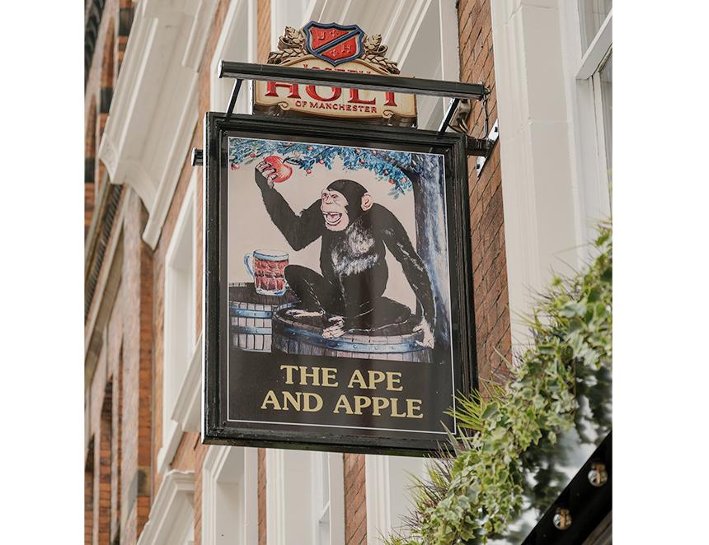

As one of the UK’s few female master brewers, Jane Kershaw has achieved plenty in her career, including being named All-Party Parliamentary Beer Group’s Brewer of the Year. But one of her proudest achievements dates back to when she was just 10 years old — designing the sign for Manchester’s Ape and Apple pub. Now, following a £400,000 refurbishment, that childhood artwork still hangs above the Holt's pub door as a quirky nod to the past amid the new marble-topped bars and a full top-to-bottom revamp. Kershaw said: “The sign is one of my proudest moments. “I was only 10 at the time when CEO Richard Kershaw, asked me to draw something for the pub one rainy Saturday morning — just to keep me busy. “I couldn’t believe it when they actually put it up. Seeing it still there, after all these years and the refurbishment, is really special.” The sign depicts an ape perched on a beer barrel, balancing an apple in one hand. A playful image that’s remained ever since the pub was officially opened in 1997 by footballing legend Denis Law. Alongside its legendary comedy night, which helped launch the careers of Alan Carr and Sarah Millican, the Ape and Apple is also one of the few pubs in the UK to host weekly salsa classes. A blue plaque outside commemorates scientist John Dalton, who announced his atomic theory in Manchester in 1803, laying the groundwork for modern chemistry. “The Ape and Apple is a key part of our city centre offering. With the refurbishment complete, it’s ready for a new chapter — whether you’re here for the comedy, the cask ales, or just a great night out in the city,” said Kershaw.