Brewery insolvencies cast shadow over sector

27/05/2025 by Timothy Hampson

Industry

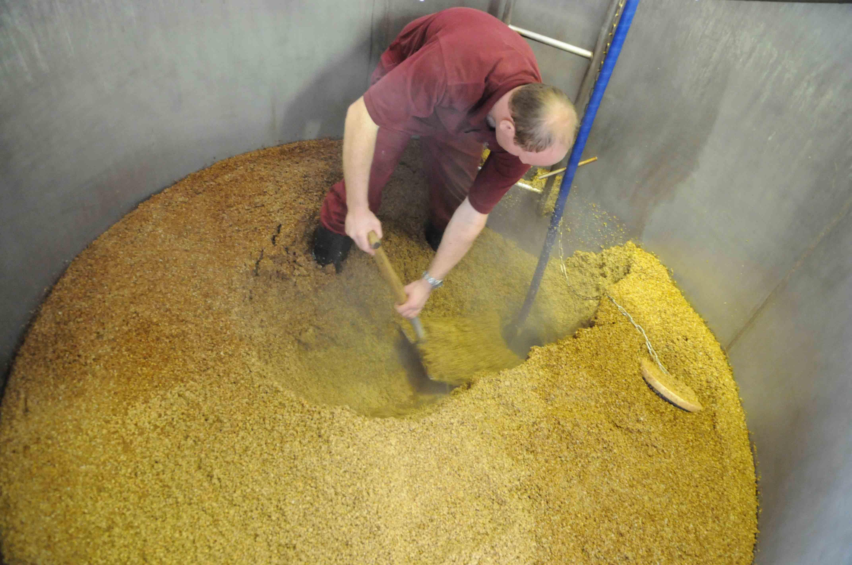

Increasing cost pressures saw 43 small brewers declared insolvent last year including Fourpure, By The Horns, Magic Rock, Burton Town and Wild Weather Ales. UHY Hacker Young partner Brian Johnson said: “The craft beer boom was one of the most exciting recent trends in food and drink. Unfortunately, it is a sector that attracted too many entrepreneurs who struggled to break even. “The recent closures suggest the UK’s craft beer market cannot continue to support all the independent producers that have sprung up in the last 15 years. Weak consumer spending means many breweries will have to adapt to leaner times.” Johnson added many small brewers are now caught in a perfect storm of production costs soaring while household spending remains tight. Recent increases in the national minimum wage and employer national insurance contributions have pushed up the wage bill for brewers. Margins have been further squeezed by inflation across ingredients, brewing equipment and energy bills. Johnson said small brewers, who are often reliant on local bars and direct sales, are particularly vulnerable if their customer base cuts back spending. There is a concern many consumers will trade down to cheaper beer brands as they tighten household budgets. This trend is making it harder for craft brewers to justify their typically higher price. Johnson said: “For smaller brewers who rely on loyal local followings, even a slight dip in demand can tip them over the edge. With so many brewers competing for attention, it’s increasingly hard to survive.” He added many small brewers are struggling to scale up. Only the bigger craft breweries can access supermarket shelves or national pub chains meaning that many breweries cannot achieve the economies of scale needed to break even.