Brewers in survival mode

26/05/2025 by John Porter

Industry

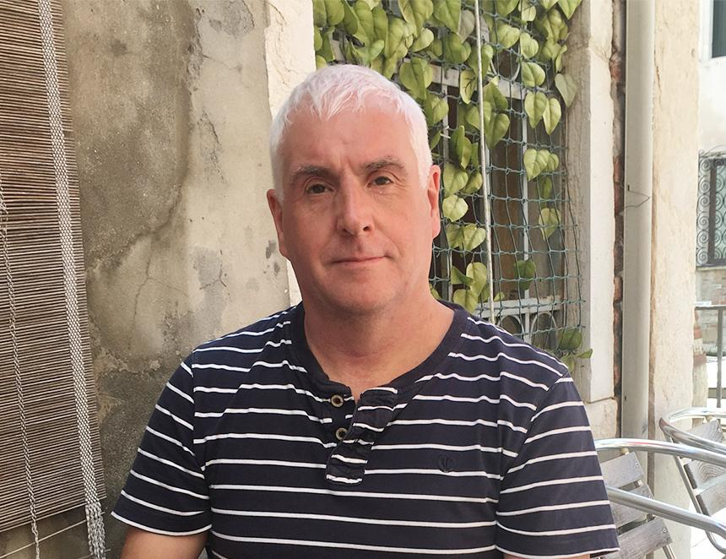

Independent brewers are locked out of 60 per cent of the UK’s pubs, due not just to those outlets operating under a formal beer tie, but increasingly because of factors such as brewery loans which include onerous beer supply agreements, and bigger players restricting access to dispense equipment. A survey of members of the Society of Independent Brewers and Associates (SIBA), carried out for its Independent Beer Report 2025, found 46 per cent of brewers list simple survival as their number one priority this year. That concern seems well founded, with SIBA’s Brewery Tracker recording 1,715 active brewers in the UK market at the start of 2025, down 100 from a year earlier. Restricted access to the pub market is key to SIBA brewers’ concerns, with 82 per cent of members’ beer production packaged in cask and keg format, targeting the on-trade. However, members reported they cannot sell to 60 per cent of their local pubs, on average, while 79 per cent said beer lines permanently allocated to large brewers are the main obstacle to growth. With the government currently considering whether there are grounds for legislation to open up beer supply, SIBA chief executive Andy Slee told What’s Brewing: “SIBA isn’t arguing for abolition of the beer tie per se, it’s about making sure that independent brewers and global brewers can live alongside each other, whatever the solution to that is. “Some pub companies, such as Greene King, are very supportive, with our members’ beers in 25 per cent of the estate. Others are much less so.” A YouGov poll for the SIBA report showed that 56 per cent of beer drinkers are more likely to buy a beer if it’s locally produced, and 81 per cent feel misled when they discover beers they thought were independent, actually aren’t. Slee added: “These report findings mean we can make the commercial case for pubs to serve independent beers, as well as having conversations at government level.” He suggested that if the government identifies a problem with the current beer supply arrangements to pubs, the industry should try to find a solution before legislation is required.     While cask beer volumes continue to decline, it still accounts for 58 per cent of SIBA members’ total production. That represents a five per cent volume share decline in cask production year-on-year. In contrast, stouts, lagers and no and low alcohol beers are in growth, which has pushed keg volumes among SIBA members up to 24 per cent of the total, up from 18 per cent a year earlier. Darker beers are increasingly popular, and 80 per cent of brewers now produce a stout or a porter, with industry analyst CGA reporting a 121 per cent increase in “craft stout” by value in the on-trade last year. In addition, 60 per cent of SIBA brewers now produce a lager, suggesting independent breweries are making inroads into the market usually dominated by global lager brands. CGA figures show a decline in sales of most cask brands, with a few notable exceptions such as Timothy Taylor’s Landlord, which continues to grow in both volume and value. Speaking at the launch of the report, CGA’s Nick Riley said cask as a category “definitely has a throughput issue, which in turn leads to a quality issue. It seems to be harder for pubs to sell good cask than it is to sell good keg.” While CGA recorded a two per cent decline in non-craft cask beer in 2024, and a larger 5.7 per cent fall in craft cask beer, Riley acknowledged that frequent changes of beer, typically seen in specialist cask beer pubs and tap rooms, are harder to track in terms of sales data. The YouGov survey found that 36 per cent of 18 to 24-year-olds say they never drink alcohol, a trend which is a strong driver of the increased production of no and low alcohol beers. However, report author Caroline Nodder also highlighted an increased take up of cask by younger beer drinkers, which she suggested may be partially driven by price among a demographic that has been hit harder than most by the economic downturn. “Cask generally tends to be a cheaper option on the bar.” Last year saw SIBA launch its Indie Beer campaign, in a drive to reduce confusion over the use of the term craft. While CGA’s data includes beers from global brewers which are positioned as craft beers to consumers, the Indie Beer logo and description is restricted to brewers with less than a one per cent share of the UK beer market, and at least 75 per cent of production in the UK. More than 500 breweries now actively support the campaign. Those supporters include Devon-based brewer Utopian Brewing, which has expanded into cask, and opened its first venue, a bar and eatery called Arcadia, in Exeter at the start of this year. Utopian founder and MD Rich Archer told What’s Brewing: “I was a big advocate of SIBA’s Indie Beer rebranding, because I think craft is a very confused term. In many ways cask is the most craft of all beers. “We’ve been brewing cask for two or three years, and I think there’s a strong market for good cask beer. Our cask is growing as fast as anything else we brew in terms of volume. It’s maybe harder to find the outlets. We’re seeing bigger outlets and the pub chains dropping cask. That means cask becomes less visible overall, but there’s a really strong opportunity in the indie outlets.”      Andy Slee summed up: “Cask beer is unique to Britain. To a global drinks company, Europe as a whole is a region. If they’re producing loads of beers, and only one country in the region is selling this fiddly cask thing, they’re not interested. No matter what bullshit they give out about their passion for cask beer, they’re not interested. What makes the money is global lager brands. “So, over the next few years, SIBA can play a role in the rejuvenation of cask beer. There’s strong demand for well-brewed, regional cask beers, as well as consumers wanting to support local, independent businesses. My call to the global players is, just because cask’s of no interest to you, don’t take your bat and ball home. Where we can work alongside each other, it can work well for all of us.”