Beer can chicken

25/05/2025 by Christian Gott

Uncategorised

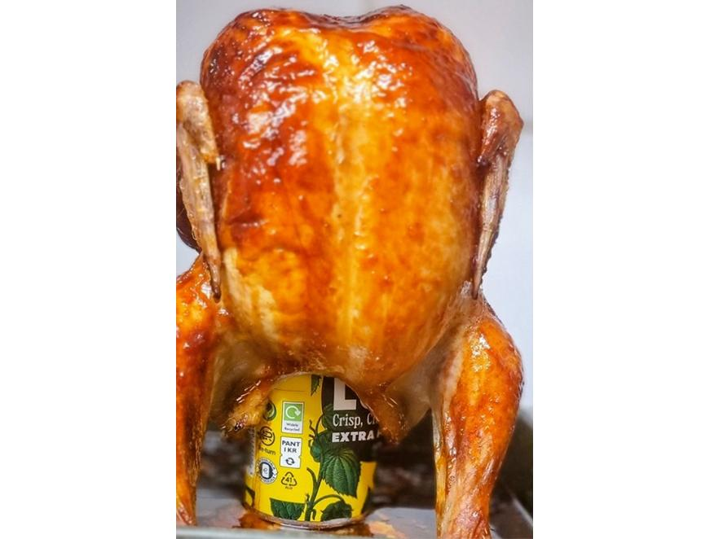

I read this week we have had more hours of sunshine so far this year than the whole of last summer. I’m not sure how this is calculated but I can guarantee that there will have been a corresponding rise in barbecuing. If you are lucky enough to have a large barbecue with a lid, beer can chicken is a revelation. It produces a beautifully tender, juicy chicken like one cooked on a rotisserie but don’t worry if you have haven’t got a barbecue as your oven will produce a fabulous result too. Beer can chicken is also known as beer butt chicken, chicken on a throne and, my personal favourite, coq au can. There is some debate about how much flavour the beer adds during cooking but using a beer brine beforehand enhances it. Standing the chicken upright on the can and allowing the fat to drain out of the chicken during cooking does however produce a fabulously crisp skin. I also use a sticky soy marinade to add lots more depth of flavour. The dish itself first attracted attention at a World Championship Barbecue Cooking Competition in Memphis, where a Texan team, the Bryce Boar Blazers, first presented the technique. There is some debate about where it first originated, possibly Louisiana, but it soon became popular across the whole of the southern states of America. It went all the way to Camp David, the summer retreat of the US president, when it was prepared for George W Bush. For my choice of beer, I have gone for Lush Extra Pale Ale from Galway Bay brewery in the west coast of Ireland. The brewery was founded originally by a group of friends at a brewpub more than 10 years ago. Lush was created to fit in between the brewery's west coast-style ales and hazy IPAs. Nicely balanced, this session beer is brewed with a little wheat to give a smooth mouth feel and is packed with juicy, citrus flavours that work perfectly with the chicken. Beer can chicken 1 1.8kg whole free-range chicken 2 cans Lush Extra Pale Ale 200ml golden syrup 100ml dark soy sauce 50g brown sugar 20g sea salt 6 cloves of garlic 1tsp dried thyme Half tsp smoked paprika To brine the chicken, dissolve 15g of the salt and sugar in 500ml of boiling water. Allow to go cold. Peel and halve two cloves of the garlic and add with the thyme to the marinade. Stir in one can of the beer. Place in a large plastic container and add the chicken. Add more water to cover the chicken if necessary and refrigerate overnight. Remove the chicken from the brine, drain and pat the skin dry with kitchen paper and preheat your oven to 400°F/200°C/Gas mark 6. Peel and crush the remaining garlic and mix the remaining sugar and salt. Stir in the paprika, soy sauce and golden syrup until thoroughly combined. Open the beer, pour half into a glass and drink for the purposes of quality control, then carefully lower the chicken cavity downwards onto the open can so it looks like it’s sitting up. Carefully place the chicken so it’s upright on a deep roasting tray balancing on the can. Brush the chicken with the soy mix and leave for 15 minutes. Then brush again. Carefully transfer to the oven and cook for 30 minutes. Remove and brush with more marinade before returning to the oven and turning down the temperature to 375°F/190°C/Gas mark 5. Cook for another 45 minutes. Remove from the oven and allow to rest for 15 minutes before carefully lifting the chicken off the can. Brush with any remaining marinade and carve. Serve with rice or chips and salad.