Cask joins Bloomsbury group

23/05/2025 by Timothy Hampson

Pub

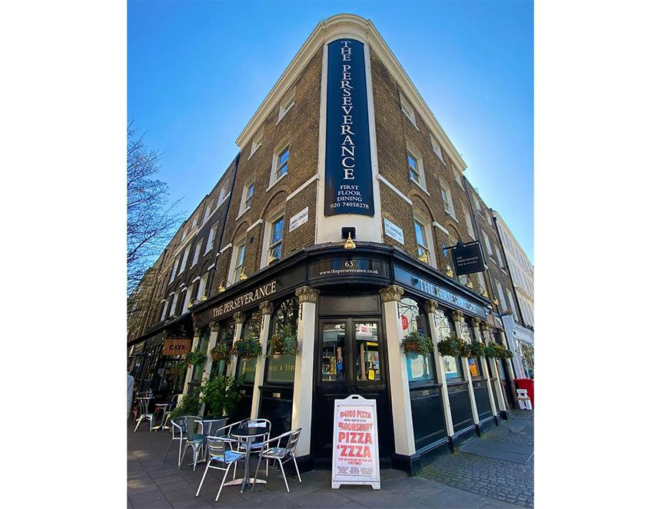

The Perseverance (above) and the Lady Ottoline pubs will be hosting the first Bloomsbury Cask Social on Saturday 21 June, bringing local and UK-wide brewers together for a one-day beer and cider takeover. Running from noon-11pm, the showcase will involve more than 15 breweries and cider makers, including South London’s Mondo and Drop Project, both of which will make their debut at the Perseverance. The event coincides with the Lamb’s Conduit Summer Solstice Street Fair, an annual family-friendly celebration hosted by local businesses. There will be a dog show, waiter’s race, raffle and much more to enjoy along the street. Market Taverns, which owns the pubs, chief executive Adrian Laws said: “The Bloomsbury Cask Social is going to be a great event, bringing the community and beer enthusiasts together. “We’re looking forward to welcoming our beer and cider partners and introducing guests to new pours. The teams have been working hard behind the scenes to ensure we have something for every taste – the hardest question will be which to try first.” Following its inclusion in the Good Beer Guide for the first time in 2025, the Perseverance will accompany the beers from Mondo and Drop Project with cider from 13 producers. These include One Tree Hill, Against the Grain, Duck Chicken and a wonderful selection sourced through the Real Ale Company. At the Lady Ottoline experts from Timothy Taylor and Gosnells will host a tap takeover and offer hourly guided tastings until 3pm. Timothy Taylor will bring some of its most popular beers, including Boltmaker and Golden Best. Gosnells, meanwhile, will pour its Hazy Nectar mead.