Kingfisher reigns supreme in Sheps’ competition

22/05/2025 by Timothy Hampson

Industry

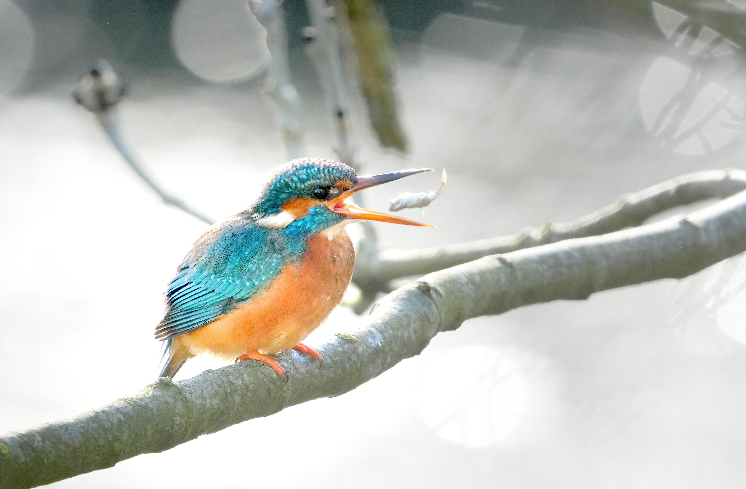

A stunning image of a hungry kingfisher won Shepherd Neame’s latest photography competition. The top prize of a £150 Shepherd Neame gift card went to Jim Higham, from Canterbury, whose winning image of a kingfisher was taken in his home city, on the banks of the River Stour. He took it in February this year, not far from Shepherd Neame’s Millers Arms pub. Higham said: “I’d seen the kingfishers on two separate occasions, so thought it was worth going down there to have a look. They come here in the winter because it’s more sheltered and so they have become accustomed to people going past. “It was so close it was unbelievable. I took a few shots and it had the fish in its beak. To swallow them, they have to have them the right way round, so it flipped it, and I got the shot. It was just incredible.” He added that it was a female kingfisher, which he could tell from the colour of its beak. Higham, who has been a keen photographer since he was just eight, is also a wildlife lover, and is involved with a number of Kent charities, including as a regular volunteer at Elmley Nature Reserve, one of the largest bird reserves in England. Sheps director of marketing and communications Kathryn Tye said: “We are always delighted by how many entries we receive for this competition, and the high standard. Our judges felt Jim’s winning image was a stand-out winner, capturing the beautiful kingfisher the very second it had the fish in its mouth.” The winning image and others can be seen in Shepherd Neame’s brewery reception in Court Street, Faversham from Tuesday 27 May where they will be on display during normal office hours for a month.