Champion Beer of Britain top six revealed

21/05/2025 by WB Reporter

Campaign

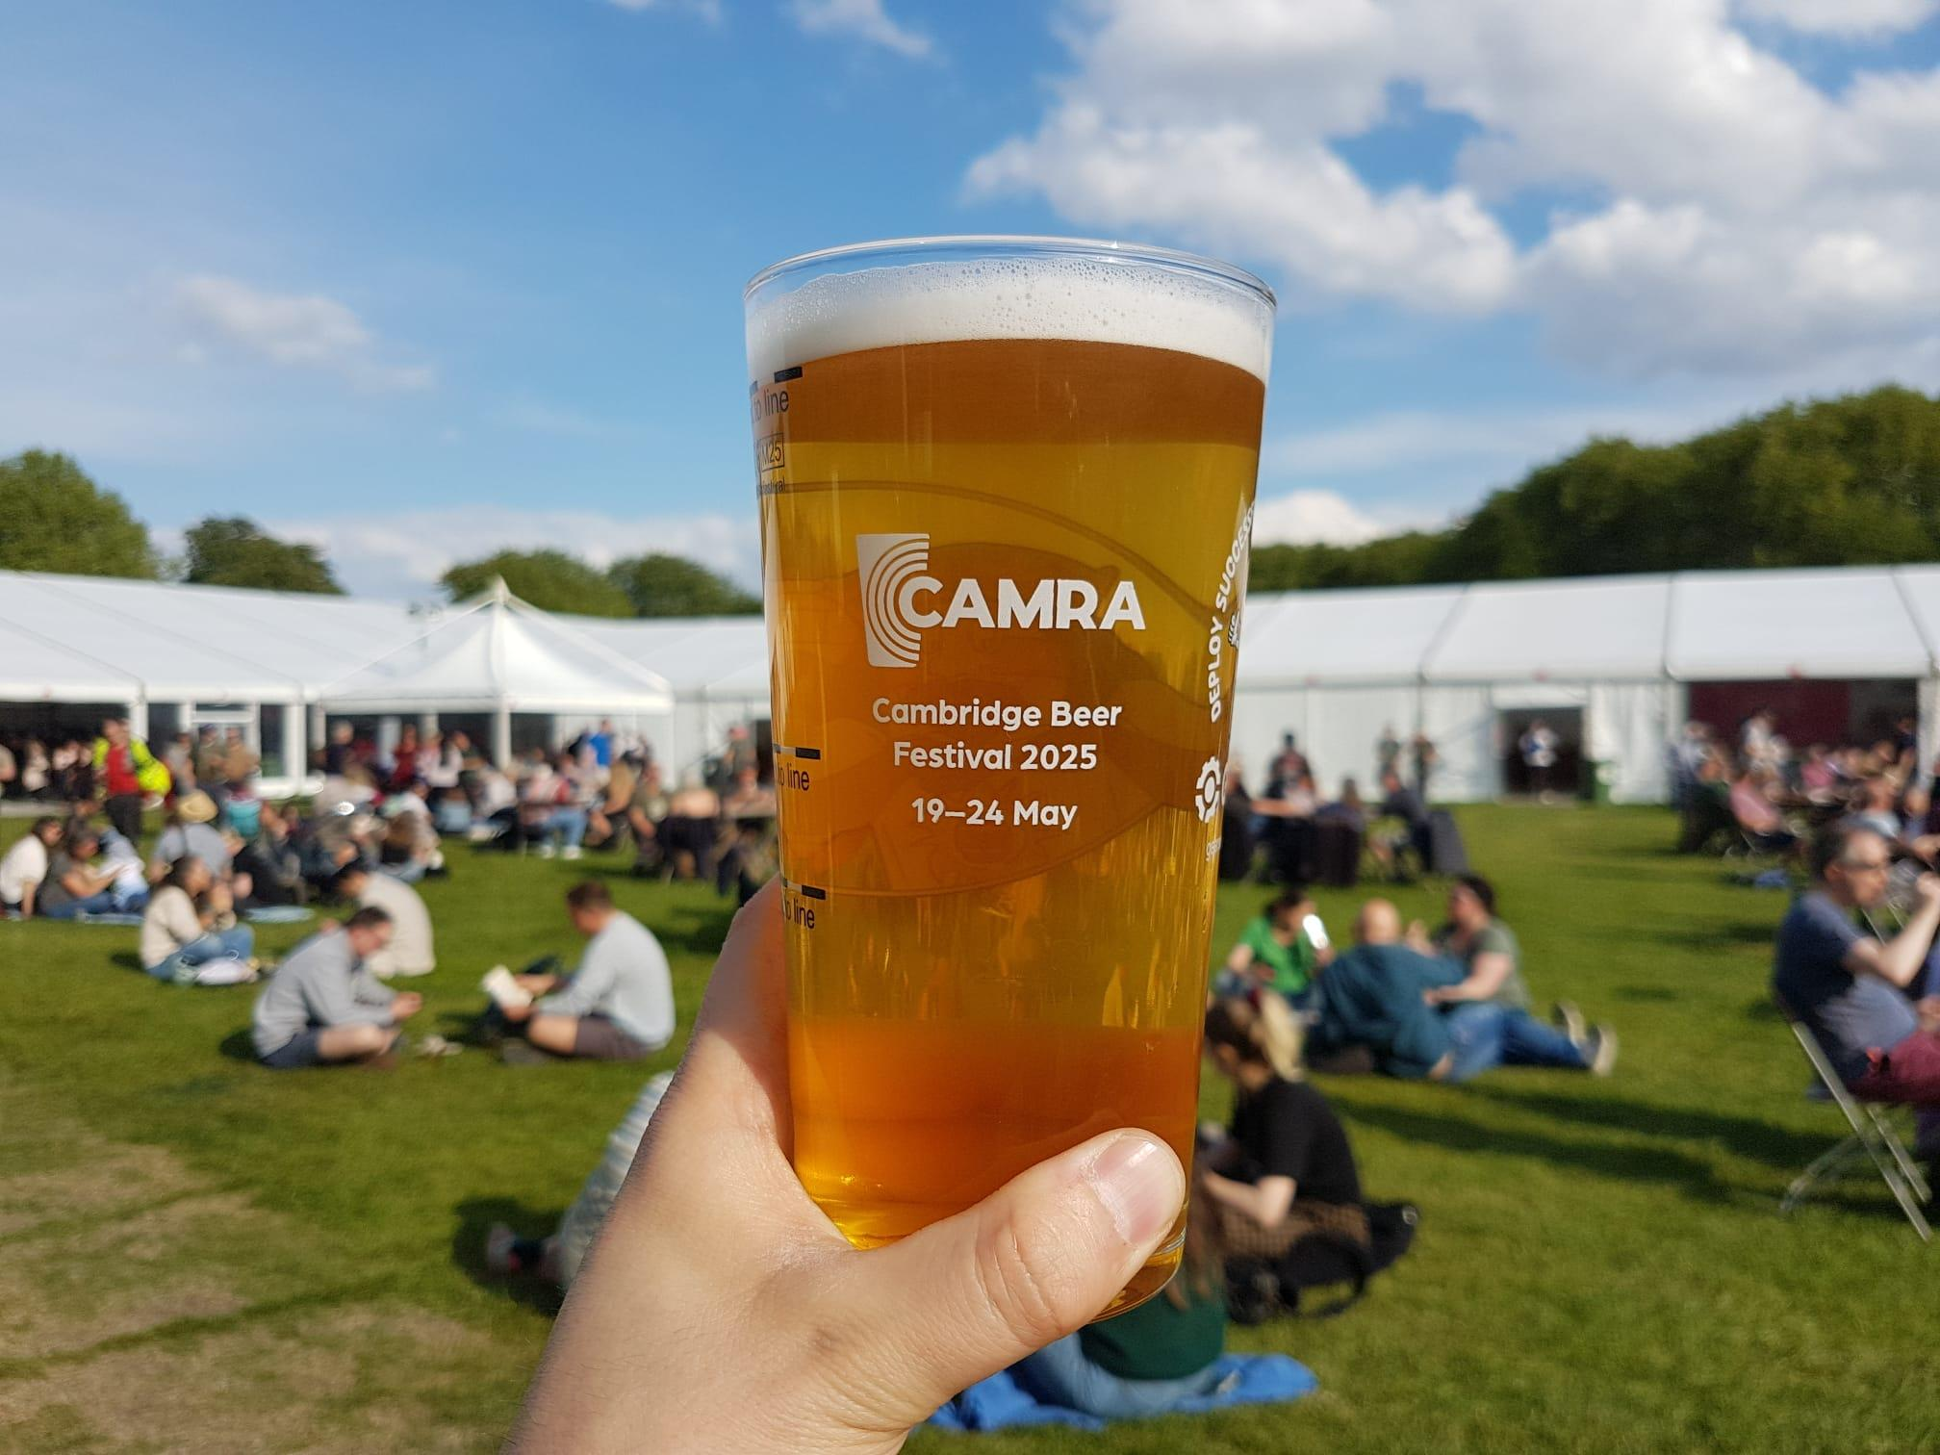

Finalists for CAMRA’s top beer award have been unveiled at Cambridge Beer Festival. The winners in the IPA, mild, bitter, blonde, pale and golden beer categories will join the finalists announced at the Great British Beer Festival Winter, and all 12 will battle it out to be crowned Champion Beer of Britain 2025. The overall winner will be announced at the Great British Beer Festival at the NEC Birmingham, in August.  The winners in the six categories, with tasting notes provided by Champion Beer of Britain Judging Panel organiser Christine Cryne, were:   Mild: Penzance, Mild (3.6 per cent). Grainy malt coffee and chocolate dominates the taste with dried fruit notes.  Session Bitter: Butcombe, Butcombe Original (4 per cent). Sweet-tasting bitter with malt dominating over a trace of dark fruit.  Premium Bitter: Cairngorm, Wildcat (5.1 per cent). Malt predominates but there is an underlying hop character through to the well-balanced aftertaste.  IPAs (English and New World): Elusive, Oregon Trail (5.8 per cent). A bold and bitter classically styled west coast IPA.  Session Pale, Blond and Golden Ales: Track, Sonoma (3.8 per cent) A well-balanced sweet, fruity beer with moderate bitterness and plenty of citrus hops. Premium Pale, Blond and Golden Ales: Church End, Fallen Angel (5 per cent). Sharp, full-flavoured bitter with an edge of lemon.  CAMRA awards director Gary Timmins said: “This was a fiercely fought battle, and the winners and category runners-up should be extremely proud of themselves. Champion Beer of Britain showcases the best of cask beer in the UK, with beers entered by CAMRA members and volunteer tasting panels before being judged using a blind process, so it’s a truly independent competition.  “If you’re in the area, get yourself to Cambridge Beer Festival this week to try the winners before they run out. You won’t be disappointed!”  The festival runs until Saturday 24 May and more information, including tickets can be found here: cambridgebeerfestival.com  For more on the Champion Beer of Britain go to: camra.org.uk/awards/champion-beer-of-britain  More information about the Great British Beer Festival including tickets: greatbritishbeerfestival.co.uk  Who won what  IPAs  Gold: Elusive, Oregon Trail  Silver: Castle Rock, Screech Owl  Bronze: South Hams, Sherman  Mild  Gold: Penzance, Mild  Silver: Five Kingdoms, McGregor’s Mild  Joint Bronze: Mr Winter’s, Fusioneer / Half Moon, Dark Masquerade  Premium Bitter  Gold: Cairngorm, Wildcat  Silver: Fuller’s, ESB  Bronze: Brains, Rev James Original  Premium Pale, Blond and Golden  Gold: Church End, Fallen Angel  Silver: Stone Henge, Danish Dynamite  Bronze: Big Lamp, Prince Bishop Ale  Session Bitter  Gold: Butcombe, Butcombe Original  Silver: Dancing Duck, 22  Bronze: RedWillow, Feckless  Session Pale, Blond and Golden  Gold: Track, Sonoma  Silver: Ossett, White Rat  Bronze: Arbor, Shangri La