One night for Twelfth Night in Kent

20/05/2025 by Timothy Hampson

Industry

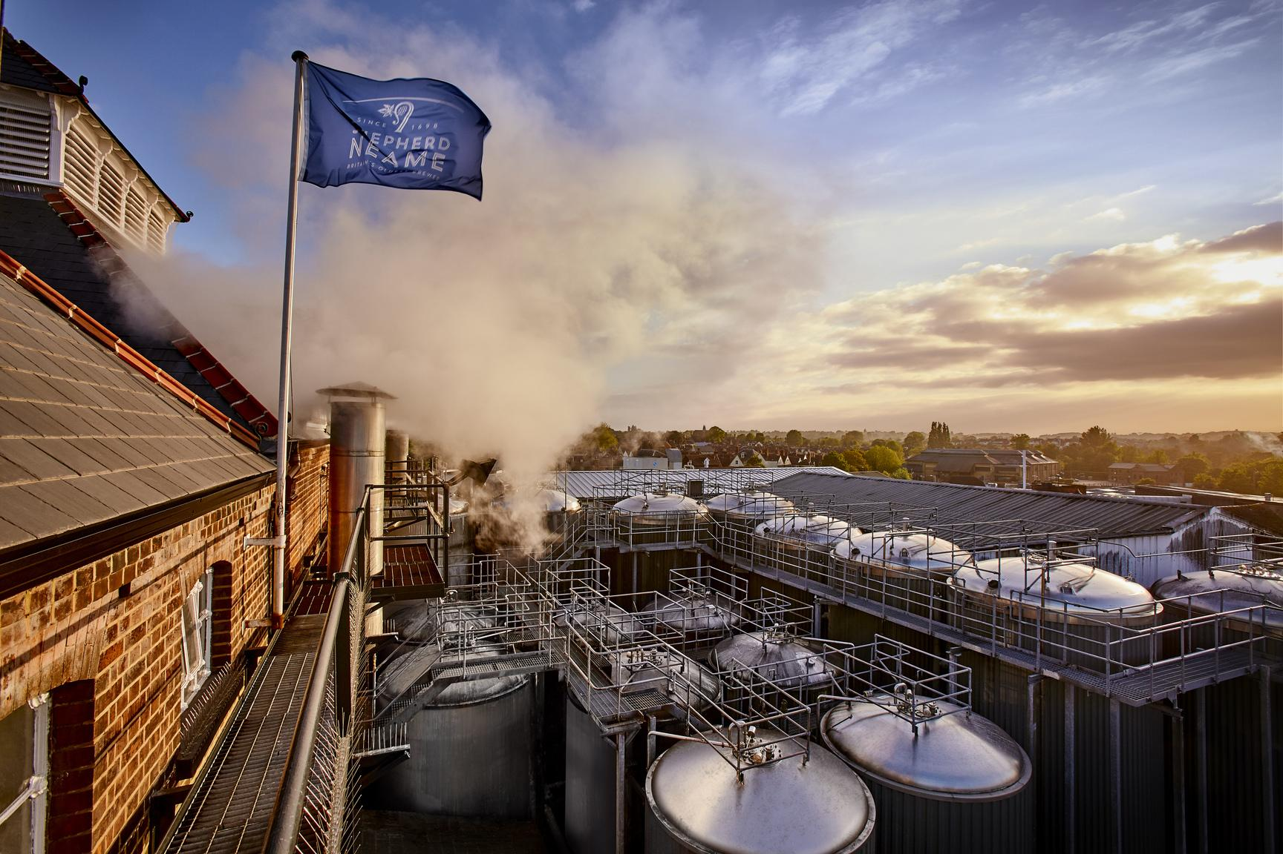

Shepherd Neame is joining forces with Kent theatre company Changeling for a third year to stage a live performance, but this summer’s show will take place inside its Faversham brewery (pictured) for the first time. Shakespeare’s romantic romp Twelfth Night will come to the Old Brewery Store events space on Wednesday 16 July for one night only. Best known for its open-air tour each summer, the Changeling Theatre has staged Shakespeare’s most popular plays in locations ranging from castles to beaches for more than 20 years. And for the past couple of years, after teaming up with Shepherd Neame to launch Shakespeare with Sheps, the troupe has also performed in some of its pub gardens around Kent. This summer’s show promises a top night’s entertainment with the audience also able to enjoy Shepherd Neame's beers, wines and spirits. Shepherd Neame’s head of customer relations Giles Hilton said: “We are delighted to continue our partnership with the Changeling Theatre for another year – and even more delighted that we will be hosting it inside our historic brewery. “We look forward to welcoming the cast and crew, and theatre fans into the Old Brewery Store for what we think will be a very special night.” Changeling artistic director Rob Forknall said: “Although this isn’t the first time we have performed indoors it will be our first time in a brewery and how exciting to be performing in one of the oldest in the world and even better in Kent. “As a proud Kentish theatre company, we are chuffed to be working with such a majestic brand as Shepherd Neame in its home in Faversham.”  Tickets cost £25 for adults, £15 for children 10-18 with under 10s free. To book go to: medwayticketslive.co.uk/event/Changeling-Twelfth-Night-Shepherd-Neame