Tough times for independent brewers as numbers drop

19/05/2025 by Timothy Hampson

Industry

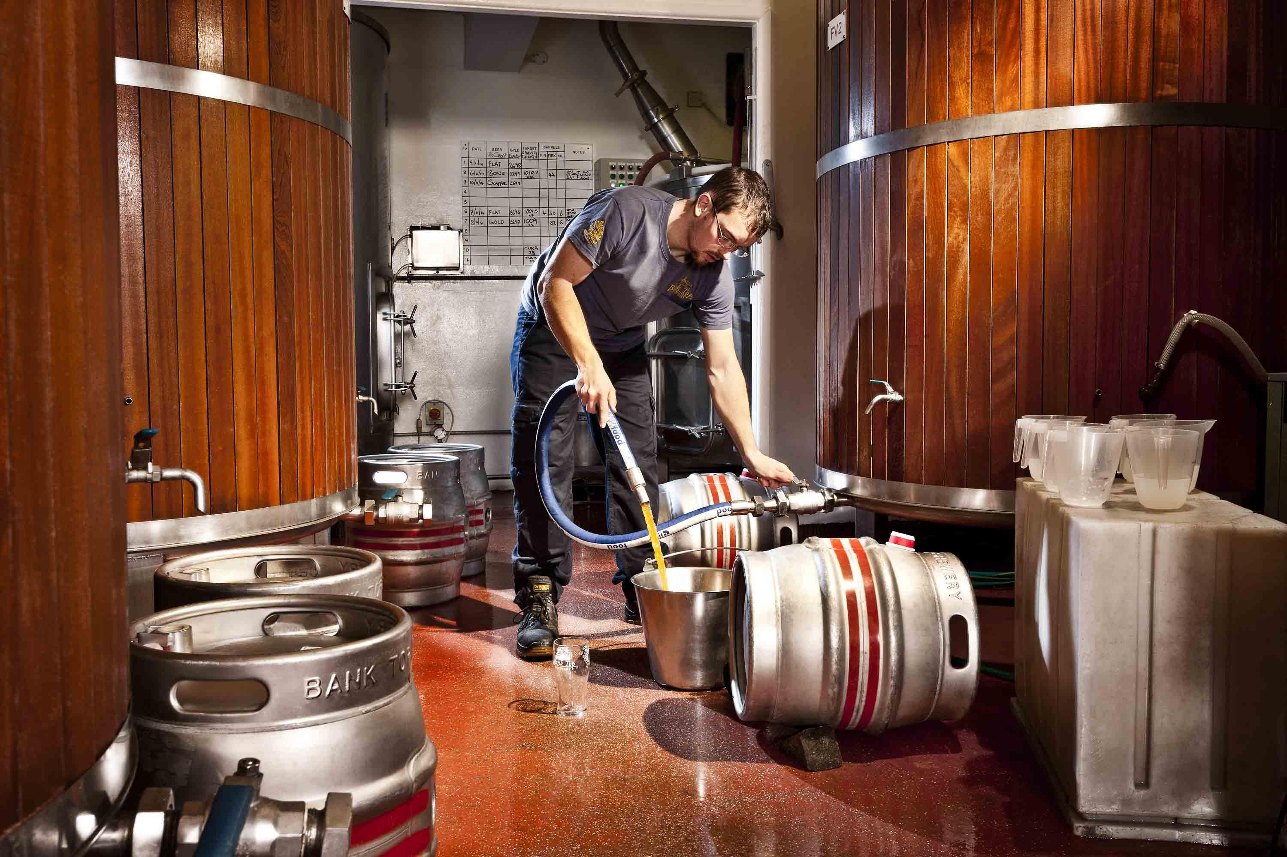

The number of breweries in the UK has continued to drop, with 136 fewer at the end of March 2025 compared to the same time last year, continuing the downward trend seen in January. The number of active breweries now stands at 1,641, according to figures released by the SIBA UK Brewery Tracker. SIBA chief executive Andy Slee said: “Times are incredibly tough for independent breweries, and while the price of a pint in pubs may be rising for drinkers, the price brewers are paid for their beer actually dropped over the last 12 months. “What is desperately needed is a lower tax burden for pubs, lower direct taxes for brewers, and greater access for independent breweries to sell to pubs in their area – many of whom are currently controlled by global beer supply. “The latest brewery tracker figures do take into account some brewing businesses which have been winding down during the last 12 months and we have also further improved our tracking processes, but even factoring that in, clearly things are not moving in the direction the industry would have hoped.” The SIBA Independent Beer Report 2025 showed that on average 60 per cent of pubs within 40 miles of an independent brewery were inaccessible to them, blocking sales and reducing consumer choice. The regional figures show a very mixed picture across the UK, with some seeing greater closure rates than others. Looking at the Moving Annual Total (MAT) figures, the South East had the biggest loss with a -38 net closure rate, the Midlands has lost 33 breweries overall in the last 12 months, followed by the East which was down 20. It’s a similar picture in the North East with a -19 net closure rate. Scotland had the next largest drop, at -11 net closure rate, with Northern Ireland (-6), the South West (-6), and the North West (-5) posting more moderate drops. Wales was the one region of the UK in growth, with a small +2 increase. To view the full regional and national brewery numbers visit siba.co.uk/brewerytracker