CAMRA’s guide to 50 years of beer festivals out now

18/05/2025 by Timothy Hampson

Campaign

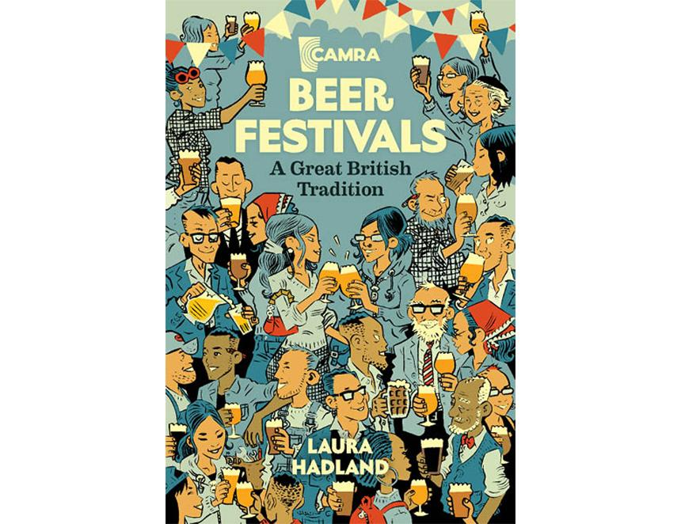

Beer Festivals: A Great British Tradition by Laura Hadland is now available and is the first of its kind. Laura, the award-winning author of 50 Years of CAMRA, has comprehensively explored the long history of CAMRA’s beer festivals over the last half century. She details their origins, how they operate, and tells the incredible stories of the people behind these festivals. CAMRA’s latest book digs into the social history of festivals and tracks how they have changed since 1975. Learn how integral CAMRA was in shaping the modern beer festival we love today and find out the crucial role the consumer group took in changing the way the public find and taste beer over the past half-century. Beer Festivals: A Great British Tradition is a love letter to the richness and diversity of beer festivals and to the people who make them happen. Laura said: “I believe beer festivals are significant cultural events and without them the beer scene would look very different. “But just like the people that organise the festivals, this book is light-hearted and fun. Expect exploding ales, kidnapped cats and mushy pea beer in amongst the serious business of giving traditional cask ale a new lease of life.” To buy go to shop1.camra.org.uk/product/beer-festivals-a-great-british-tradition