Campaigners save iconic beer

17/05/2025 by Roger Protz

Industry

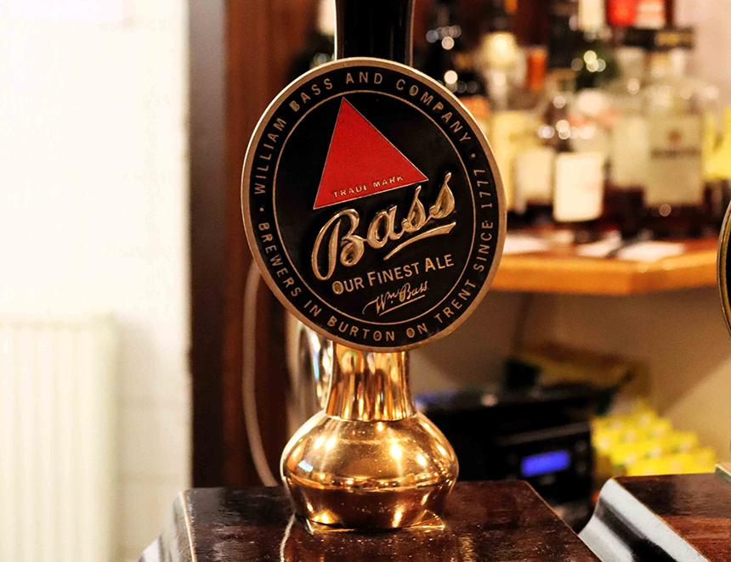

Draught Bass, a legendary Burton pale ale, has been saved from oblivion thanks to tireless campaigning by lovers of the beer. At its peak, Draught Bass, brewed in Burton-on-Trent, accounted for close to a million barrels a year and was the biggest-selling premium cask beer in the country. But Bass left brewing in 2000 and the brand ended up owned by the world’s biggest beer group, AB InBev, best known for American Budweiser and Stella Artois. It said it had little interest in such “low volume” beers as Draught Bass and sidelined it. Production was moved to Marston’s in Burton. While the quality of the beer remained high, the beer became difficult to find outside its heartland of Burton and Derby and sales dwindled to around 30,000 barrels a year. In 2010 AB InBev – a merger of breweries in Belgium and Brazil with Anheuser-Busch in the US – said it was putting up for sale Draught Bass, Boddingtons Bitter, Flower’s Original and Flower’s IPA with an asking price of £15m. There were no takers as AB InBev refused to include the beers’ trademarks, one of which, the Bass Red Triangle, was the first registered mark in Britain when new legislation was introduced in 1876 to protect companies from fake and misleading brand images by rivals. Draught Bass aficionados leapt to the beer’s defence, determined to restore its availability. They were keenly aware of its keynote role in the pale ale revolution of the 19th century. While Bass never called the beer India pale ale, just pale ale, it was an integral part of the revolutionary beers produced in Burton. The first beer brewed for the British Raj in India came from Hodgson’s brewery in East London, based close to the docks where goods – including beer – left on epic three-to-five-month sea journeys to Mumbai (Bombay) and Kolkata (Calcutta). But Hodgson fell out with the East India Company that controlled trade to the sub-continent. As a result, the EIC encouraged brewers in Burton, notably Allsopp and Bass, to supply beer to India. The mineral-rich waters of the Trent Valley, with such flavour enhancers as gypsum and magnesium, brought out the full flavours of the new pale ales and the Burton brewers swiftly outsold Hodgson. Bass became a world-wide phenomenon. Exports went on from India to Australia and New Zealand, while the beer in bottle was sold in the dining cars of Union Pacific trains in the US. A famous 1882 painting by Édouard Manet of the bar at the Folies-Bergère night club in Paris showed two bottles of Bass with the familiar red triangle trademark on the labels. Worried that the beer in AB InBev’s hands would continue to decline or even disappear, its supporters launched a spirited campaign to bring it to the attention of fellow beer lovers. A National Bass Day was organised every year, with drinkers encouraged to visit pubs and consume generous quantities. Ian Thurman, based in Youlgreave in Derbyshire, produced a register of all known pubs that serve Draught Bass. Ian Webster, in Burton, is a historian of the local brewing industry. He created a Facebook page with the slogan Great Stuff This Bass – an advertising slogan once used by Bass to promote its leading beer. Finally AB InBev responded and announced this month that it would invest in and promote the beer, “which will remain in Burton”. There will be new pump clips, stamped glasses and merchandise. AB InBev will include the red triangle trademark in its promotion with the slogan “Trademark No 1: true quality that stands the test of time”. As well as being prompted by the British campaign, the global brewer will have noted that many versions of IPA are now brewed around the world and a large number of American breweries produce their interpretations of the style. AB InBev itself owns Goose Island brewery that started life in Chicago but now has plants in New York State, Colorado and Canada where its IPA and other beers are produced. Its major international rival, Heineken, owns the Lagunitas brewery in California that brews a popular IPA. If the Draught Bass (4.4 per cent) brewed at Marston’s remains true to its old Bass recipe, it will be brewed with pale malt, maltose syrup and Challenger and Goldings hops. The beer will no longer be fermented with Burton Union yeast as the owner of Marston’s, Carlsberg Britvic, has closed and disposed of the Victorian vessels that were developed to make sparkling pale ale. But regular Bass drinkers agree that the Marston’s beer is well made and has a fine palate of biscuit malt, peppery and spicy hops and a pronounced note of sulphur on the aroma from the Trent water. AB InBev’s decision to promote Draught Bass is proof that even global giants can be forced to listen to consumers. The task now is for supporters of the beer to encourage publicans to stock it and introduce customers to history in a glass. Thanks to Colston Crawford of the Derby Telegraph for additional information.