Cat’s Cat got the cream

16/05/2025 by Timothy Hampson

Campaign

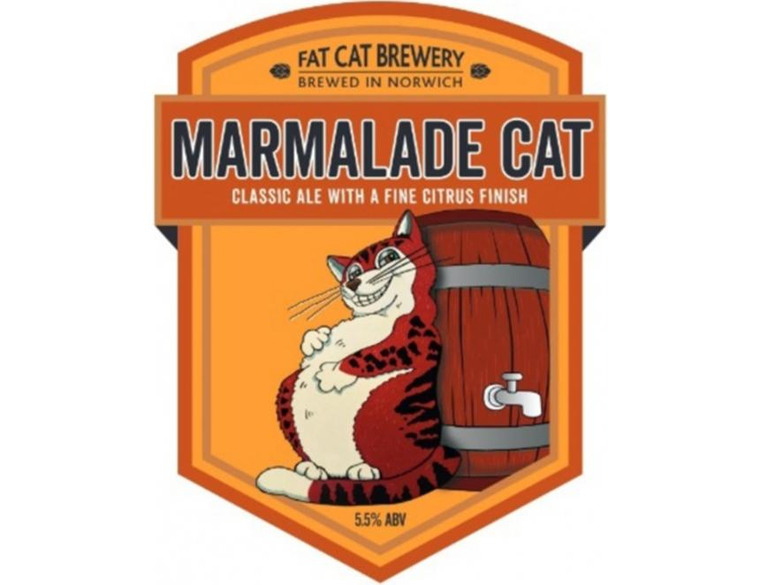

Norwich’s Fat Cat brewery has just claimed the Champion Cask Ale of Norfolk crown with its Marmalade Cat. The zesty 5.5 per cent brew is described in the Good Beer Guide as “Oxford marmalade throughout. Orange and malt pervade both aroma and taste. A full-bodied mix of contrasting but balanced flavours. A bittersweet hoppiness holds firm in a fine unsullied finish”. Fat Cat’s brewery manager Chris Riches said: “We’re delighted Marmalade Cat is Champion Beer of Norfolk as it celebrates 20 years of being brewed.  “One of our original recipes, it has been a consistent favourite with customers across the county, proving that good taste and quality never go out of fashion.” But Fat Cat wasn’t the only brewery with something to cheer about. Tombstone in Great Yarmouth was right behind completing the podium. Taking second place overall was Blackfoot, a 4.8 per cent session porter described as “rich and creamy with a sweet malty aroma and taste. Plum, chocolate, and caramel flavours soften the roasty undercurrent”. And third was Arizona, a 3.9 per cent session bitter, described as having “malt and lemon aroma, with initial lemongrass and sweet biscuit flavours, quickly fading to reveal a sweet juicy finish, enhanced by tones of malt”. Norfolk CAMRA panel chair Alan Edwards said: “Norfolk beers are among the best in the country, and these awards recognise the very best. They, and others like them, can be found and enjoyed in pubs far and wide. “If we wish to ensure the survival of these brews, and the pubs that serve them, we must take every opportunity to seek them out and enjoy.” Lynn’s Ferry Bitter, a 4.1 per cent session bitter is the Champion Bottle Conditioned Beer of Norfolk while Duration is celebrating a double triumph after two of its beers were named the top Can-Conditioned Beers. Taking the top honour was Ebb and Flow, a 4.8 per cent American stout.