PUBlic Affairs round up – May

15/05/2025 by Tori Wood

Campaign

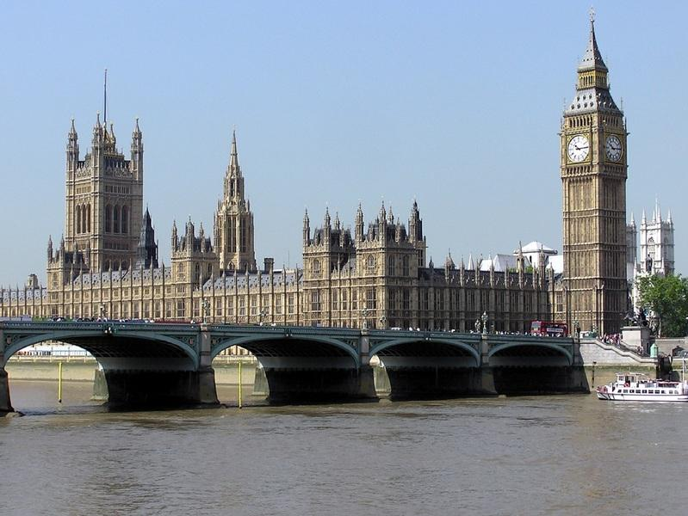

The Campaigns and Communications team is back for its regular PUBlic Affairs round up.  May is an exciting time at the Campaign, as the annual Mild Month celebration kicked off to help revive this much-loved beer style. Discover a mild event near you this May.  Read on to find out how our wider campaigns for pubs, pints and people are progressing across Westminster, devolved parliaments and local government.     Westminster  Business rates [England only] The chancellor announced a reform of the unfair business rates system at her Autumn Budget 2024, with a lower multiplier rate promised for retail, leisure and hospitality businesses.  To review how the current system can be reformed into a fairer rate, the government has held discussions and consultations with industry bodies.   Earlier this year, CAMRA’s senior campaigns and communications manager Ellie Hudspith met Treasury officials to discuss business rates reform at a roundtable consultation.  An interim report with “a clear direction of travel for the business rates system” is expected to be published by the Treasury, and “further policy detail” will be revealed in the Autumn Budget 2025.  Extended Producer Responsibility scheme CAMRA wrote a joint letter with industry bodies to the environment secretary on issues imposed on pubs, wider hospitality and consumers as part of the Extended Producer Responsibility scheme.  The team is waiting for a formal response, but it has seen a standard UK government response when asked about how the scheme will affect consumers, pubs and brewers: “Since Autumn 2024, the government has been working with stakeholders, including representatives of the hospitality sector, to consider potential amendments to the definition of household packaging. We are planning next steps as a priority and will share more information soon.”  CAMRA continues to work with other trade organisations to ask governments in all four nations to make sure the Extended Producer Responsibility scheme doesn’t place unfair extra costs on consumers, pubs and independent breweries.  Licensing hours extension: Victory in Europe day [England and Wales] To mark VE day on 8 May, the government brought forward secondary legislation which allowed pubs in England and Wales to stay open later.  The team sent a briefing to MPs in England and Wales ahead of the parliamentary debate that was held to approve the legislation.  The Campaign welcomed extended opening hours for pubs but emphasised government support is necessary to allow the beer and pub sector to survive and thrive.   Andrew Ranger MP (Labour, Wrexham) has a Private Members Bill calling for an easier licensing hours extension for pubs during special occasions. It is currently before parliament, and CAMRA hopes it receives government support and becomes law.  Review of quangos and arms lengths bodies The Cabinet Office is reviewing all government quangos and arms-length bodies.   The review could see some abolished while bringing others back in-house within government departments. Expected to be removed is the Valuation Office Agency, the department in charge of valuing properties for business rates and council tax purposes. The Treasury has confirmed its functions will merge with HMRC.  CAMRA pub and club campaigns director Gary Timmins wrote to the Cabinet Office minister, Pat McFadden, to ask that the Pubs Code adjudicator for England and Wales should stay as part of this review with the role’s powers strengthened.   UNESCO and cask beer  The team has been working with the Craft Beer Channel to get cask beer listed with UNESCO as Intangible Cultural Heritage.   The e-petition to recognise the production and serving of cask beer as Intangible Cultural Heritage recently passed 10,000 signatures, ensuring a full response from the government.  The government said it would welcome an application to list cask beer, and CAMRA will be supporting the Craft Beer Channel to make an application when the process opens later this year.  The team is still promoting the petition to get it up to the 100,000 signatures needed so it can be considered for a parliamentary debate. Please sign the petition here.     Scottish government and parliament  Scottish Parliament Cross-Party Group on Beer and Pubs (secretariat service provided in part by CAMRA) A brewery tour for MSPs with the Cross-Party Group on Beer and Pubs took place on 25 April. Breweries included Pilot, Campervan and Newbarns, and industry challenges for independent producers were discussed.  Members from Edinburgh and South Scotland branch and Scotland director Stuart McMahon attended the tour, joining useful discussions with breweries and a good turnout of MSPs.   Separately, the Cross-Party Group has discussed how the Extended Producer Responsibility scheme affects the hospitality industry in Scotland.   MSPs are now submitting questions to Scottish government officials while pushing governments in all four nations to work together to support pubs, breweries and consumers.      Northern Ireland executive and assembly  Licensing review  The University of Stirling published an independent review of Northern Ireland’s alcohol licensing system in February.   To discuss next steps, CAMRA campaigns and communications manager Paul Edgeworth and Simon Hyde from the Northern Ireland region met with Naomi Long MLA, leader of the Alliance Party of Northern Ireland, and Kellie Armstrong MLA, the party’s Communities spokesperson.     Non-parliamentary  Handpump Hijack  For the one-year anniversary of Carlsberg’s Fresh Ale on 25 April, CAMRA issued a statement calling on the brewing giant to stop selling imitation cask beer.  An update from West Northamptonshire Council Trading Standards, who are responsible for giving trading standards advice to Carlsberg is expected soon. The team is planning the next steps in the campaign and developing new resources for members and branches.