Black Horse to ride again?

14/05/2025 by Timothy Hampson

Pub

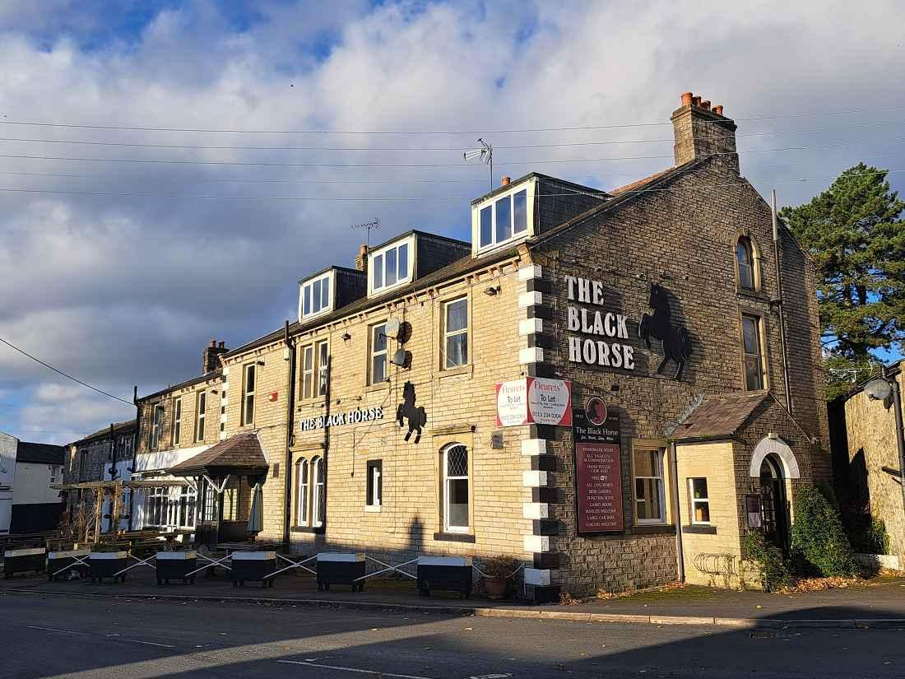

A closed village pub could be taken over by the community after winning support of residents. More than 100 people attended a meeting in Hellifield, North Yorkshire to gauge support for buying the Black Horse, which is on the market for £495,000. The meeting voted overwhelmingly in support of moving to the next stage, which will mean an application to North Yorkshire Council for the pub to be listed as an Asset of Community Value. The property, owned by Gargrave Poor’s Land charity, is the only pub in the village, although there is licensed social club Hellifield House, which has for many years operated alongside the Black Horse. Hannah Crabtree-Day told the meeting how questionnaires were sent out last month to see if people would be interested in saving the Black Horse. Of the 233 who responded, 98 per cent said they would use the pub with 93 per cent believing it should serve food. Just over a third said they would be interested in buying shares, while 23 per cent said they would be willing to help run it. Crabtree-Day said they had been offered support from the Plunkett Foundation. It is estimated around £600,000 will be needed to buy and renovate the pub. North Yorkshire councillor Simon Myers said it was unfortunate that a government grant scheme which supported the setting up of community pubs had now come to an end. Myers told the meeting the project had his support and added there was a need for guest accommodation in the area and the Black Horse had suitable rooms. He suggested ways the community could raise funds, such as an application by the parish council to the Public Works Loan Board and through the selling off of part of the site to a housing association. The group will now move to the next step and has appealed for people with specialist knowledge, including a treasurer and someone with experience in fundraising.