Dutch favourite’s cask debut

13/05/2025 by Timothy Hampson

Industry

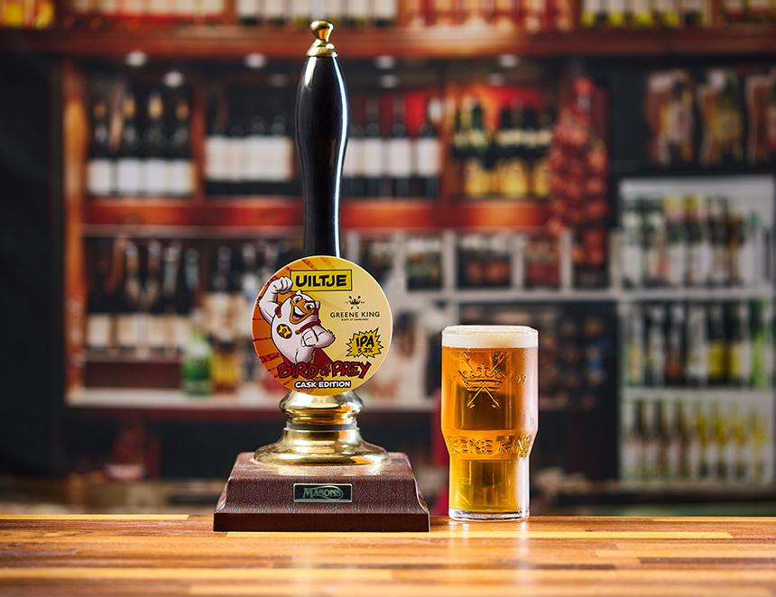

Greene King is launching its first international cask collaboration, recreating the popular Dutch Bird of Prey, with Uiltje Brewing Company.  The seasonal golden Bird of Prey is a fruity, hoppy IPA, full of citrus and tropical flavours and will be available throughout May and June. The project began in 2024 with the two brewers discussing how they could turn Bird of Prey into a cask beer. Following Greene King’s visit to Haarlem and the Uiltje brewery, the recipe was crafted in Bury St Edmunds and the beer tailored to the brewery. The original Bird of Prey continues to be produced by Uiltje as a keg product at 5.8 per cent. The cask edition available in the UK will be 5.2 per cent ABV to meet consumer preferences in the UK. Greene King technical brewer Alan Fulcher said: “Bird of Prey is a fantastic opportunity to work with the brilliant brewers at Uiltje. It has been a great challenge to craft a beer that was not originally brewed as a cask ale, and this really showcases the flexibility of cask and the variety it can offer drinkers. “We have conducted consumer research on Bird of Prey, and feedback is really positive so I am confident it will be a hit for the new seasonal calendar.” Uiltje master brewer Aditya Parupudi said: “We are excited to make our first cask debut with Greene King, and we can’t wait for guests to try the beer in pubs. “Working with the brewers at Greene King has been a great experience and it’s been so interesting to take one of our favourite products and give it a British cask finish for people to enjoy on the bar this summer across the UK. It really is going to blow people’s socks off.”