Clear focus on transparent labelling

12/05/2025 by WB Reporter

Campaign

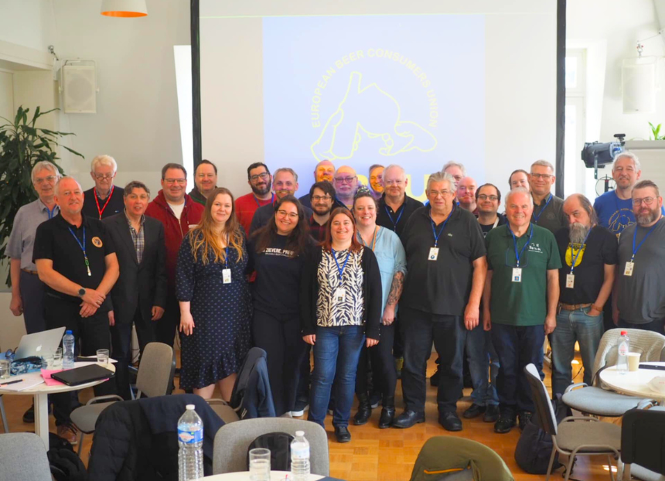

Transparent labelling to ensure consumers know what they are drinking was a key topic at the 71st delegates meeting of the European Beer Consumers’ Union (EBCU). CAMRA joined delegates (pictured) from other member organisations across Europe at the Confederazione Italiana Agricoltori centre for a seminar and a two-day conference at De Markten cafe and the Muntpunt library in Brussels, Belgium. Kicking off the weekend, representatives from Austria, the Netherlands, Czech Republic, Denmark, Finland, Belgium, Germany, Ireland, Italy, Spain, Poland, Sweden and Switzerland took part in the Rising Costs, Rising Expectations: Beer Consumer Trends 2025 – Environment, Transparency, and Wellbeing seminar. It focussed on how the beer industry can adapt to rising production costs and inflation, while still championing affordability, health, and sustainability. As well as accessible product information such as ingredients, customers need to know where the beer is being brewed, and labels should clearly state if a global conglomerate owns the drink. The positive impact of pubs on wellbeing was also a major talking point. Pubs provide a welcoming place for people to feel part of a greater community, helping to tackle loneliness and social isolation. When discussing the topic of the environment and sustainability, the importance of supporting local brewers to minimise the ecological footprint of beer production was a key theme. Delegates also examined internal affairs, including sharing member and executive reports, finance and budget updates, strategy proposals and working group reviews in the first of a two-day delegates meeting. The final day featured workshops and discussion groups aimed to develop ideas for the future of the EBCU and improve the organisation. The meeting concluded with Brussels Beer Challenge technical advisor Yannick de Cocquéau discussing EBC-endorsed beer competitions. More information about the European Beer Consumers’ Union can be found here. Photo by Anikó Lehtinen