Women’s brew day back with a bang

11/05/2025 by WB Reporter

Industry

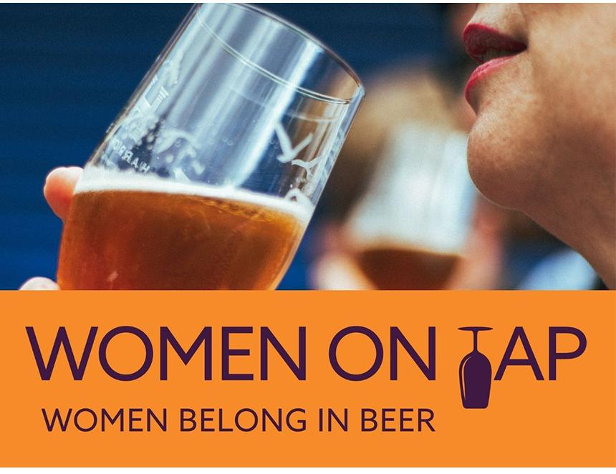

International Women’s Collaboration Brew Day (IWCBD) bounced back this year with 61 sessions, 837 participants, 66 beers and more than £26,000 raised for 44 women’s causes around the world. Launched in 2014 by Sophie de Ronde of Burnt Mill brewery, the global brewing celebration ran for 10 years before taking a break in 2024. Later that year, Women On Tap CIC – the social enterprise championing gender equality in the beer industry – announced it would be picking up the reins. With backing from headline sponsor Society of Independent Brewers and Associates (SIBA) and support from Simpsons Malt, the campaign not only returned but evolved. For the first time, every IWCBD brew day committed to donating at least £100 to a women’s cause of its choice to ensure lasting impact. Meanwhile, education partner Wines and Spirits Education Trust (WSET) offered 18 fully funded Level 1 Beer Award places, with an extra four paid for by 71 Brewing. Women On Tap CIC founder Rachel Auty said: “This campaign is about more than brewing great beer as a community – it’s about showing that a better, more connected and diverse beer industry is possible. Seeing women and non-binary people come together globally, taking up space, creating new opportunities, and driving real impact has been inspiring. And we’re just getting started.” SIBA’s head of comms Neil Walker said: “SIBA was proud to sponsor this year’s IWCBD because representation matters. The independent  beer community thrives on innovation and passion – and the more diverse the industry becomes, the stronger and more resilient it will be.” Feedback from breweries underlined just how vital IWCBD is:– Hand Brew Co: “IWCBD is building a powerful network that empowers women and non-binary people to take up space, educate, and create new opportunities. A more balanced beer industry is a better beer industry”– Turning Point Brew Co: “It’s essential for women in beer to have spaces where they are truly supported” – Tap Social Movement: “This initiative puts vital conversations about diversity centre stage, and shows that beer really is for everyone.”  Plans for 2026 are already being looked at including expanding its international reach, launching the UNITE Awards to recognise stand-out efforts, and exploring staging an IWCBD beer festival.