CAMRA Pub Heritage Group Update – April

08/05/2025 by Tom Chapman

Campaign

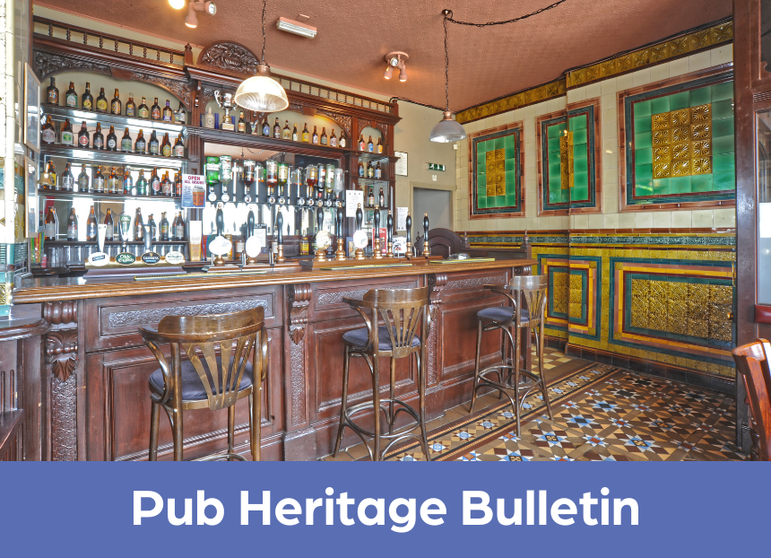

CAMRA’s Pub Heritage Group shares news and updates about pubs with historically significant interiors across the UK. For further news, see the Pub Heritage webpage here.   Three Star Heritage Pubs  Bulls Head, Telford, West Midlands  The Bulls Head (above) is included on the inventory primarily for the front bar with its exceptional tilework dating to 1904. Unfortunately, the bar is currently closed but will be reopening soon with cask beer being reintroduced. Alterations are being carried out to the more modern parts of the pub, and reports suggest some damage has taken place to the tiling of the former right-hand corridor. Owner Inglenook Inns is currently looking for someone to take on the Bulls Head. Find more information about the pub’s tenancy on the Inglenook Inns website here.

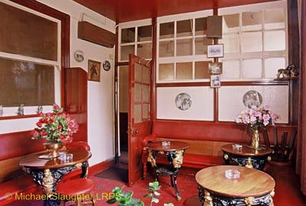

Vine, Stoke-on-Trent, Staffordshire (above)   The Pub Heritage Group last reported on the sale of this rare, small, Victorian back-street local in January, with news that the new owners was intending to reopen it. A new premises licence has now been applied for, so it is anticipated that it will be opening its doors soon. The building is grade II\*-listed, and no planning applications have been submitted yet, so it is hoped no changes will made to the pub.

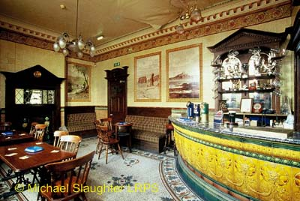

Mountain Daisy, Sunderland, Tyne Wear (above)  The Pub Heritage Group reported on the sudden closure of the Mountain Daisy last month. The local community are extremely concerned about its future and have now lodged an application with the council to have the pub recognised as an Asset of Community Value (ACV). The grade II\*-listed pub would require planning consent for any change of use, but an ACV listing would further protect the Mountain Daisy’s future as a pub, and give the community the opportunity to purchase it if it is put up for sale in the future. Find more information about the ACV bid on the Sunderland Echo website here.

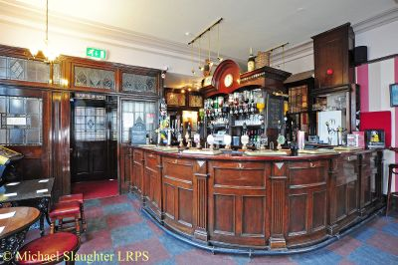

Duke William, Stoke-on-Trent, Staffordshire (above)  The freehold of the Duke William was sold at auction in early March. The pub was put up for sale after a period of instability with a number of licensees unable to make a success of running it, which the Pub Heritage Group reported in January. It is included on the inventory for its 1930s interior.    Two Star Heritage Pubs

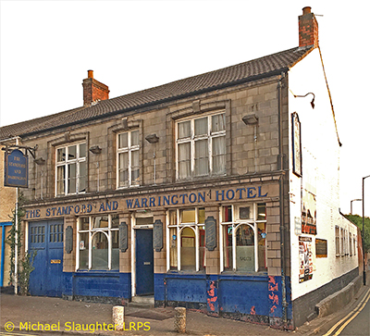

Stamford and Warrington, Coalville, Leicestershire (above)  Closed since June 2023, the 1950s interior of this unlisted pub has been stripped out, and a planning application has been lodged for change of use to retail and residential.

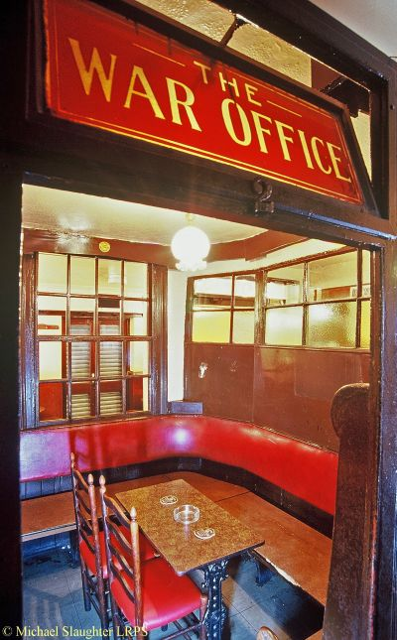

Crake, Liverpool, Merseyside (above)  Ye Cracke, is currently closed following its recent sale, and the new owner intends to reopen the pub following a refurbishment. Ye Crake’s multi-room layout has evolved over the last century with fittings dating primarily from the 1960s. It also includes a Victorian-era panelled snug known as The War Office, where it is said that locals would discuss the progress of the Boer War. Find out more about the pub’s sale on the Liverpool Echo website here.

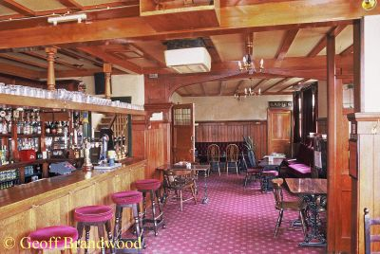

Builders Arms, Teddington, Greater London West (above)  After being closed for two years, this Edwardian two-room local reopened in November following a respectful refurbishment which retains the pub’s historical features.

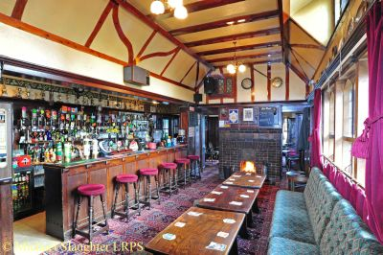

Gatehouse, Norwich, Norfolk (above)  The Pub Heritage Group reported on the potential sale of the grade II\*-listed pub to the Gatehouse Community Hub in February. Unfortunately, its bid was unsuccessful and the pub has been sold to another buyer. The Gatehouse has been closed since April 2023 and is registered as an Asset of Community Value. It was built in 1934 by Morgans as an improved public house and was listed grade II in 2015 by Historic England – just one of 21 pubs listed at the time recognising the heritage value of locals of the period. The Pub Heritage Group would welcome any updates. Read more about the failed bid on the Norwich Evening News website here.

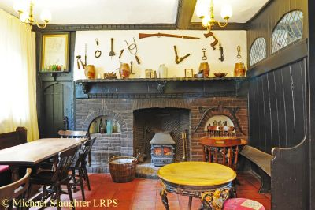

Green Dragon, Wymondham, Norfolk (above)  Admiral Taverns is once again seeking new tenants for this ancient town pub, with the previous licensees expressing frustration with the pubco for not committing to the investment they felt is required to rejuvenate this venerable old inn, which was built in 1378 and has functioned as an inn since the 16th century. The rent has been reduced and an open day was held in April for potential tenants. Find more details about the pub on the Admiral Taverns website here.    One Star Heritage Pubs

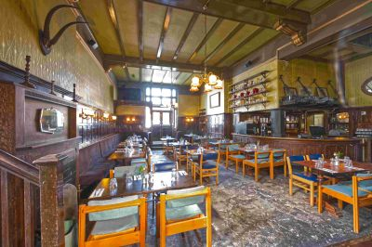

Antelope, Tooting, Greater London South West (above)  The Antelope reopened 11 April following a £1m refurbishment by new owner Urban Pubs & Bars. Regrettably, the refurbishment has resulted in the loss of most of the pub’s interwar features, including bar counter, stillion bar-back in the centre of the servery and the mirrored bar-back at the rear of the servery with its Barclays Beers illuminated panel. The double doors and glazed panel separating the main bar from the dining room at the rear have also been lost, leaving a wide opening. The servery bar counter and bar-back in the dining room have been removed to accommodate more seating, and the dining room has been shortened to make room for a kitchen. However, the former billiards room at the back is virtually unchanged, although the panelled walls have been painted magenta, and a modern bar counter has been added.  The pub has now been downgraded from two to One Star status following these changes.

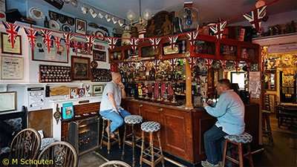

Volunteer, Ventnor, Isle of Wight (above)  The freehold of this small, two-room, Victorian town pub is for sale due to the retirement of the current owner. It is being marketed by agents Gully Howard with an asking price of £285,000. Find out more about the sale here.

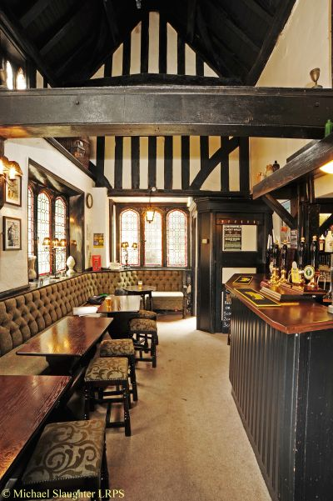

Royal Oak, Chesterfield, Derbyshire (above)  After being closed for three years, Chesterfield’s oldest pub, the Royal Oak, reopened over the Easter bank holiday weekend after a light refurbishment and now has eight cask beers at the bar. Find out more on the Derbyshire Times website here.   Highland Laddie, Leeds, West Yorkshire Previously named the Highland, the Highland Laddie in Leeds reopened on 17 April after being shut for two years. The new owner also runs the Empire Café in Leeds and, while it will be more food orientated, it is committed to retaining the character and culture of the pub.  Other news  The UK government has announced funding worth £20m to protect heritage assets in England. This is split between the Heritage at Risk Capital Fund and the Heritage Revival Fund. Potentially both funds could be used for heritage pub projects. CAMRA released a supporting statement for the Heritage Revival Fund, with Pub Heritage Group chairman Paul Ainsworth highlighting the need for more funding for community pubs that do not satisfy the criteria, in particular those that are considering community ownership. Currently there is limited funding for these initiatives since the disappointing closure of the Community Ownership Fund last year.  If you have any news for CAMRA’s Heritage Pubs team, send to:  info@pubheritage.camra.org.uk . If you wish to receive the bulletins directly, sign up by sending an email to bulletin@pubheritage.camra.org.uk with “subscribe” as the subject or “unsubscribe” if you wish to stop receiving bulletins.