Generation game

03/05/2025 by Laura Hadland

Opinion

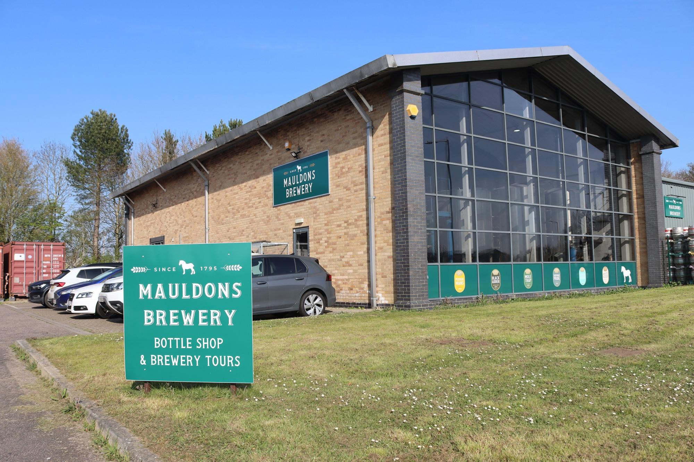

A couple of weeks ago my phone pinged as a press release dropped into my inbox. It told me the story of Steve Birch, the head brewer of Mauldons brewery in Sudbury, who has crafted his 25 millionth pint this month. The weird thing was, when I opened that email, I was with Steve taking a look around the brewery. Steve is a modest and immediately likeable man whose fierce loyalty to Mauldons and intense passion for cask beer shines through from the moment you meet him. It is thought that he has served the longest tenure at a single brewery of anyone in the UK, having joined the business in 1983. This was just after Peter Mauldon bought the family brand back from Greene King and recommenced brewing in 1982. The brewery building is of its time. The industrial estate unit is spacious. The legacy of Steven and Alison Sims, who owned the brewery from 2000 to 2019, includes plenty of room to expand. Mauldons moved into this all glass-and-stainless-steel space in 2005 when its original premises had been outgrown. There has been an upward trajectory ever since Black Adder stout won Champion Beer of Britain back in 1991. Now under the ownership of Charlie Buckle of the Nedging Hall Estate, Mauldons is investing heavily in its future. The brewery has been made more sustainable and a new insulated cold store has just opened. It is called the Birch Building, recognising Steve’s commitment to the business. They are bottling more beer than ever before and currently Steve is working on perfecting its first lager. With more than 40 years of brewing under its belt, Mauldons has a right to be proud of its heritage even as it looks to the future. It sits in good company with the likes of Wye Valley and Titanic breweries, which both celebrate their 40th this year. All venerable names in British cask beer. But Mauldons' history actually stretches back much further. It is often touted as Suffolk’s oldest brewery, founded by Mrs Anna Maria Mauldon in the late 19th century. The business began out of Sudbury’s White Horse Inn on Ballingdon Road, where Anna Maria was already the licensee and brewing for sale on the premises. She bought the pub in 1875 and the Bull, also a brewpub, in around 1880 and so Mauldon & Son began. As the business expanded, it became Mauldon & Sons. A new brewery was built behind the White Horse. When that was destroyed by fire in 1900, an even bigger tower brewery was built in its place. Mauldons was a successful business until the Second World War. It struggled to regain composure after the war years, fighting with technological change in the industry. The brewery and its sizable estate of 27 licensed houses and an off-licence was eventually snapped up by Greene King in 1958. In a familiar tale, the purchase was an exercise in asset acquisition. Greene King never brewed under the Mauldons name and the brewery was demolished, although the original pub building, with its white horse moulding, still exists. It stands empty now. Starting in 1875 doesn’t actually make Mauldons the oldest brewery in the county. Adnams was founded in 1872. Greene King was even earlier, setting up shop in 1799. Although Anna Maria is acknowledged as the founder of Mauldons – see the special-edition beer that was released in her honour this March – the brewery also claims to have begun in 1795. That is about 33 years before Anna Maria was born. I’ve delved deep into the archives to try to understand this puzzle – where does the 1795 (or sometimes 1793) date come from? I’ve drawn a blank. There are vague claims, all from auxiliary sources, that the family were home brewing for a century before Anna Maria bought the White Horse. But as yet, I’ve not been able to find any evidence for it, much less be convinced that the business can trace its formal origins to the 18th century. There are plenty of examples of breweries that have bought back their name and resumed trading after an extended hiatus thanks to the ravages of the Big Six. Think of Joules, or more recently, Allsopp’s. They are right to recognise and celebrate their important contribution to the history of British beer, even though they are now in a new chapter of their story. And Mauldons has a lot to be proud of even if it is not, as the current evidence stands, the oldest brewery in Suffolk. It makes wonderful beer. Officially some of the best in the country, no less. Steve’s story as head brewer is a long and fascinating one, that speaks of a lifetime of dedication to that beer. While no longer owned by the Mauldon family, the business is run by another family, one that offers an incredibly significant contribution to the gastronomic landscape of Suffolk, via the Nedging Estate. Enjoy a pint of Mauldons with an estate-sourced meal at the wonderful Crown in Bildeston and you’ll see what I mean. Maybe one day, the hard evidence of a foundation date of 1793 or 1795 will drop into my lap, and I will revise this story. I’ll be happy to do so. But until that day, I think that Mauldons should be focusing on its latest chapter. People like Steve are the ambassadors of Mauldons' new heritage. Claiming to originate a generation before your founder was born is just plain confusing.