Chairman’s Award 2025

02/05/2025 by Timothy Hampson

Campaign

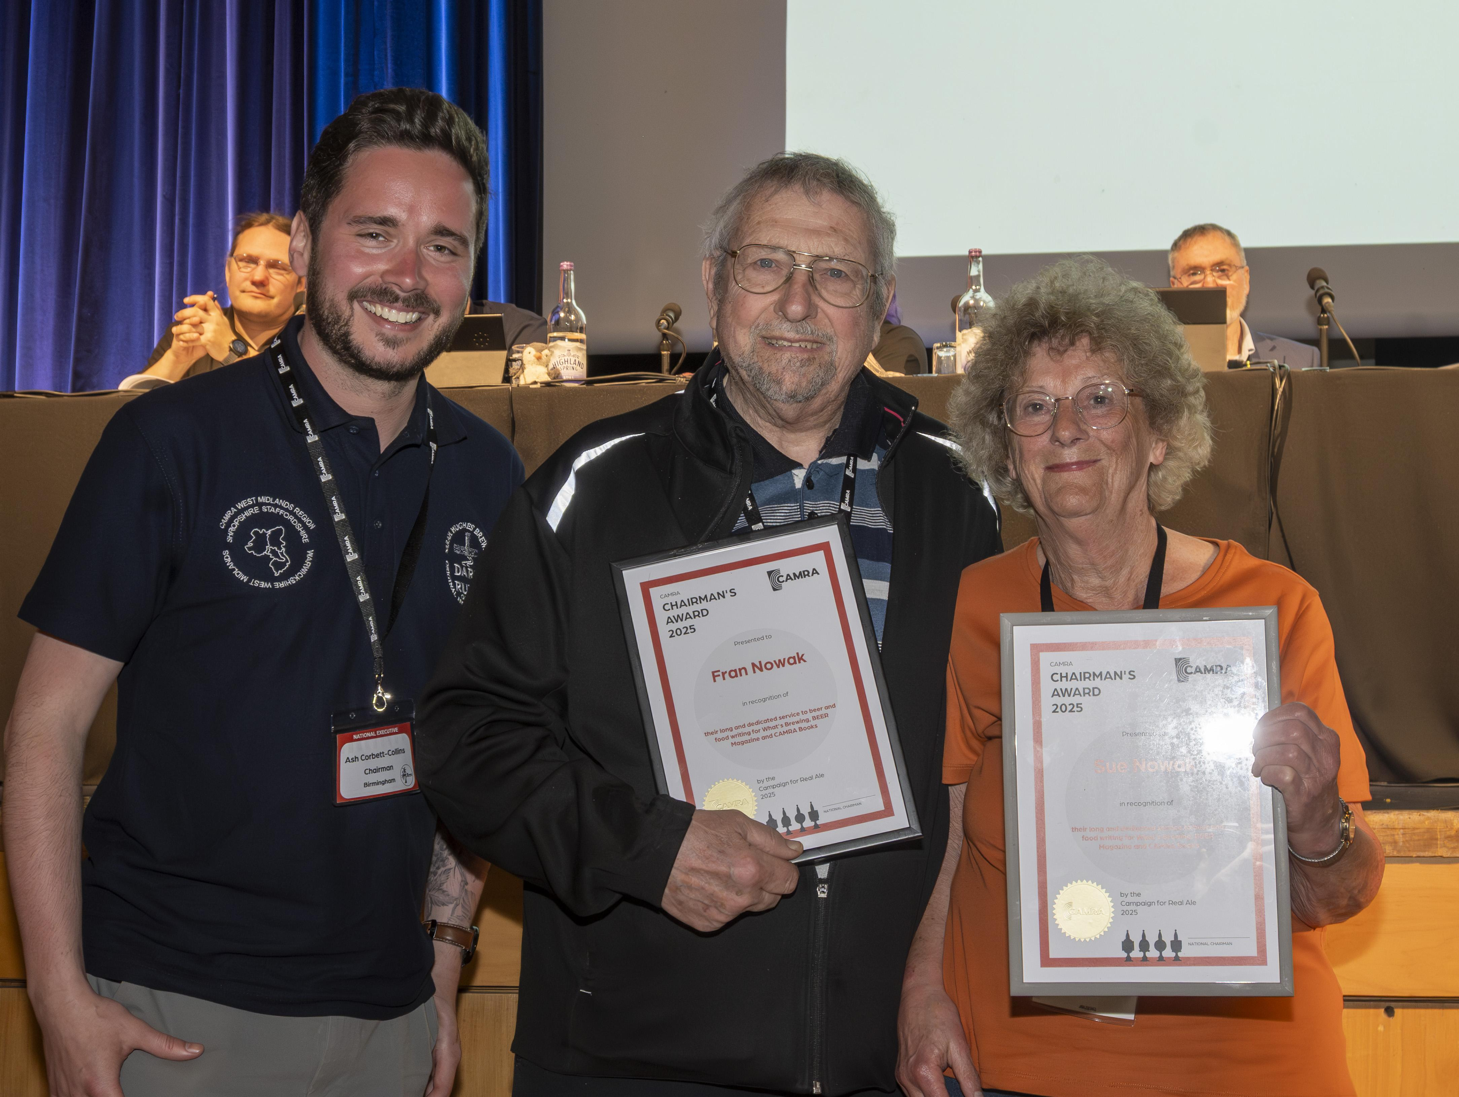

Susan and Fran Nowak were presented with awards at CAMRA’s Members’ Weekend in Torquay. The husband-and-wife team – Susan the writer, Fran photographer – gained the Chairman’s Award 2025 “in recognition of their long and dedicated service to beer and food writing for What’s Brewing, BEER Magazine and CAMRA Books”. The pair both joined CAMRA, launched in St Albans where they then lived, in 1972. Apart from striving to save real ale, CAMRA became famed for the Good Beer Guide listing UK pubs serving well-kept cask beer. Then in 1989, Susan was commissioned to write a sister guide to the pubs serving great food as well as fine beer; it ran for six editions. She also began writing for CAMRA’s newspaper What’s Brewing, and then became food writer for the award-winning BEER. Fran was the photographer for all her features – work that took them as far as the USA and Canada, Hawaii and over most of Europe including Fran’s home country, Poland. But it was in Belgium, and in particular Bruges, where they discovered the richness of beer cuisine – the art of cooking with beer and pairing styles of beer with all kinds of dishes, savoury and sweet. Quite early in her career, the couple was invited to join the British Guild of Beer Writers. Susan was thrilled to be given the task of creating the menus for their annual dinners, then held in some of the City of London’s fabulous guild halls. She was guild silver tankard winner in 1995 and chairman from 1998-2000 – the first woman to hold the position. For the Millennium Banquet in 2000 she designed a “through the ages” feast; among the beers was the forerunner of golden ale, brewed with saffron, to accompany the Elizabethan course. Apart from her CAMRA publications, Susan wrote a recipe book, The Beer Cook Book, published by Faber and Faber. As well as recipes she created herself, it contained several donated by some of the celebrity chefs she’s met along the way, such as Keith Floyd and Delia Smith. For around a decade she was a senior judge in the Great Taste awards, held annually by the Guild of Fine Food. Susan and Fran now live in Plymouth overlooking the Sound where they are members of Plymouth CAMRA branch and particularly enjoy the beers of the region’s biggest brewer, St Austell. In the words of its flagship beer, it’s been a Proper Job. Pictured, from left, chairman Ash Corbett-Collins with Fran and Susan