Climate change threat to barley and hop harvests

01/05/2025 by Timothy Hampson

Industry

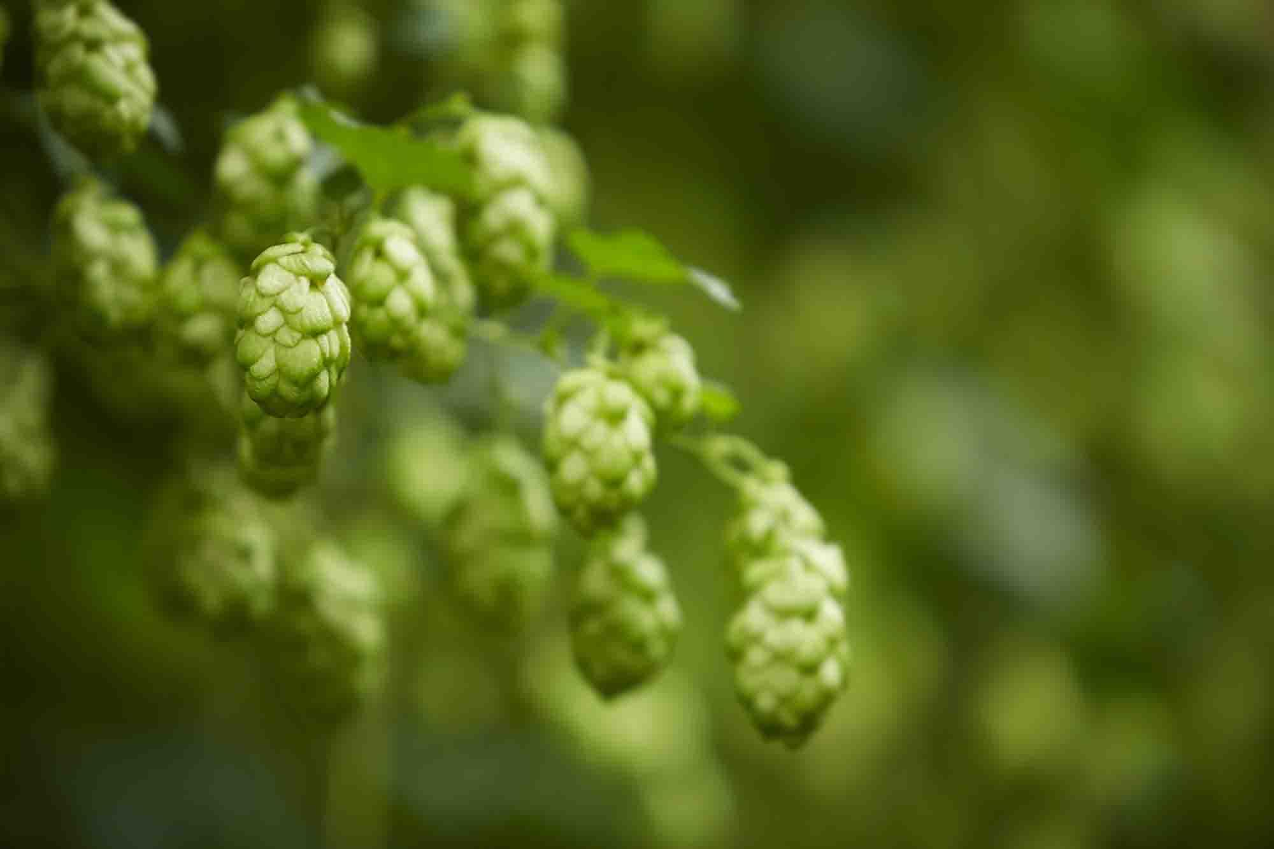

Britain’s brewing heritage is at risk from climate change, new research commissioned by British Beer & Pub Association (BBPA) and Zero Carbon Forum reveals. The UK Brewing Sector Risk and Resilience report demonstrates significant climate risks to key British brewing ingredients – barley and hops. The report urges UK brewers, farmers, and government to work together to secure future access to home-grown brewing ingredients as, without action, brewers face greater reliance on imported barley. The call for urgent collaboration to protect domestic production of British barley and hops from climate change is outlined in a new report commissioned by BBPA and Zero Carbon Forum and authored by specialist sustainability consultancy, 3Keel. Key findings include: – wetter autumns and drier, hotter summers are putting UK and international malting barley and hop cultivation at increasing risk of diminishing yield and quality for both crops – adaption measures are required, including switching to climate-resistant crop varieties, plus using irrigation and regenerative farming techniques – government support is required to help fund climate-adaption measures – the brewing sector and stakeholders across the supply chain must take collective action to build resilience. The report highlights the potential impact of domestic and global supply disruption and shortages as a result of the changing climate, which could lead to price volatility.   In the future, crops may be prioritised for food rather than brewing, which would risk livelihoods across the supply chain. Traditional British hop varieties, which are vital to the cask beer industry, could be at risk if – as the report projects – flooding increases and the spring and summer seasons become hotter. The bodies are urging collaboration across the sector and supply chain to mitigate the risks to barley and hop production and protect both the heritage of British beer – but also the economic contributions and jobs the industry provides.   BBPA chief executive Emma McClarkin said: “This important research couldn’t sound the alarm any clearer – we now know the risks climate change poses to our sector. “More importantly, this should be heeded as a rallying cry that we all need to pull together and collaborate so we can protect our unique heritage and homegrown crops. “For centuries, Britain has relied on its barley and hops to make delicious beer, and we must act to preserve and protect this proud tradition, by everyone in the supply chain meaningfully working together.” Zero Carbon Forum director Bob Gordon said: “If we are to ensure our brewing industry is resilient enough to cope with drier summers and wetter winters, proactive steps are required. These steps must be taken together. Challenges on this scale require strong collaboration. “The Zero Carbon Forum, with the support of UK brewers and pubcos, is looking forward to working with the sector to turn this report’s recommendations into action.” The Maltsters Association of Great Britain said: “The risk from climate change in disrupting this situation is real and all measures to mitigate this are supported; we welcome the report commissioned by the BPPA.” The British Hop Association said: “Charles Faram Farms and other grower members of the British Hop Association are very grateful to 3Keel and the BBPA for this excellent report. “It highlights the difficulties growers are facing worldwide, not just today but also how things will develop in the coming years. It highlights some important ways forward for breweries and growers and perhaps most importantly shows how important the UK could become in hop production moving forward.”