Warm welcome for Cold Town

28/04/2025 by Timothy Hampson

Industry

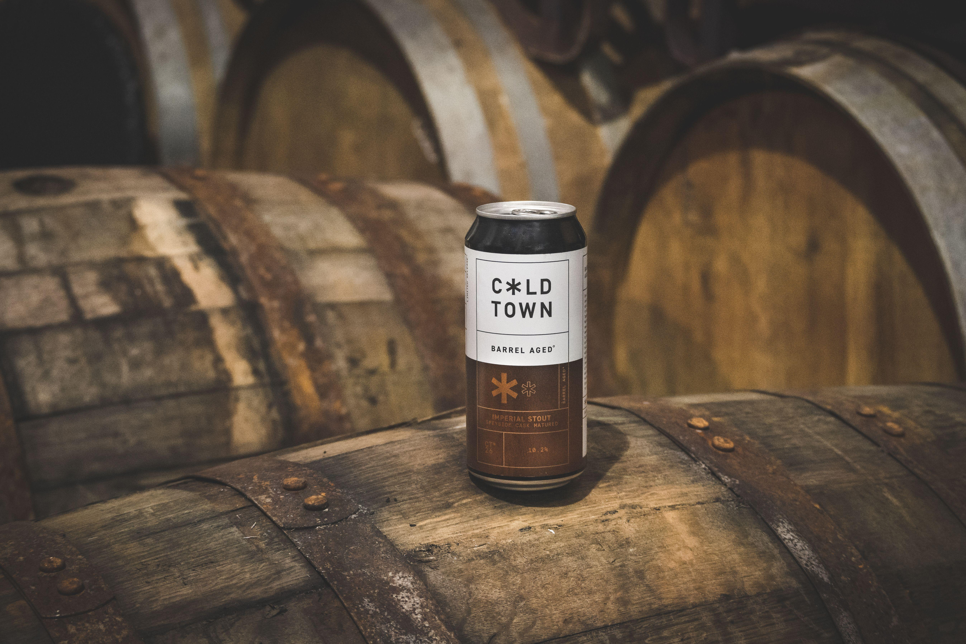

An Edinburgh beer has been crowned UK Beer of the Year at the London Beer Competition. Cold Town Beer clinched the national accolade for its flagship beer, Barrel Aged Imperial Stout – Speyside Cask Matured, 10.2 per cent. The London Beer Competition rewards beers based on quality, value, and packaging. This year’s competition brought together a panel of beer buyers, bar owners, and industry experts from around the world. The judging took place in London, where hundreds of beers from more than 20 countries were blind tasted, assessed, and scored. Cold Town Beer head of production Ian Kennedy said: “We’re absolutely thrilled. We’ve spent the last seven years building a range we’re truly proud of, and it’s incredibly exciting to see Cold Town getting national recognition. “This beer is something special. It’s a celebration of everything we’ve been working towards and a real moment for our team to put Cold Town firmly on the map.” Cold Town Beer director Euan Bain added: “From day one, we set out to create beers that were full of character and brewed with care – and our Barrel Aged Stout is the perfect example of that ethos. Maturing it in Speyside whisky casks was a passion project for the team, and the result has exceeded all our expectations.”