Old Shoe has new cider soul

27/04/2025 by Dave Pickersgill

Pub

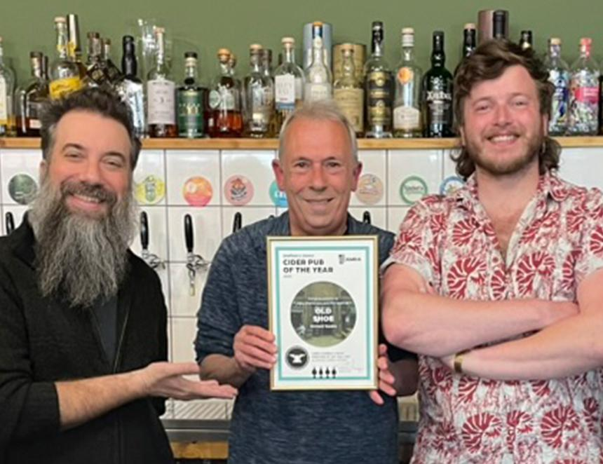

The Old Shoe has been named Sheffield & District branch’s Cider Pub of the Year 2025. The bar opened on 12 July 2023 as the new home of Exemption Ciderhouse, when it relocated from its previous premises at the Cider Hole. Owner Mike Pomranz moved from Brooklyn, New York to Sheffield in 2015, and he continued to produce cider, focusing on using local garden apples. In 2020, he launched drinks import company, Quality Ferments. Then, in September 2021, came the Cider Hole, an urban micro-cidery, bar and bottle shop, where he made and served his own Exemption Ciderhouse cider along with other canned and bottled ciders, beers and natural wines. Now, he is at the Old Shoe and looking to open an upstairs speakeasy. The Old Shoe serves a large variety of drinks from independent producers. In addition to both cask and keg beer from independent breweries, its serves three draught ciders and a wide range of bottled options. The ciders are almost invariably from smaller producers. Recent cider suppliers include Against the Grain (London), Ascension (Sussex), Iford (Bradford on Avon), Temple (Dorset), Zapiain (from the Basque region in Spain), and from Herefordshire, Little Pomona, Oliver’s and Ross-on-Wye Cider Company. To celebrate the award, one Exemption cider is currently available. It’s made from apples which were harvested in autumn 2023, the Fox and Lazy Dog (6.5 per cent ABV) a mix of local garden and Foxwelt apples. The pub also has vinyl records spinning all day and has a well-stocked shop, with art prints, bags, bottles, cans, chocolate, coffee beans, glasses, local pub heritage books, records and more. Pictured, from left, Mike Pomranz, Dave Pickersgill and bar manager Nathan Hehir Photo: Alan Gibbons