Pub of the Year archives – 1988

26/04/2025 by George Robbins

Pub

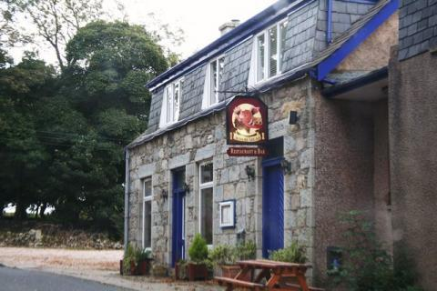

It is hard to believe it is almost 40 years since CAMRA crowned its first overall Pub of the Year.   The award has gone from strength to strength since 1988, with pubs across the UK vying to take the crown after a year’s judging. Not only does the coveted award bring the winning pub glory, but it also encourages people to make the pilgrimage to visit not only the winners, but those which reached the final stages of the competition.  In 2025, the Bailey Head in Oswestry was crowned overall Pub of the Year. Extensive media coverage followed, including on the BBC One Show, articles across major UK newspapers, along with a host of online and radio coverage.   This series will explore the history of the award, shine a spotlight on past winners, take a look at how the competition has changed over the years plus highlight the impact it has had since its introduction. The first winner was the Boars Head, Kinmuck, Aberdeenshire.  Close to Inverurie, but well off the beaten track, the small bar was a haven for locals, while offering a warm welcome to all visitors. In recent years, it ceased to be a pub and became an Indian Tandoori, before becoming a private house. It is now a legend of the distant past but will always be known as the first winner.  Just a short drive from Aberdeen, it was a cheery little village pub with a bank of handpulls offering a range of cask beer from Timothy Taylor’s Landlord to Marston's Pedigree and Hall and Woodhouse beers.   The presentation took place in May 1989, with news of the victory published in What’s Brewing (below).   The small feature image and story acknowledged the award as one of the most prestigious for publicans. The then CAMRA chairman Rob Walker presented a certificate and a working solid brass Homark traditional handpull to landlord Stuart Singer.   Singer was a massive contributing factor to the pub’s success. An article in What’s Brewing said: “You will find most bar staff friendly and helpful in their own ways and many are fully qualified members of the Tom Bruce (barman in Aberdeen) School of Charm and Diplomacy. Stuart Singer is the only person ever to be expelled from this course, for the crime of persistent jollity.”   Roger Protz described Stuart as “the epitome of cheerful”. The article’s focus was on the lack of interest in cask in Aberdeenshire, highlighting how Stuart was one landlord who proved his dedication to the cause reaps rewards.   Famous for his Ale Cupboard, which was seemingly never bare, he had casks stored on end with the beer drawn to the bar through an extractor tube, inserted through the tap hole.  Just before receiving the award, he had put on his 100th cask brand and the Broughton brewery had helped him celebrate by brewing a special centenary ale. He was determined to hit the 250 mark soon.   Roger said: “It would be cheering to think that Stuart’s success might encourage people to follow in his pioneering footsteps. But the economic realities suggest that he will remain a bibulous voice crying gold cheer into the surrounding wilderness.”   Fast forward to the present day, Stuart’s efforts to showcase cask beers in Scotland have proven to be a success. Real ale is a significant part of Scottish pub culture and many pubs – particularly in Edinburgh and Fort William – are known for serving high-quality cask beers. There’s a growing trend of people wanting to drink beers brewed locally, helping to safeguard the future of cask beer in Scotland. While it has had a difficult few years, it is rapidly gaining popularity again with younger drinkers and those new to beer.  Stuart’s achievements will no doubt have helped pave the way for this success and the Boars Head will remain in the minds of those who visited it back in the day and to those who called it their local.

