Easter beer brownie

21/04/2025 by Christian Gott

Uncategorised

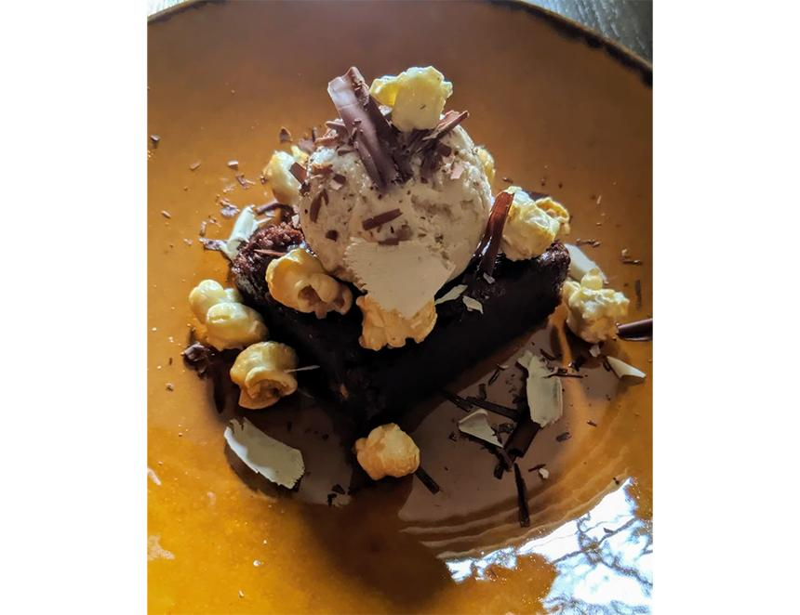

This recipe’s inspiration is Easter and if, like me, you have school-aged children and a house full of chocolate. Dark chocolate is a key flavour you get from heavily toasted malts and is easily identifiable when you drink a stout. It is no surprise then that stout and dark chocolate is a classic pairing. The combination of bitter and sweet flavours in both the chocolate and stout develops the characteristics of each. My go to chocolate recipe is a slightly gooey dark chocolate brownie with an almost fudge-like sticky centre. I have used the recipe in numerous pubs and restaurants. It’s the only brownie recipe you will ever need. You can serve it with almost anything, from strawberries to an orange sorbet, but one of my favourites is with ice cream and caramelised popcorn. If you can find beer caramel popcorn even better! To make this combination even more chocolatey and delicious, I have chosen Choco Choco chocolate egg stout from the Tiny Rebel brewery. Tiny Rebel started out on an industrial estate in Newport, Wales in 2012. Since then, it has expanded, bought pubs, hosted its own beer festival and won a host of awards. Choco Choco has a rich chocolate-filled aroma and is packed with baked biscuit, chocolate and sweet molasses flavours - perfect for our brownie. Beer brownie 185g good quality dark chocolate 185g unsalted butter 275g golden caster sugar 100g self-raising flour 100g milk chocolate drops 40g cocoa powder 120ml Choco Choco stout 2 large free range eggs Half tsp baking powder Preheat your oven to 350F/180C/Gas Mark 4. Butter and line a 20cm square baking tray (the sides should be at least 5cm deep) with non-stick baking paper. Break the dark chocolate into small pieces and place in a medium-sized, heavy-bottomed pan and add the butter. Place on a very low heat until the butter and chocolate have melted, stirring occasionally to mix them together, then remove from the heat. Sieve the flour, salt, cocoa and baking powder into a medium bowl to remove any lumps. Save the sieve to one side. Crack the eggs into a large bowl, add the sugar and whisk until thick and creamy. The mixture will be really pale and about double its original volume. This is called the ribbon stage. The whisk will leave a trail for a couple of seconds if removed from the mixture. Pour in the chocolate mixture and gently fold together, in a figure of eight motion. Carefully mix while trying to keep in as much of the whisked air as possible. Hold your sieve over the chocolate mixture and resift the cocoa, salt and flour mixture. Gently fold this in using the same figure of eight action as before. Add the stout and repeat. Stop when the mix is thoroughly combined. Lightly stir in the milk chocolate drops. Carefully transfer the brownie mixture into the lined baking tray and gently level out. Place into the oven and cook for 25 minutes. Pull the baking tray to the edge of the oven shelf and carefully shake the brownie. If the brownie is still wobbly in the centre, quickly shut the oven door and cook for five more minutes. If you like a firmer brownie with a more sponge-like texture that is ideal for pack-ups, cook for another five minutes. When the brownie is done, the sides should not be beginning to come away from the tin. Remove the oven and leave until completely cold. Do not try to move or cut the brownie while it is still hot. When cold, remove from the tin and take off the baking paper. Portion as required, but remember it is very rich. The brownie will keep in an airtight container for a week and can be frozen. Serve with caramel popcorn, vanilla ice cream and chocolate sauce.