More Jaipur for JD

20/04/2025 by Timothy Hampson

Industry

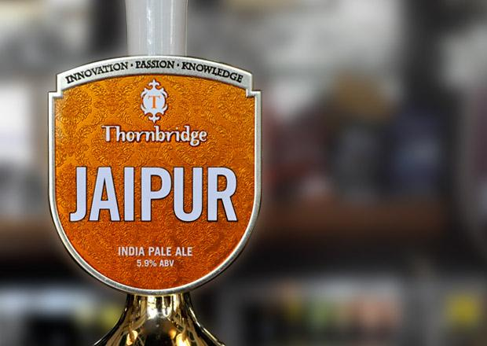

Fans of Thornbridge’s Jaipur should find enjoying a pint easier as JD Wetherspoon is now rolling it out to almost all its pubs. Originally brewed in 2005, the 5.9 per cent India Pale Ale quickly developed a loyal following thanks to its bold and refreshing flavour profile with notes of lemon, pine and grapefruit. “We’ve had a long-standing relationship with JD Wetherspoon for nearly as long as we’ve been brewing,” said Thornbridge CEO and co-founder Simon Webster. “Our mission was always to make Jaipur available to anyone who wants to drink it. This national listing with Wetherspoons helps us do that.” Wetherspoon chief executive John Hutson said: “We are proud to offer our customers the widest range of quality beers at all times. We are delighted that Jaipur will be available in the majority of our pubs for customers to enjoy.”