Pub makeover winners revealed
19/04/2025 by WB Reporter
Campaign

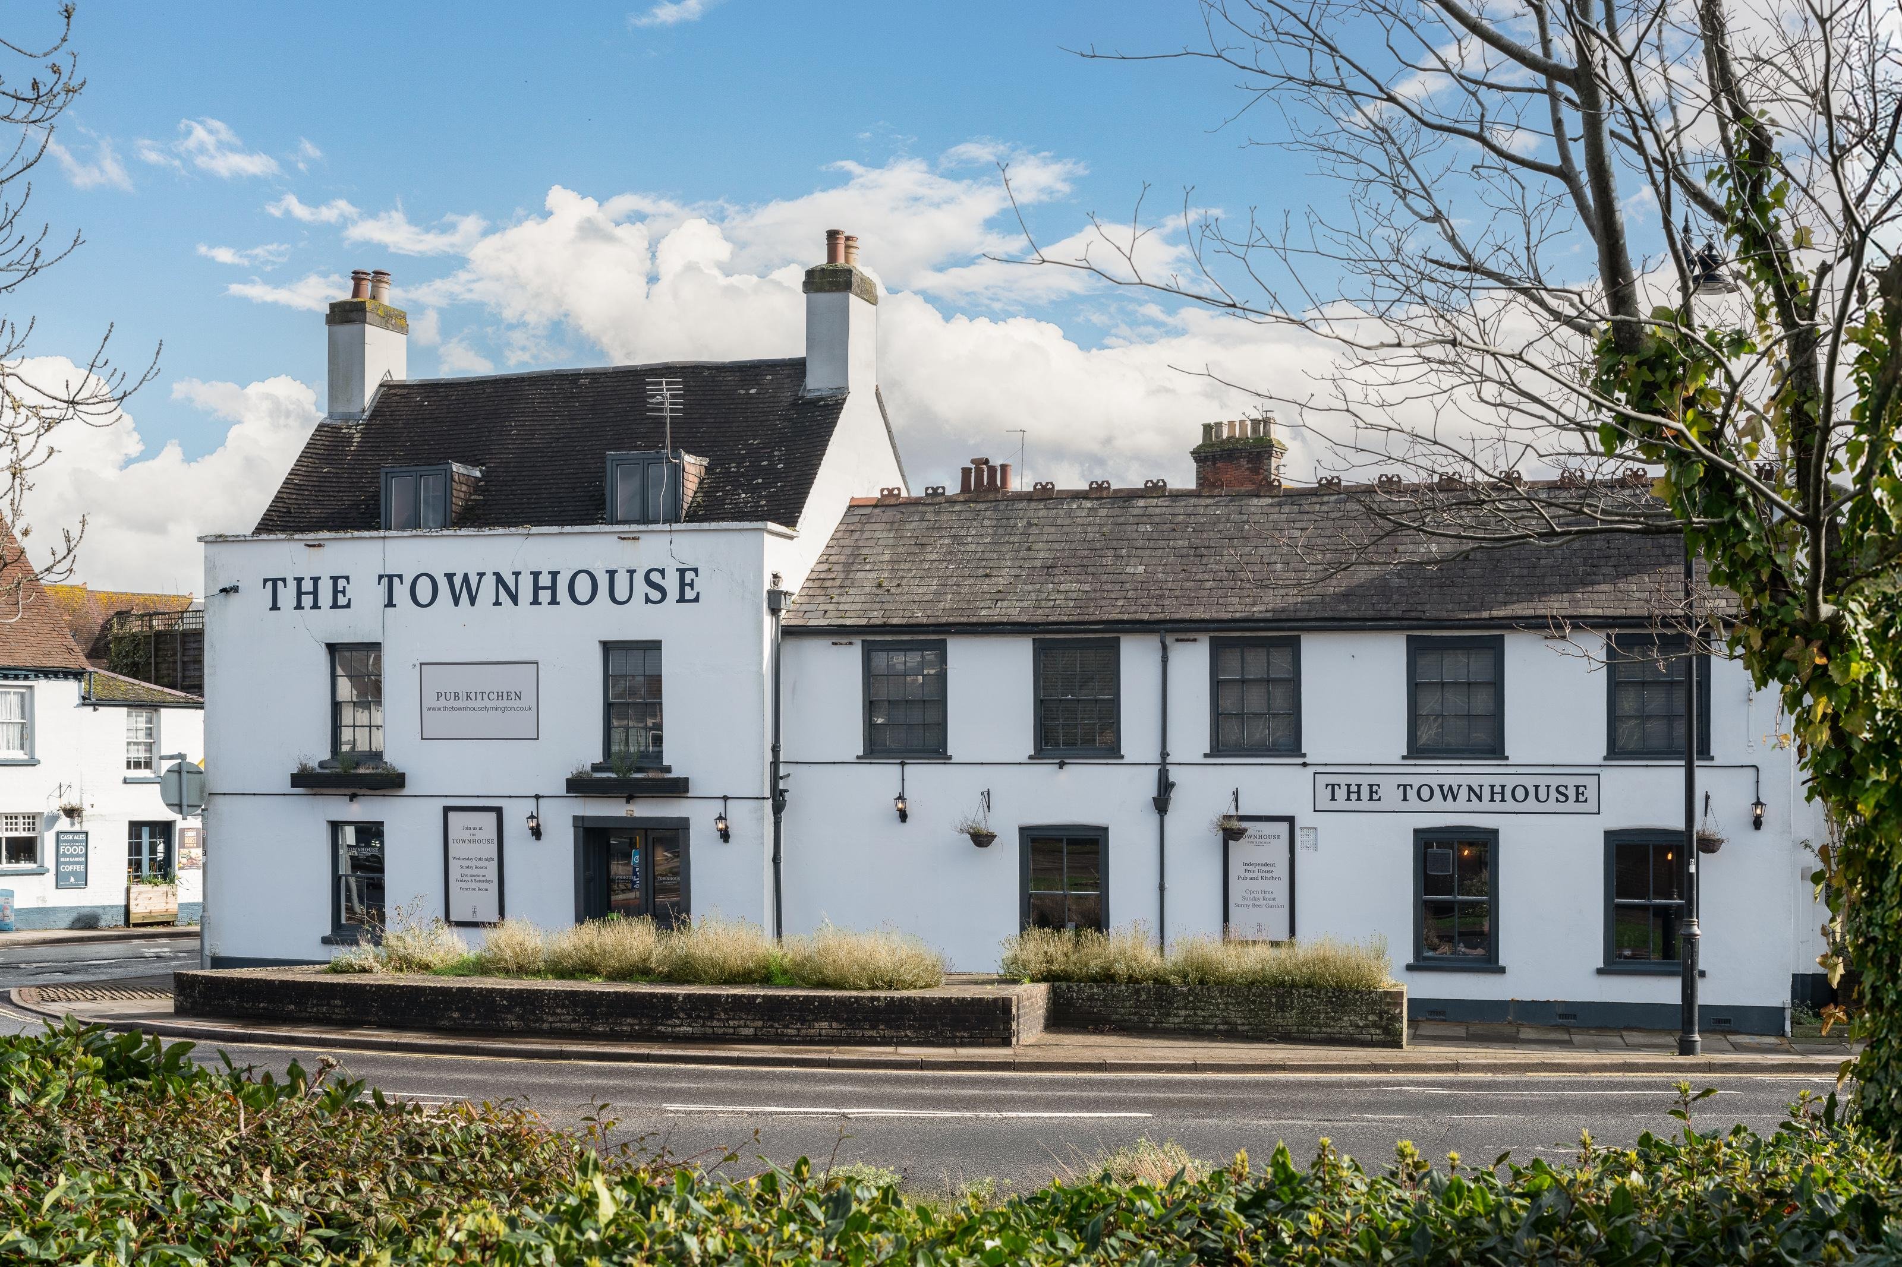

Airbnb has revealed the major renovations to rooms above three independent, rural pubs secured in a new initiative with CAMRA. Almost a quarter of Airbnb guests want to explore more of the UK and new guest rooms will allow these pubs to now welcome staycation guests, diversifying income streams as well as boosting the local economy. With a 6.7 per cent increase in pub closures, particularly in the South West and East Midlands where 37 shut last year, the partnership between Airbnb and CAMRA to refurbish and list out rooms in these pubs is timely. The three pubs now join the more than 350 British locals already listed on Airbnb that are helping towns and businesses benefit from more overnight guests. After a close-fought contest the three winners were:
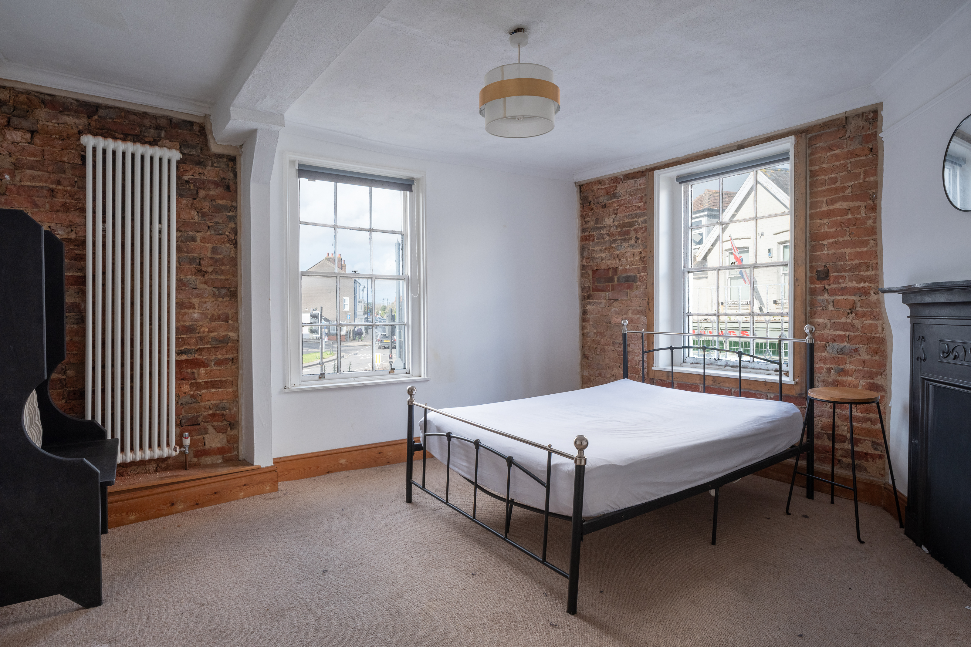

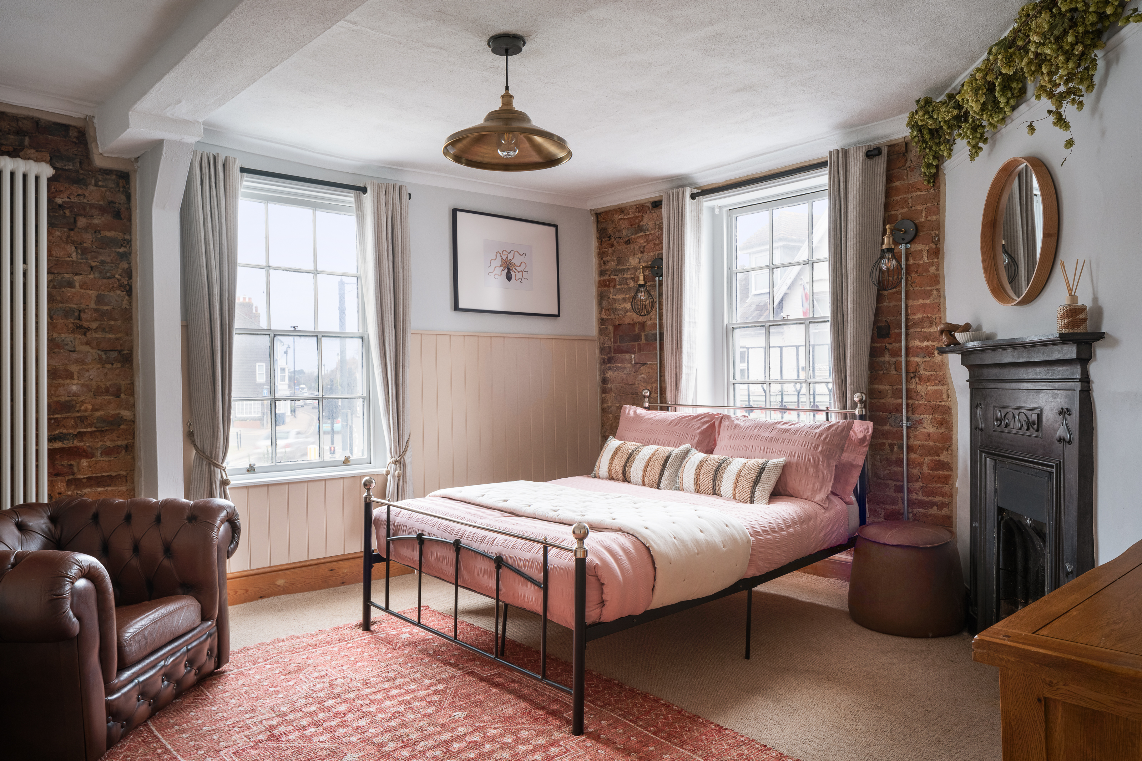
Townhouse, Lymington, Hampshire (above before and after) Since taking over the Townhouse (main image above) more than two years ago, owner Dave King has ensured the suntrap courtyard and live music events are at the centre of Lymington’s hospitality scene. Faced with a slightly run-down space upstairs, Dave saw the potential of this makeover to help him channel his experience in hospitality and his love of the New Forest region into providing a perfect experience for overnight guests. The two upstairs rooms have been transformed into contemporary guest suites, mirroring the pub’s exposed brickwork and bright airy tones. Whether guests want to bike and sail or take scenic walks amongst the roaming horses scattered across the New Forest, the rooms at the Townhouse are the perfect retreat from the lively activities in this stunning harbour town. Dave said: “I’ve worked in the hospitality industry for more than two decades and economically speaking, this January has been the toughest I've faced. Pubs need help, we need people to choose local and independent, so as a result of Airbnb’s generous investment and expert mentoring, we really hope that people will do just that at the Townhouse. My son is only eight, but he wants nothing more than to manage a pub when he’s older and I can’t wait to show him the ropes as we enter what is set to be a busy spring thanks to this incredible renovation.”
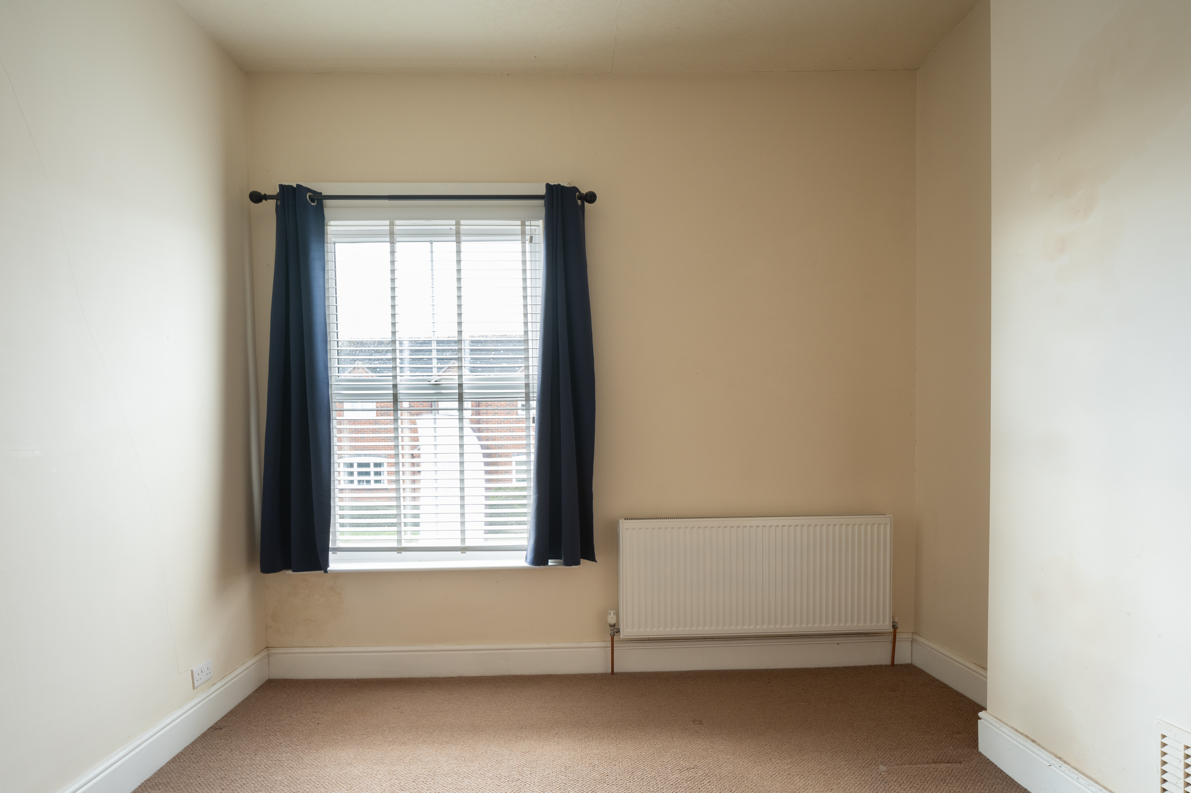

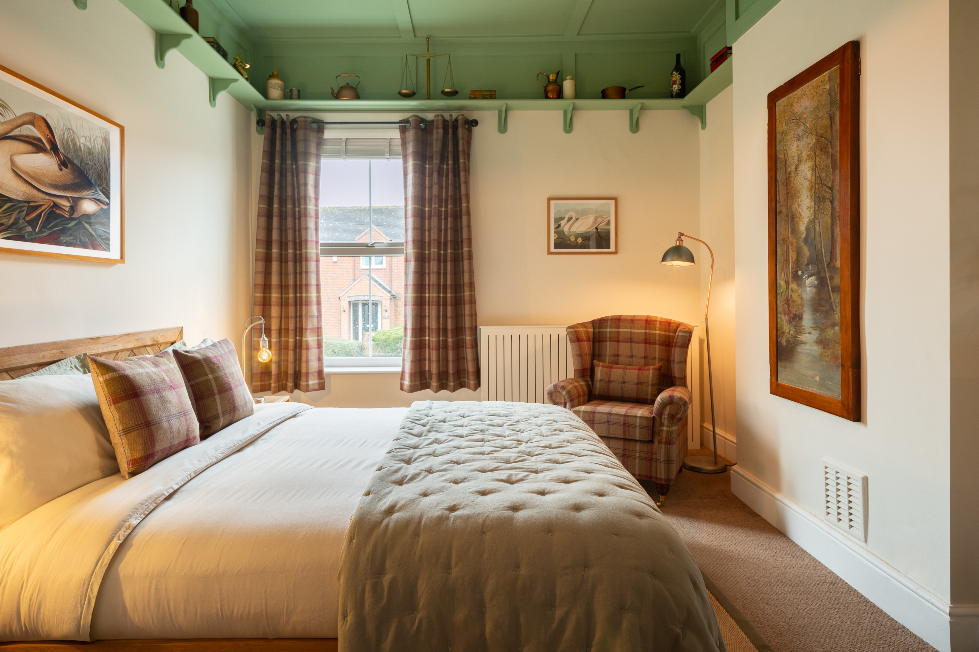
Swan Inn, Milton, Derbyshire (above, before and after) Since taking the reins in 2021, White Swan landlord Olly Way has transformed the traditional village pub into a welcoming haven for visitors. The newly renovated guest room is richly adorned with traditional Balmoral tartan and a striking green colour-washed ceiling. Olly’s vision is that these rooms will help him open the doors to the Swan even wider, inviting guests from around the globe to experience the charm of Derbyshire. Located near the Anchor Caves and Foremark Reservoir, the Swan is perfectly placed for guests to explore the natural beauty of the countryside. This welcoming inn not only stands as a testament to Derbyshire's tradition and natural beauty but also fosters a sense of discovery and connection among visitors from all walks of life. Oliver said: “I got the keys to the Swan Inn at 12pm on Friday the 13th and opened for business at 4pm the very same day – from the outset, it has been full steam ahead! Unfortunately, like many others, our pub has faced challenges in the current economic climate. Despite our passion for welcoming everyone to this little slice of countryside heaven, we had to make the tough decision to close the pub one day a week to manage costs. With Airbnb’s incredible renovation, we hope that we’ll be able to scrap this and welcome guests from far and wide, no matter the day.”
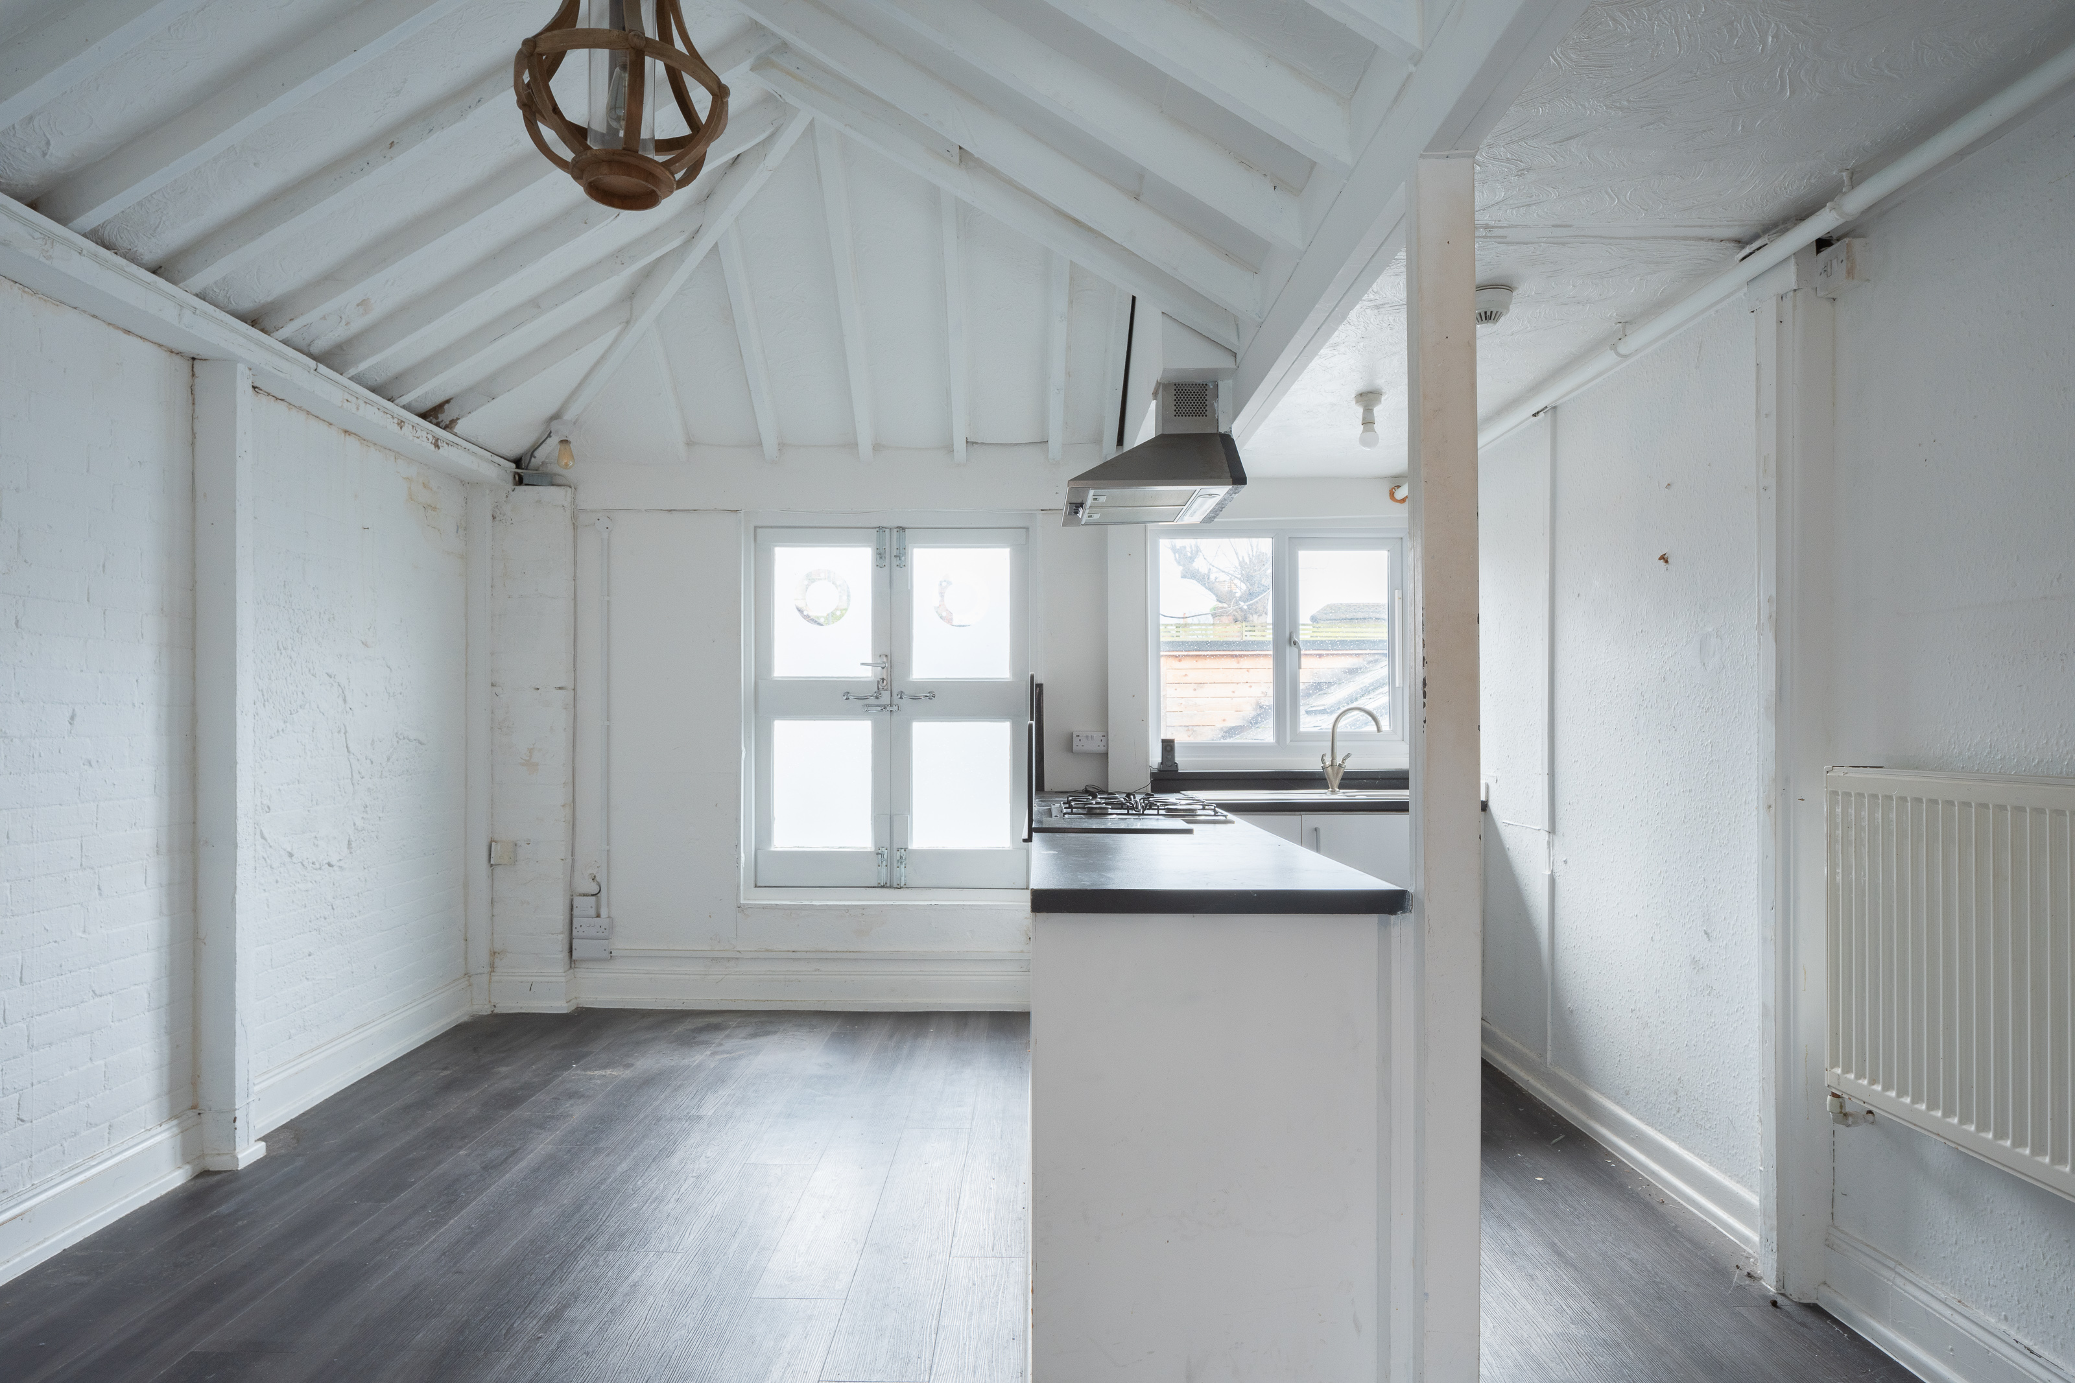

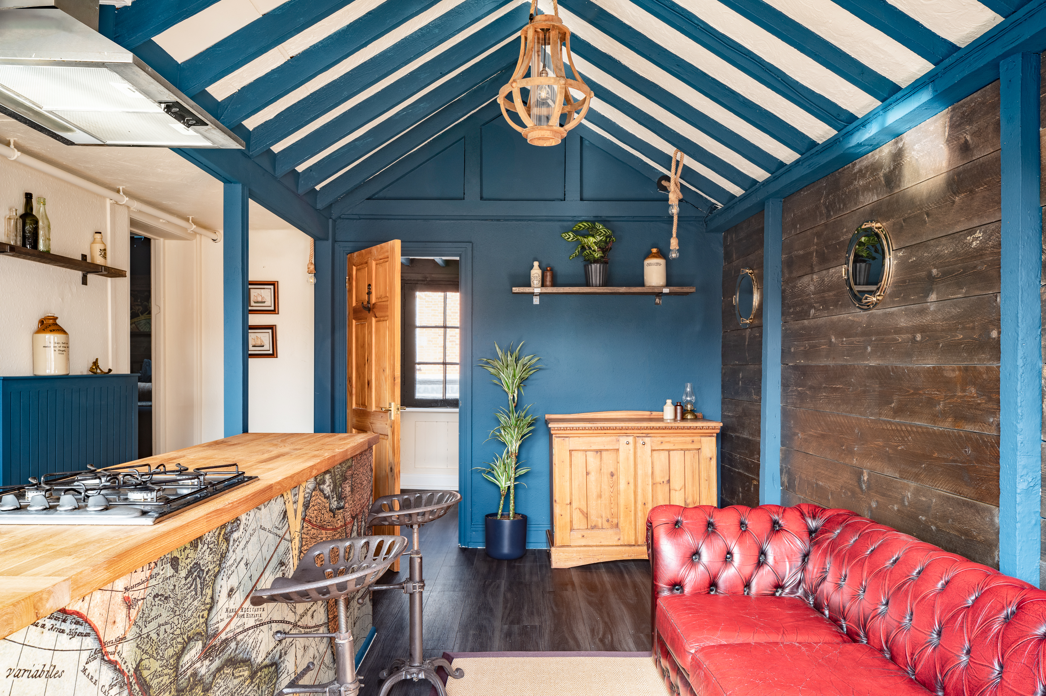
Thomas Tripp, Christchurch, Dorset (above, before and after) The storied Thomas Tripp is a pub renowned for its local legacy, which friends and co-owners Dave Burns and Jason Giddings love to lean into – even featuring portraits of regulars dressed as seafaring smugglers around the bar. The pair put an added emphasis on community action, working with several local charities and community projects in the area including the Dorset Children’s Foundation. Thinking about what’s next for the pub, they saw the opportunity to turn their empty kitchen unit upstairs into a new offering for overnight guests, encouraging more travellers to explore local attractions such as Southbourne Beach. The loft has now been transformed into a moody yet refined private space with a cosy cove for guests in the heart of Christchurch. This getaway lets guests dive into the south coast’s sea heritage, perfect for relaxing after paddleboarding on the River Stour or taking a vintage ferry to Mudeford beach. Dave and Jason said: “Like many pubs across the country, the Tripp is an integral pillar of the local community and has been for generations. While the entire industry is feeling the pinch, independents like ourselves have been particularly vulnerable, so Airbnb’s investment into the pub is truly life changing. Not only do we hope to keep this a place that is special to locals, but now we want to help more unlikely tourists discover the hidden gem that is Christchurch.” Airbnb UK’s Luke Impett said: “Pubs are the beating heart of any community and play a vital role in sustaining local economies. We’re proud to support the industry by breathing new life into these three unique, independent pubs that are so loved by their communities, helping them to welcome more guests and ultimately put more cash behind the bar. We know that travellers want to explore more of the UK’s rural gems and unique stays like these on Airbnb provide the perfect base for an authentic experience of the British countryside.” CAMRA pub and club campaigns director Gary Timmins said: “We are delighted to see the results of this partnership with Airbnb that has put independent pubs and the value they bring their local community into the spotlight. The addition of such striking guest rooms not only helps through investment into preserving the use of these important community landmarks as working pubs but also enriches the UK’s hospitality landscape by offering locals and visitors alike distinctive and immersive experiences.” The winning pubs were selected by a panel of judges including chair of the Culture, Media and Sport Select Committee Dame Caroline Dinenage, chair of the Hospitality and Tourism All Party Parliamentary Group Chris Webb MP and Gary Timmins. Dame Caroline said: “The Airbnb and CAMRA’s initiative will help holidaymakers discover a new way to explore vibrant British towns that they may not have previously considered. Pubs are at the heart of so many communities across the UK and this initiative is an example of how we can think differently about their dynamic role in supporting local economies and driving sustainable tourism through platforms like Airbnb.” Photos by Airbnb

