Beer Day Britain returns

18/04/2025 by Timothy Hampson

Industry

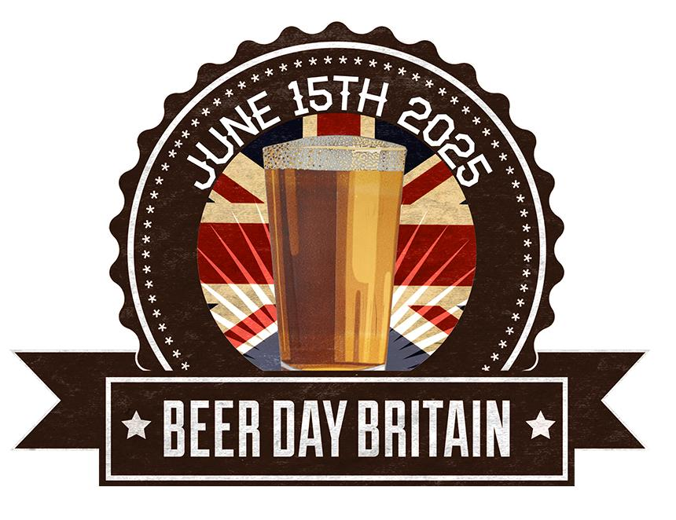

Beer Day Britain and Beer Day Northern Ireland, the UK’s annual celebration of the drink, returns on 15 June. Each year, the focus of Beer Day Britain, now in its 10th year, is the Cheers To Beer toast at 7pm. This simple gesture is not only marked across the UK but by beer drinkers around the world who participate each year. The hashtag #CheersToBeer always trends on social media. Organiser Jane Peyton said: “Beer has a supernatural ability to unite people and get the party started. With beer being Britain’s national alcoholic drink, you could say that every day is beer day, but 15 June is extra special and one to bring the nation together to say Cheers To Beer!” Father’s Day falls on Beer Day Britain and it is also the 810th anniversary of the sealing of the Magna Carta. Beer Day Britain shares the date with the Magna Carta because ale is mentioned in Clause 35: “Let there be throughout our kingdom a single measure for wine and a single measure for ale and a single measure for corn, namely the London quarter.” Not everyone can get out to a pub or taproom, especially people who live in care homes, so Jane encourages breweries to adopt one in their area and take the pub to them by donating beer so they can join the Cheers To Beer. For more information and to download a Beer Day Britain logo, visit BeerDayBritain.co.uk or on social media – @BeerDayBritain on Facebook, Instagram, and X (formerly Twitter).